

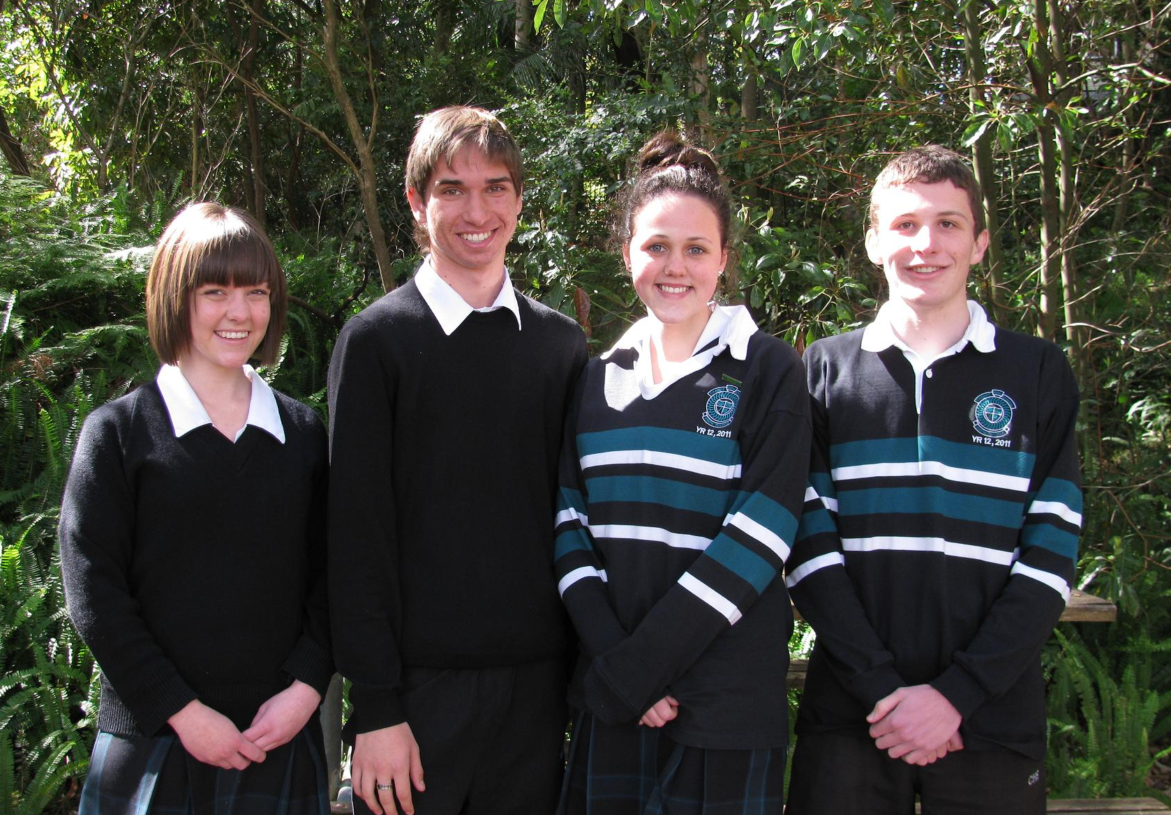

September 2010

Captain elections for 2011
Monday 22nd August saw 13 students nominate for the leadership roles at Cardiff High. Each gave a speech to staff and Year 11 students.

I am happy to announce the captains for 2011 are:
Captains: Laura Goodwin and Yuri Jaremus
Vice Captains: Matilda Eyre and Mitchell Tuck

L to R: Matilda Eyre, Yuri Jaremus,
Laura Goodwin, Mitchell Tuck.

FROM THE PRINCIPAL
It is hard to believe we are already over half way through the term already.

P&C
The last P&C meeting was very fruitful with the members deciding to purchase new stage curtains. This is at a cost of over $27,000 and highlights the incredible support the P&C and in particular the canteen helpers under the leadership of Annette and Sue support our school. We are all looking forward to the installation.

MADD Night
Another incredible night of diverse entertainment was held on 17th August. Music, Art, Dance and Drama were all well represented and a great evening of entertainment was held. Our partner primary schools also visited on Wednesday for a matinee of this event. A particular highlight was the music presented by our current Year 12 as they prepare for their practical performance exams on17th September.

Year 12
Year 12 students have been very busy completing their practical components with Industrial Technology already marked. Corey’s pool table was a highlight and Tom’s “snake” house also presented well. Textiles major works were a testament to creativity and hard work with lots of fine embroidery and detailing evident to make each piece individual. Well done girls. Society and Culture’s Personal Interest Projects were very diverse and presented each student’s research and results clearly. Extension English major works were also very unique and a result of a lot of creative energy, reflection and refinement. Our Visual Art Major works are just receiving their final touches as I write this.

Premier’s Anzac Scholarship.
Jess Madden is on the countdown for her amazing trip to France to visit the battlefields. We look forward to hearing of her adventures on her return.

Year 11 Study Skills
Mrs Hillier and Ms Gibson are busy organising the opportunity for Year 11 to participate in some study skills activities during Monday afternoons and Wednesdays. We hope students take advantage of this opportunity.

Focus Day
Year 8 recently participated in a Focus Day where the emphasis was on Cyberbullying positive relationships and personal defence. Again thanks to Ms Gibson and Mrs Hillier who organised the day. Mr Trayhurn, Mr Kinniard and Mrs Osborne presented with assistance provided from Northlakes Family Support and our Police Youth Liaison Rob Walsh.

EXO Day
Congratulations to EXO Day Organisers. Friday 20th saw out ISCF group organise a special event where entertainment and lunch was provided to students. Their organisation was terrific. Congratulations.

School Maintenance
Ground works continue. You just know when they tell you that drainage work is about to begin the sky will also open up. This is exactly what has occurred over the past 10 weeks. Our drainage work continues to sneak closer to finalisation. Our hill is all but completed – we are waiting on the planting of shrubs to consolidate the work. The remaining drainage around our main block continues. We are close to getting the walkways back to the library with concrete being laid last week. Lots of remediation work occurred on the oval over last weekend so hopefully this will be handed back to us shortly.

YEAR 10 End of Year Activities.
Parents need to be aware that with the new legislation that requires students to be at school or in training until the age of 17 the expectation that students returning to school will be in attendance until 9th December when their School Certificates arrive and are presented at a ceremony that evening. We are working on a special program for Year 10 following their exams that includes SCOPE presentations, Board of Studies Mandatory All My Own Work, Crossroads activities as well as preparation for Senior School. The only students who will be able to leave school after the exams are those who can verify in writing from an employer that they have at least 25 hours work.

Year 11 Exams and Yr 10 Trials
Good luck to all students for these upcoming exams.

Hunter Academy of Sport Award
Hunter Academy of Sport has awarded Brock Griffiths the Hunter Schools Sports Star of the Month Award for July for his sporting achievements with his BMX riding.

SRC Nominations
Invitations have been issued to all nominees to join the leadership team of the SRC. Congratulations to : Lily Gash, Melanie Gordon, Cassie Nicholas, Elly Davis, Lachlan Waide, Lauchlan Harrison, Dane Pittard, Aaron Thick, Luke Donnelly.

Healthy Schools, Healthy Futures.
Enclosed is a newsletter from Hunter Area Health providing information about a project that we are going to be involved with. You will be receiving some information through the mail shortly with more detailed information.

Sporting Representatives

Basketball
The following students represented Cardiff high school in the knockout under 15's basketball competition held at Broadmeadow basketball stadium. All girls played with great enthusiasm. Thanks Mr Hunt.
Melissa Edwards Tiffani-Lee Singler Tamara Thompson Lauren Finn
Jacinta Walker Stephanie Richardson Rhiannon Upsall Grace Dixon
Tanique Munro Allisa Clegg

Tenpin Bowling
The following students represented Cardiff high school in the knockout Bowling Championships recently.

At the last meeting it was moved and accepted to purchase new curtains for the stage in the hall. Hopefully these can be made and installed by the next Presentation Day. The cost of the curtains is over $27,000 and they should greatly enhance our school hall. The colours will be in line with our school uniform.

All of P&C funds come from the canteen, so I am encouraging you to support our canteen with purchases or volunteering. If your time is limited, just two hours one morning a month, would help enormously with food preparation. No serving involved and you are out by 10.00 am. Annette Salmon is very friendly and hospitable (great cup of coffee), she could certainly do with your help.

Congratulations to all involved in MADD Night. What a great display of our student’s talents, whether it was art works or performing, you certainly are talented. The Year 12 performers were a standout and they are leaving big shoes to fill at next year’s MADD Night.

Good luck to Year 12 when you sit for your HSC Exams, the hard work will pay off.

The next P&C meeting is on Wednesday 8th September, 7.00pm in the staffroom. Everyone is welcome to come along and participate in our great school.

Regards
Kris Eyre
P&C President

Ben Daniel Conner Harrison
Kelly Hayes Matthew Taylor
Megan Crook Caitlyn Dennison
Paige Griggs Emily Rigney

State Athletics
Alannah Jobson Year 10 has qualified for the NSW
CHS Athletics Championships at Sydney Olympic
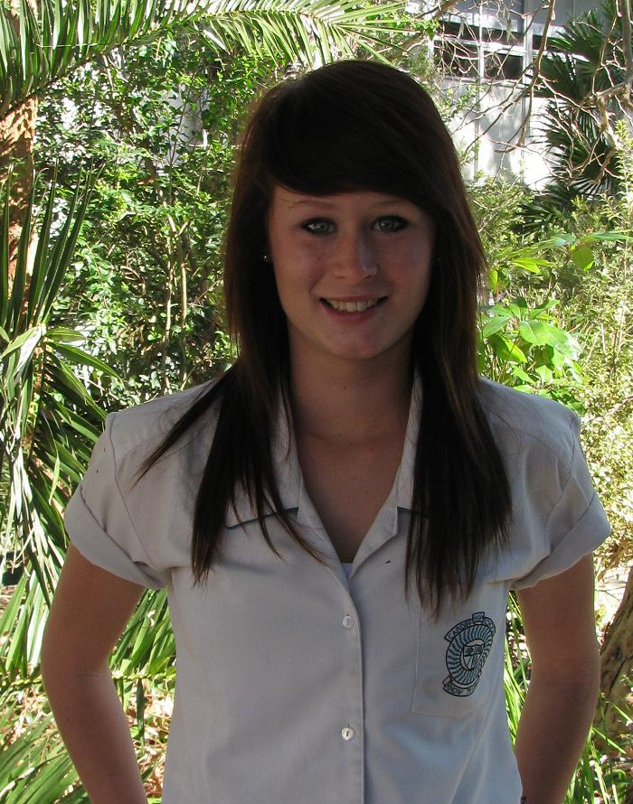
Park on September 9-11. Alannah qualified for three events after the recent Regional Championship finishing 1st in 200m, 2nd in 100m and 2nd in the Long Jump.
Congratulations and good luck Alannah.

Mrs S Russell
PRINCIPAL

DATES TO REMEMBER

September 8 P&C Meeting 7pm

September 13-23 Yr11 Exams

September 20-23 Yr10 Trial SC

September 22 Yr12 Presentation Day

September 22-24 Yr11 PDHPE Hike

September 24 Last Day of Term

October 11 Start of Term 4 (All students to attend)

October 13 HSC Commences

October 20 Yr12 2011 BOS Info Night

October 29 Yr11 Reports Issued

November 8-10 School Certificate

November 10 P&C Meeting 7pm

November 10-12 Yr7/8/9 Exams


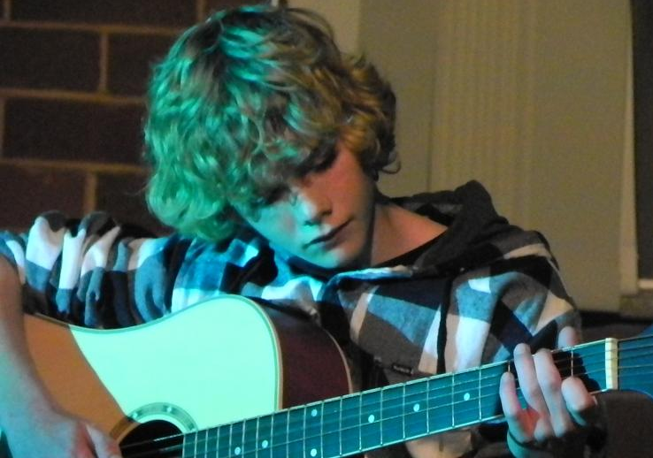


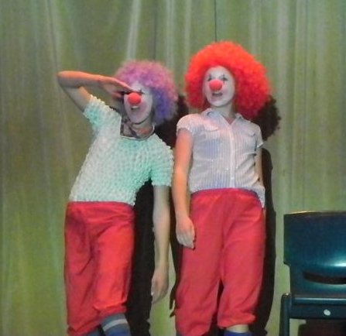
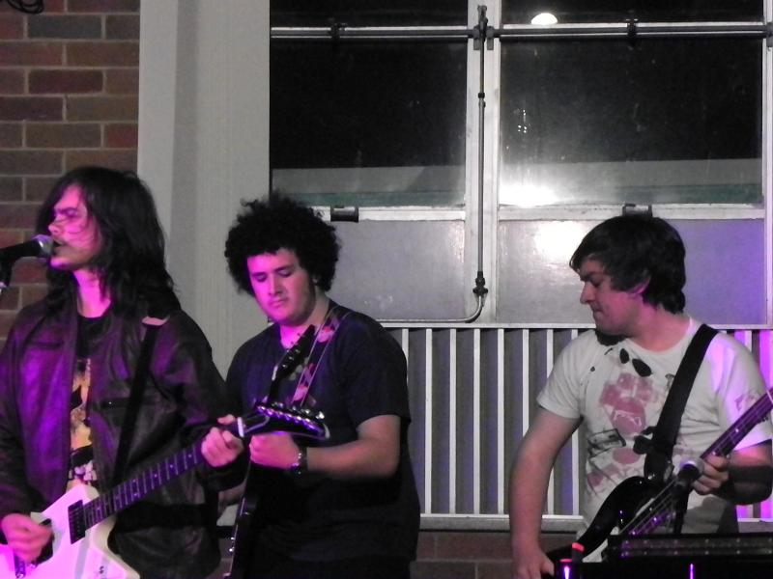


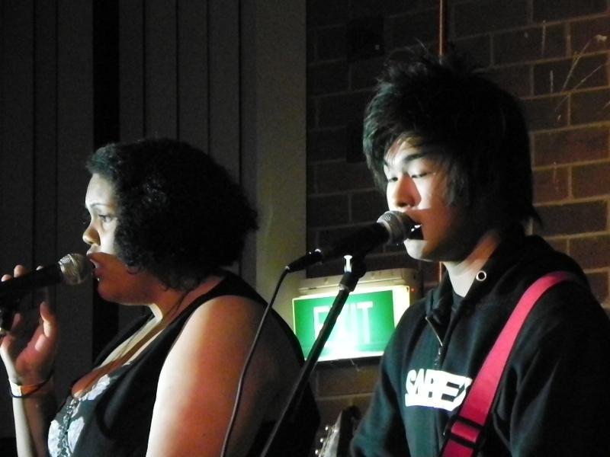
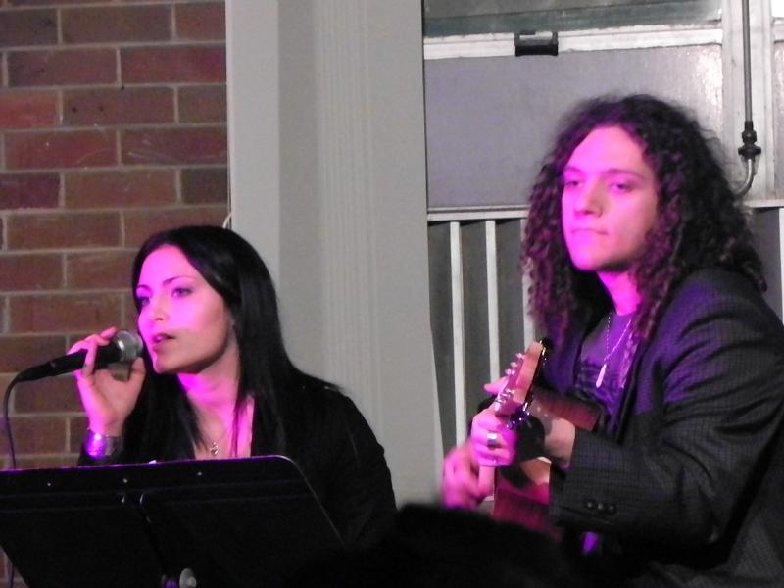
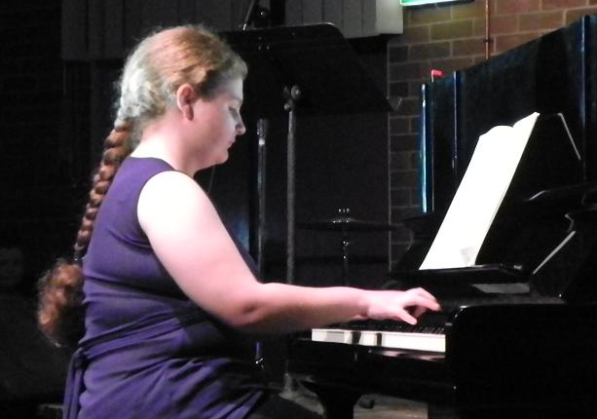


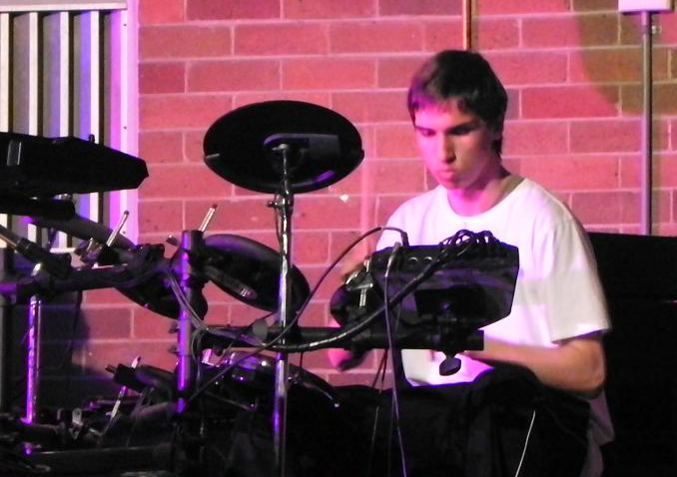

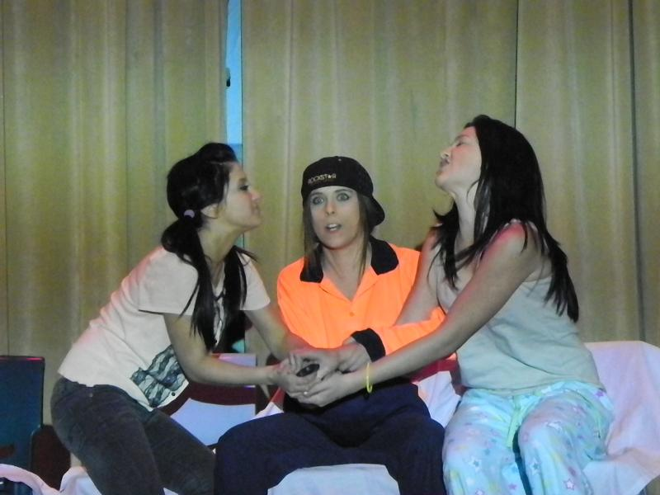

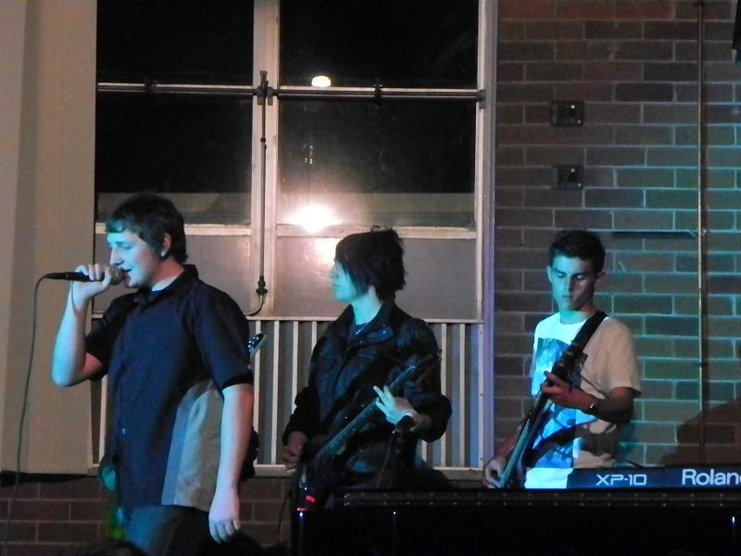
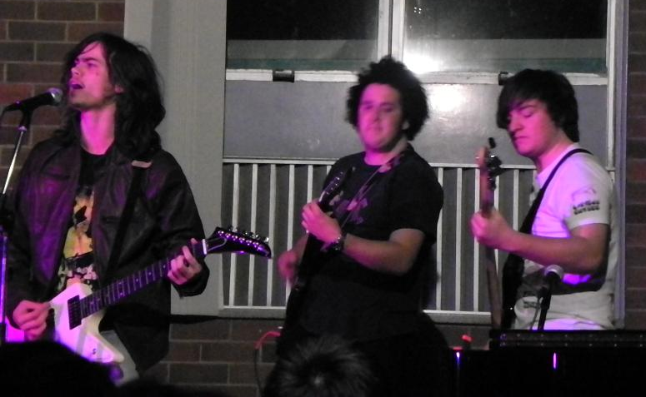
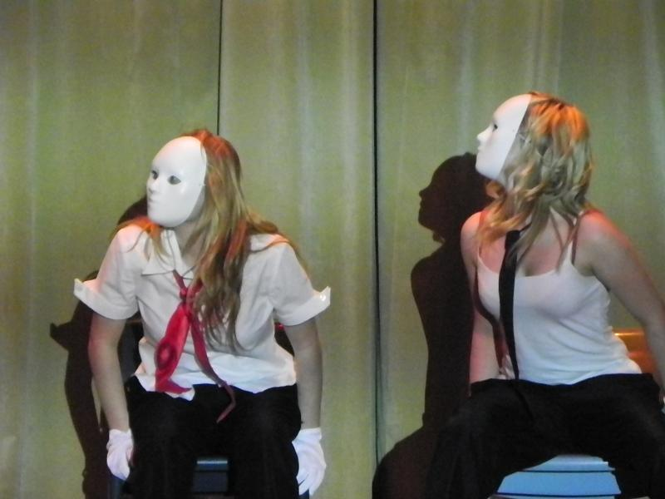
MADD NIGHT 2010

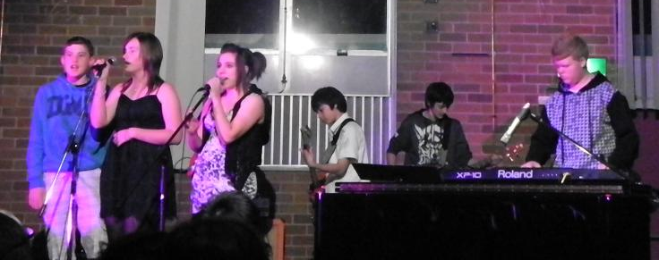

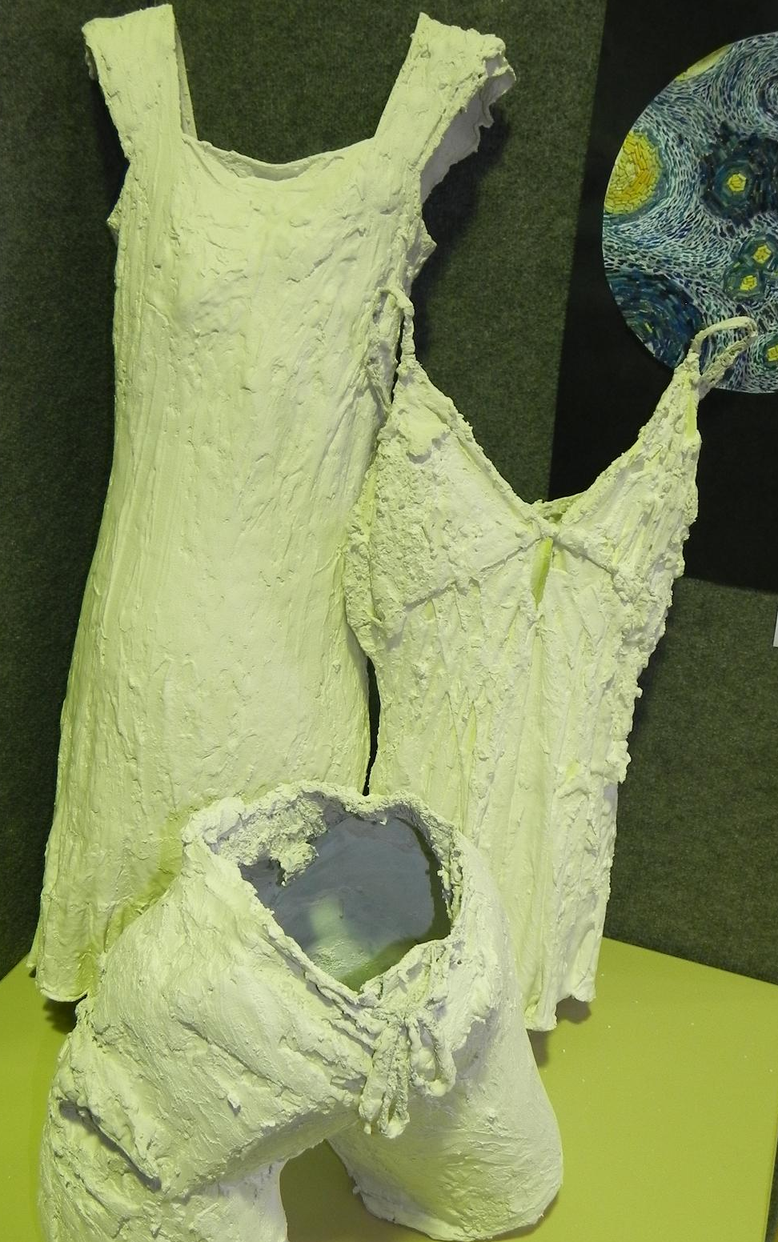
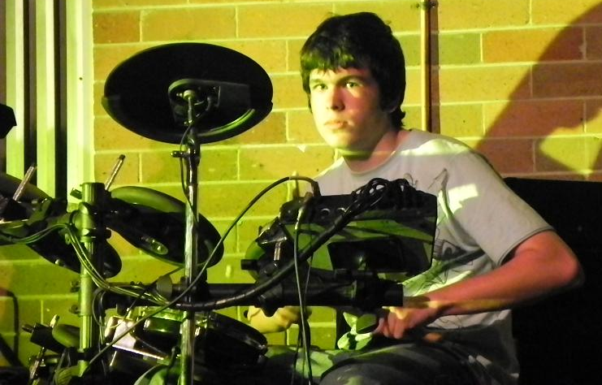

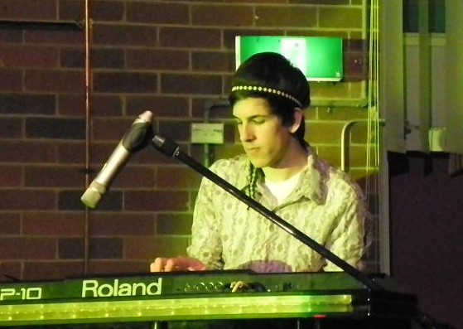
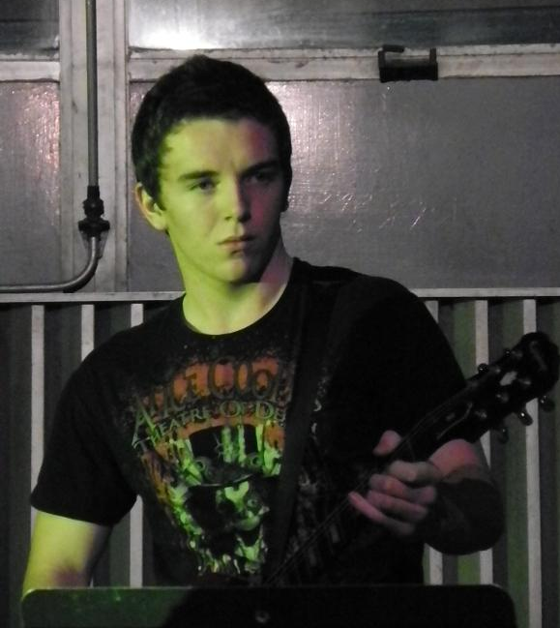
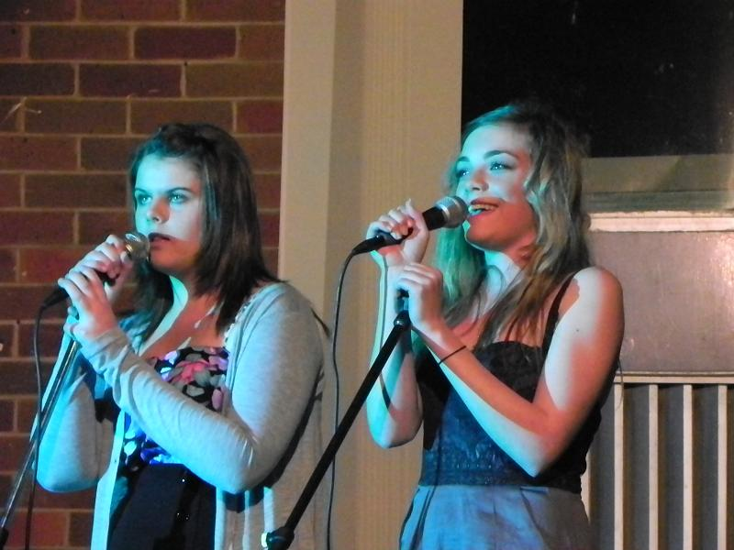
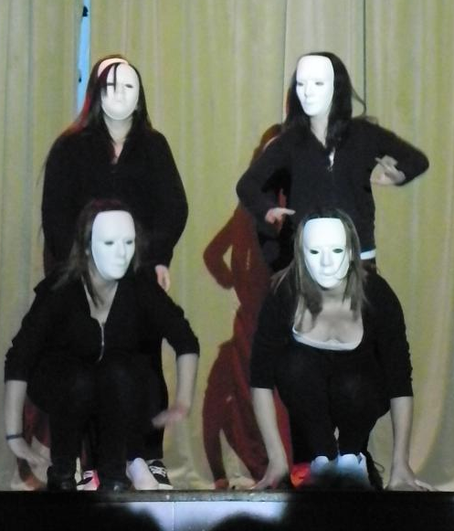
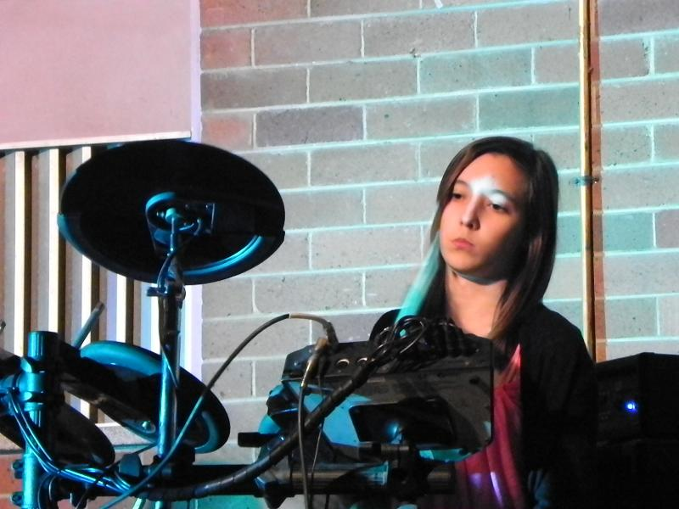
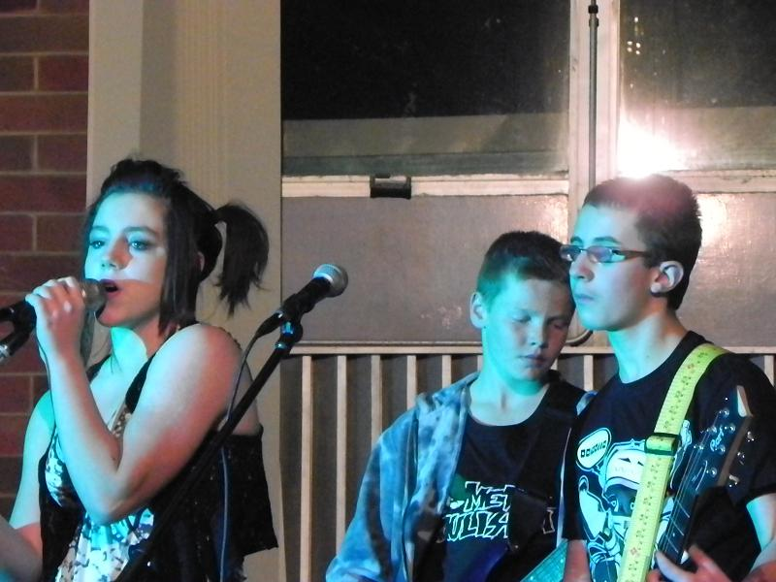
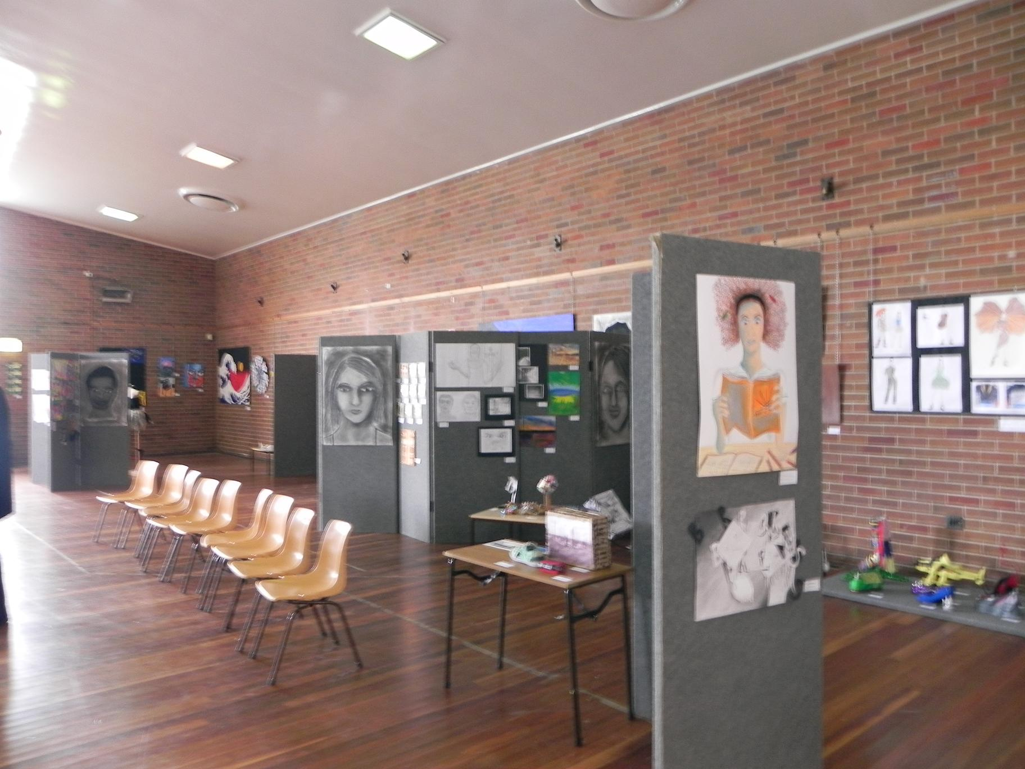
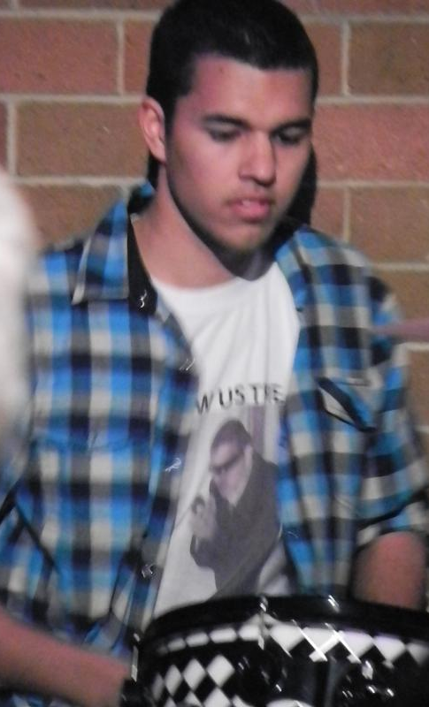
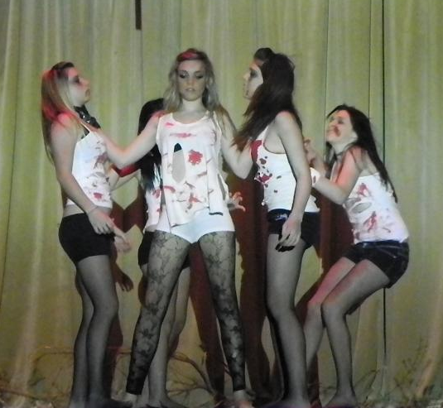
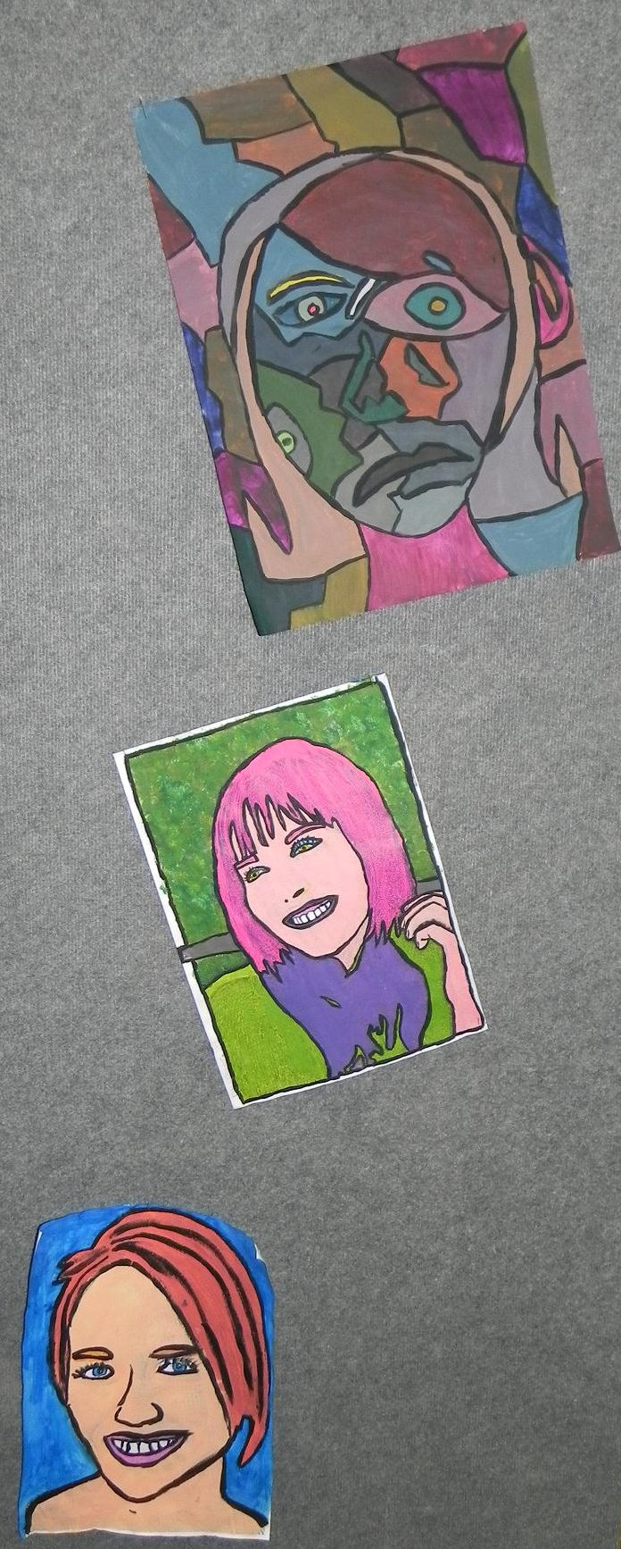
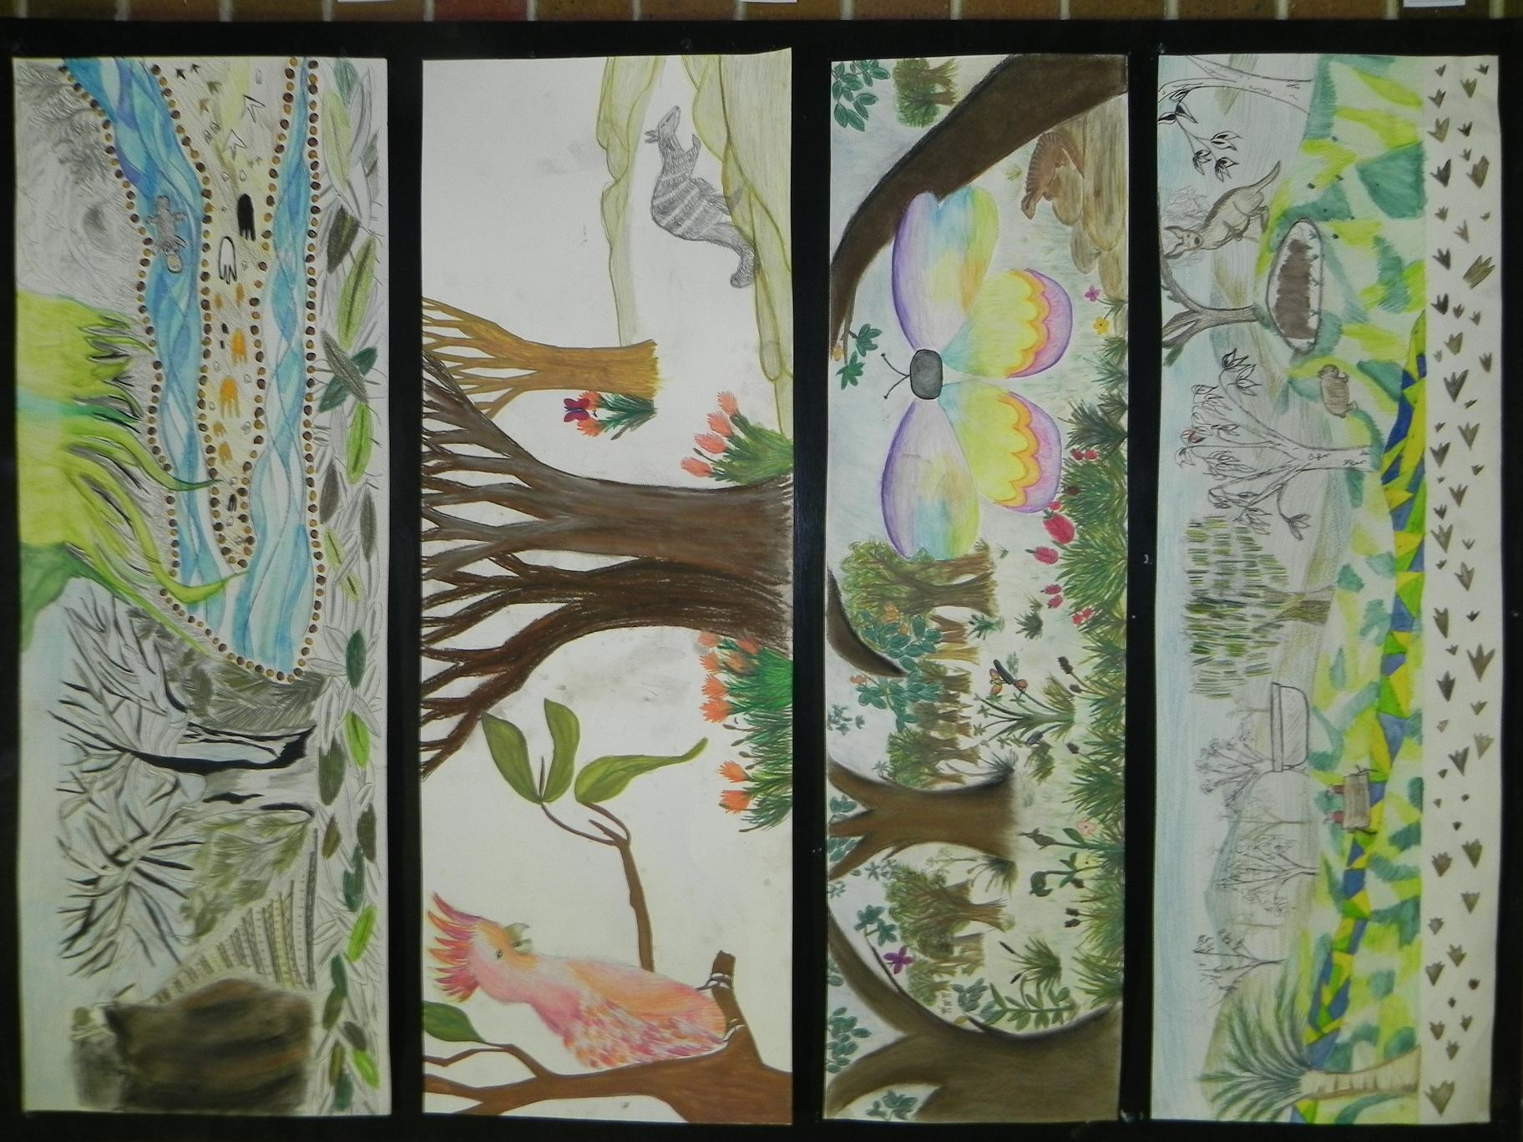
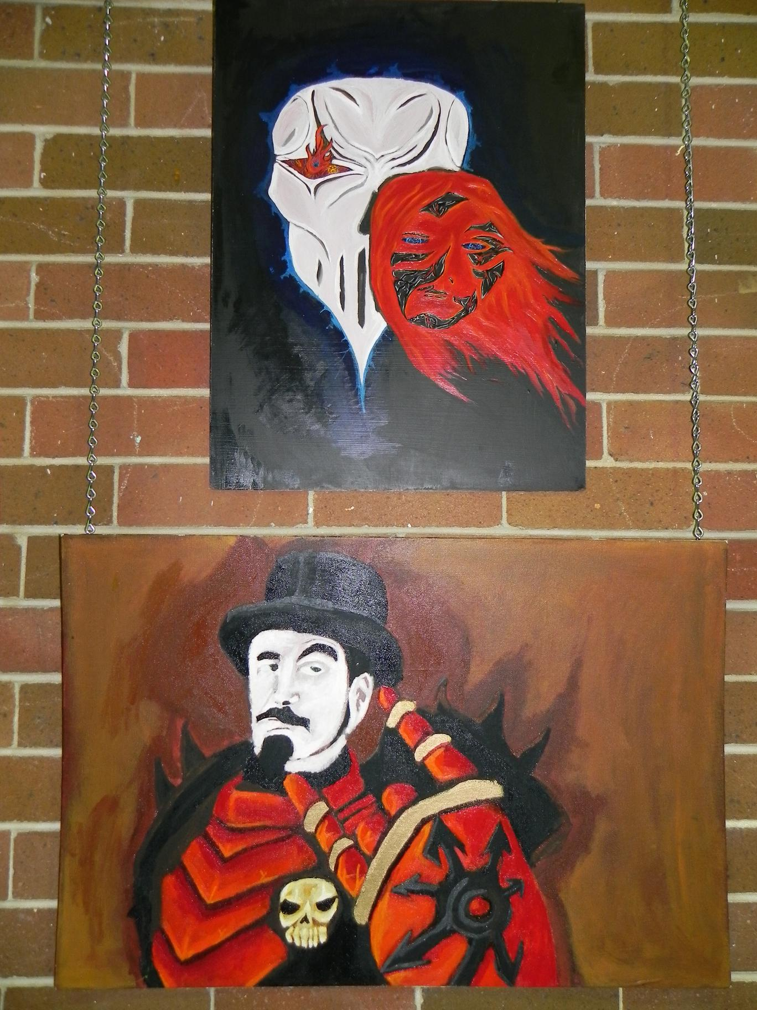

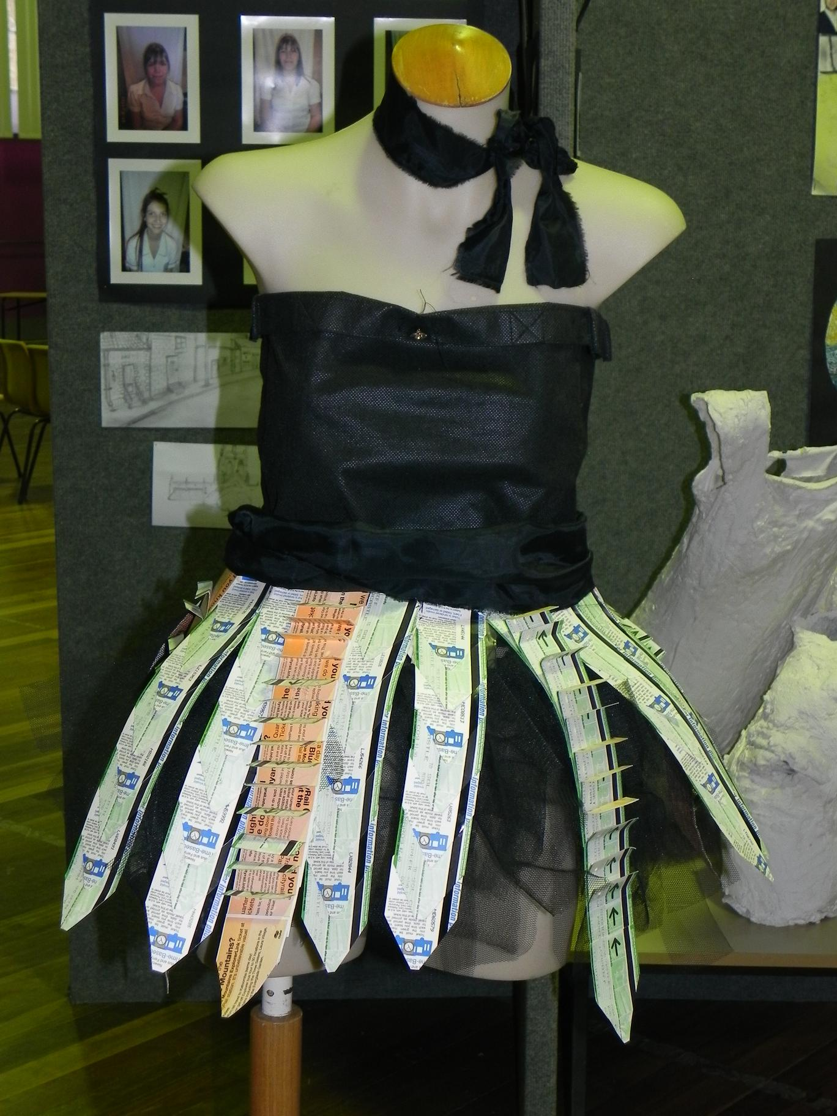

Mathematics News

The Mathematics faculty continues to encourage students to attempt all work to the best of their ability and regularly sets homework. This could be in the form of worksheets, textbook exercises or homework set for students using the web based Mathsonline. As we pass the halfway point for term 3 all years have assessments scheduled before the end of term.
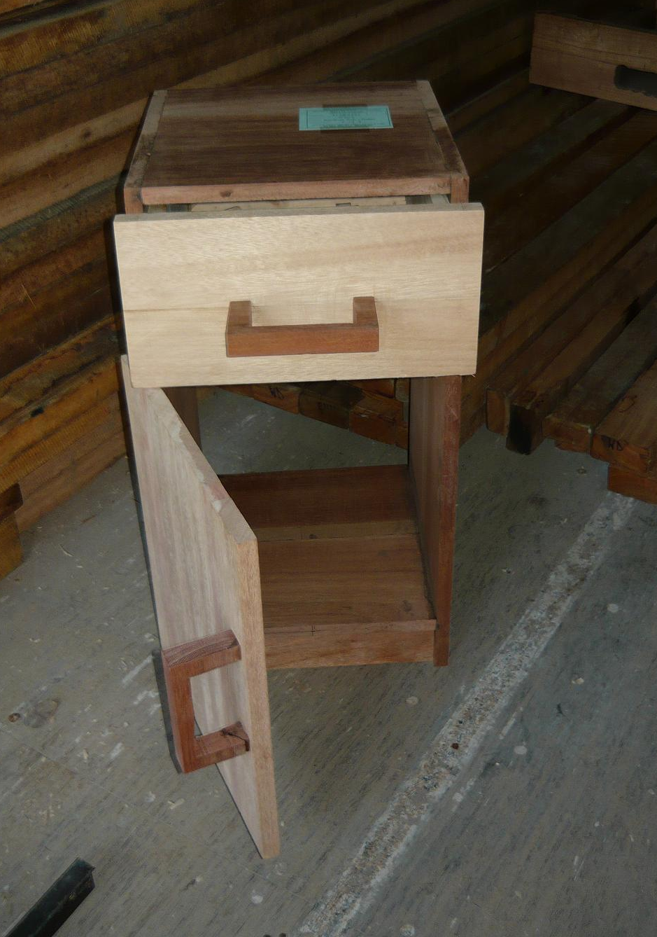
These assessments will take place on the following dates:
Year 7 Week 9, Wednesday 15/9 period 1 or 3
Year 8 Week 8, Friday 10/9 period 3
Year 9 Week 9, Thursday 16/9 period 2
Year 10 Week 7, Thursday 2/9 period 1
Week 10, Monday/Tuesday Trial School Certificate
Year 11 Week 9, as per exam timetable

Year 11 final exams will cover all course work studied this year. Students should be revising earlier work as well as continuing with new topics. Year 10 trials cover all work studied in the junior school and it would be very beneficial for year 10 students to access the Board of Studies website and work through past school certificate papers.
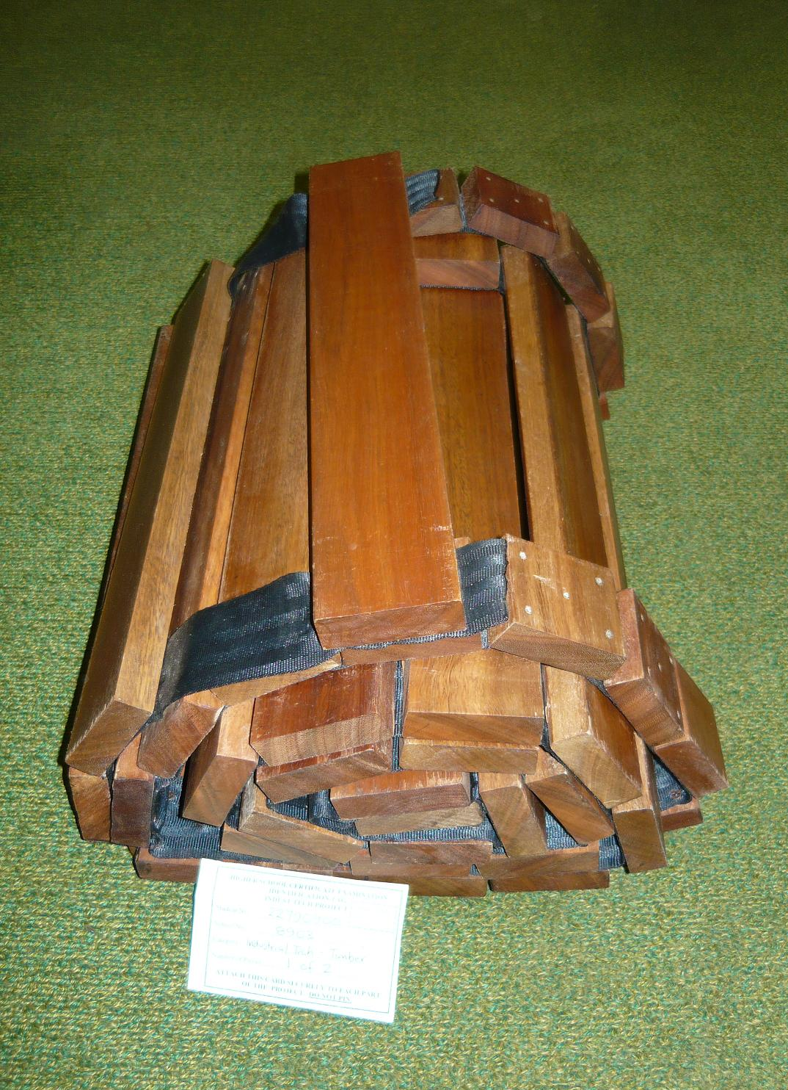
Year 12 should be firmly committed to a revision program to take them through to the HSC exams. The 2Unit Mathematics and the Extension 1 course have their last assessment scheduled for August 31st and September 6th respectively.

We wish Year 12 all the best for their last few weeks at school and support them in their quest for good results.

Miss H Kelsey
Head Teacher Mathematics

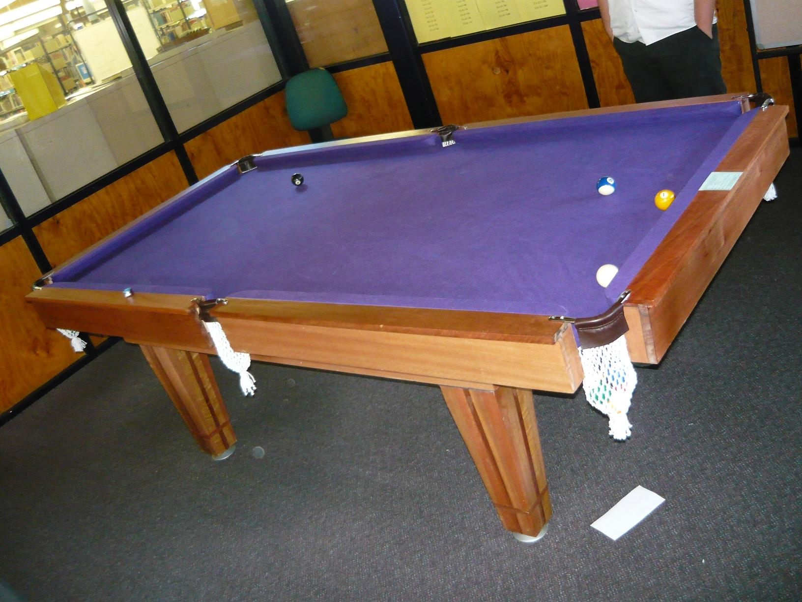
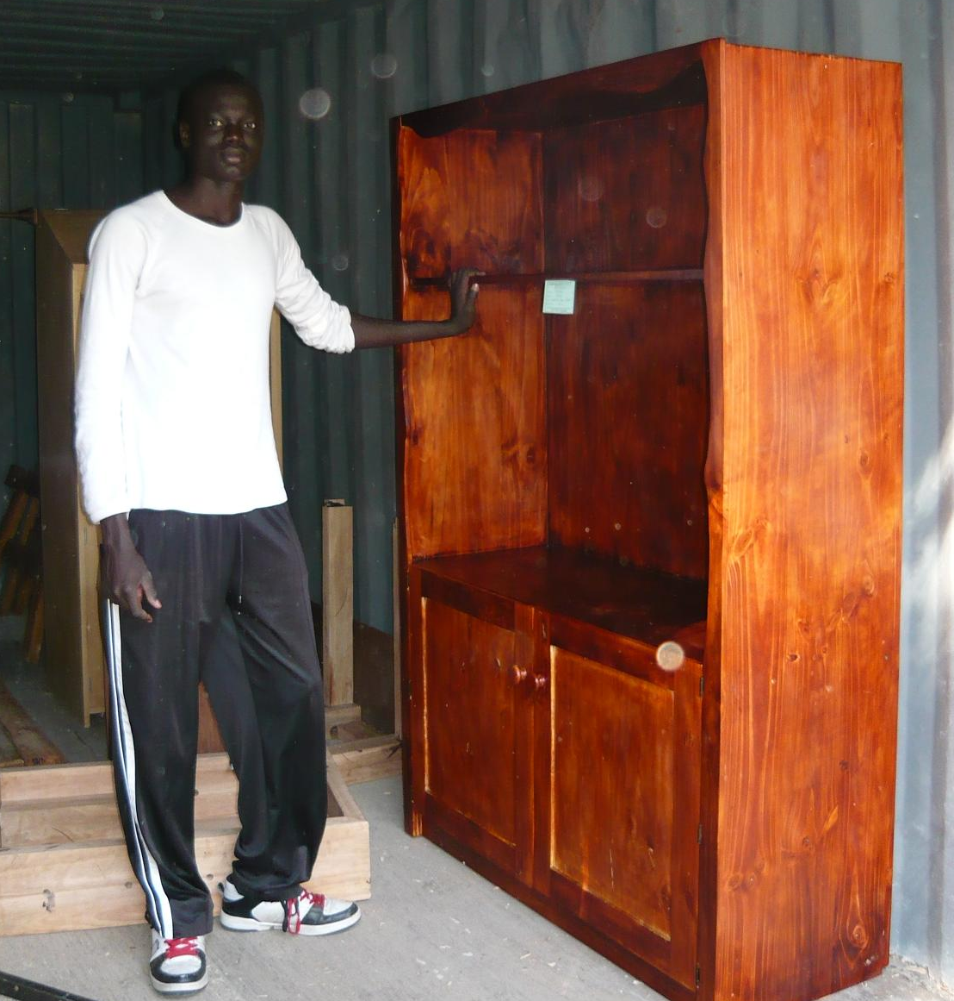

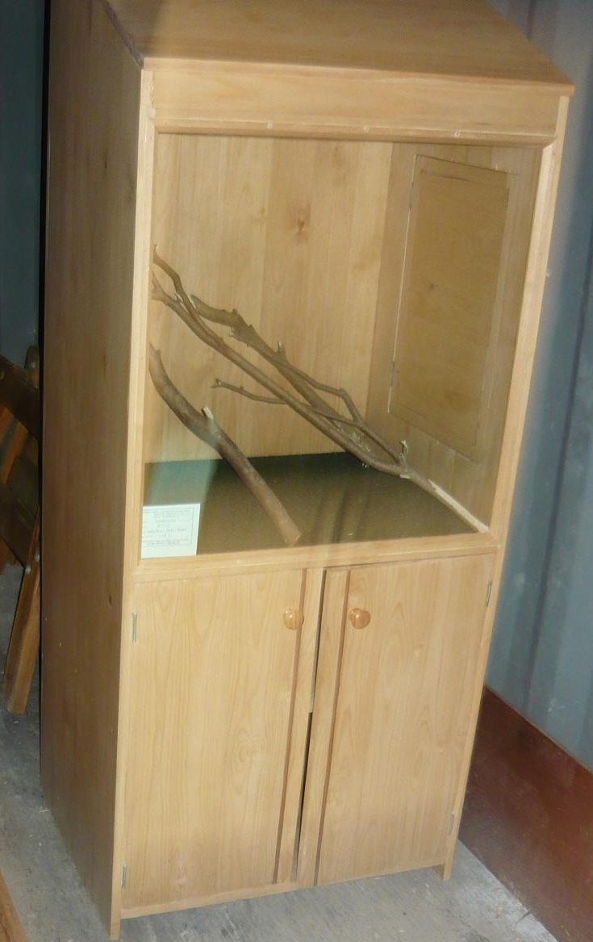

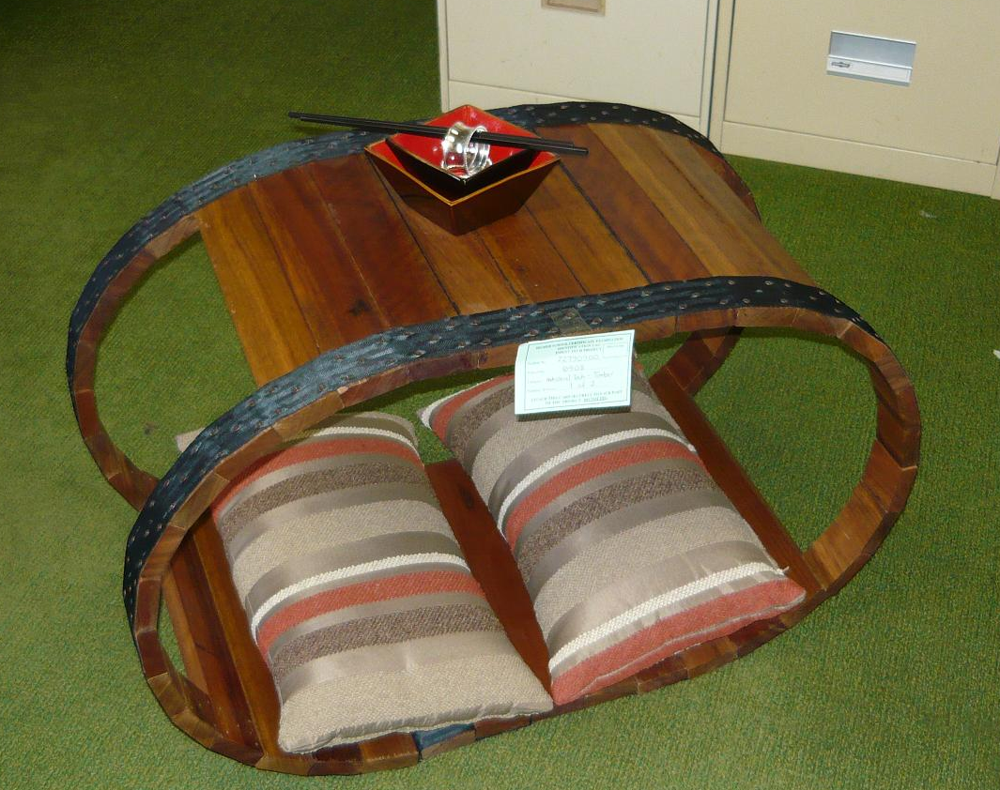

PDHPE Report
Year 12 complete Course
Year 12 PDHPE students have now completed all mandatory components of their HSC course and are now in their revision and review period. I have to say that I have been very impressed with the high level of personal application that the students have shown to their studies and look forward to their well deserved success in the HSC exam in late October.

Year 11 PDHPE Outdoor Education
Yr 11 PDHPE students are rapidly approaching the completion of the Preliminary course and are busily studying their Outdoor Education. This will conclude with a three day bush walk which will have Mr Mungovern, Mr Welch and Mrs Holmes attending to supervise our students in the great outdoors. We all look forward to the stories and photos that will follow this great experience.

PASS Ski Trip
43 Year 9 and 10 students ventured to the NSW Snowfields during week five for the annual PASS ski trip. This year’s trip was an outstanding success with students completing all work requirements set for them – even if it meant Year 10 students completing their daily journals on the bus!
Highlights included the long ski to Mount Blue Cow and some ‘interesting’ snow skills exhibited by some students and staff (how were the trees Mr Maher???). Many photographs were taken as well as some videos – it was interesting to see who are ‘morning people’ and who are not.
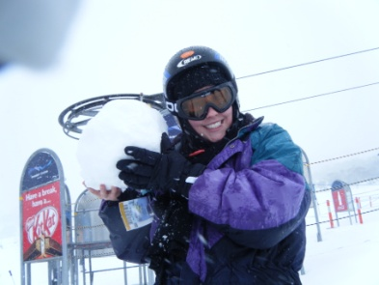
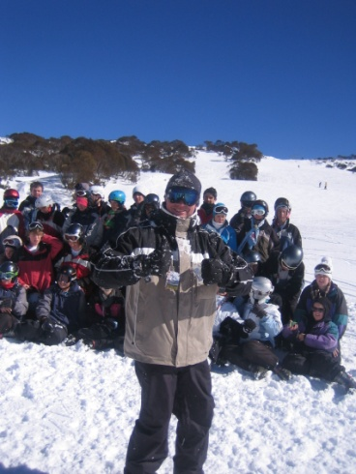
The snow itself was sensational – even though on the first day we had driving snow as the day progressed – the payoff for this was the second day with crystal clear conditions and fresh snow as far as the eye could see. Sunscreen (or the lack thereof) was a factor on this day – and some people learnt that they do, in fact, get sunburnt – right Zack??

Coles Sports for Schools program.
With our Australian sporting heroes soon to compete at the 2010 Commonwealth Games in Delhi, we believe it’s the perfect time to get all Aussie kids more active at school – and invest in our sporting champions of the future.
So, what is the Coles Sports for Schools program all about?
We’re offering every primary and secondary school across Australia the chance to get quality sporting equipment!
How does the Coles Sports for Schools program work?
From Thursday 2 September until Sunday 31 October 2010 for every $10 spent at Coles Supermarkets, Coles Online, Bi-Lo and Pick’n Pay customers will earn a Coles Sports for Schools voucher worth 1 point (given at check out). We have been notified by Bi-Lo Cardiff that they are our school’s allocated store.
Students collect these vouchers from family, friends and neighbours (even teachers!) and drop them into the voucher collection box at the school.
The school will drop off our voucher collection box into your local Coles Supermarket, Bi-Lo or Pick’n Pay store by 5pm on Friday 12 November. Coles will tally our points and then we can go shopping – for new sporting equipment.
So we need your support to team up and start collecting vouchers from 2 September.
Coles Sports for Schools vouchers will be available from Coles Supermarkets, Coles Online, Bi-Lo and Pick'n Pay stores until 31 October.
Remember the more you collect, the more sports gear we’ll get!

Mr C Maher
Head Teacher
PDHPE

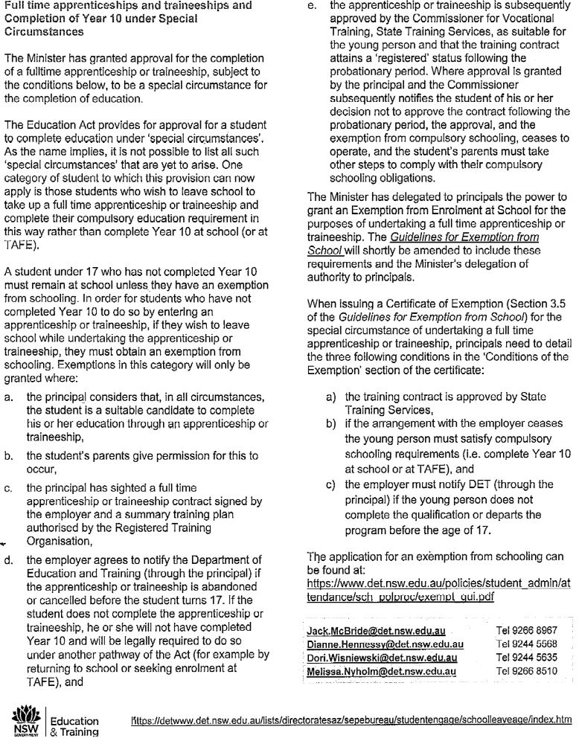
New School Leaving Age
Student Engagement and Program Evaluation Bureau



Dr Peter Vaughan
BDS, MDSc (Syd Uni)

Specialist Orthodontist

- We provide an honest opinion especially in regard to the need for treatment and timing.
- We treat most clients without extractions
- Clear braces for all patients at no extra cost
- Written guarantee with treatment
- All x-rays are bulk billed to Medicare
- Medicare Teen Vouchers accepted
- If you are thinking orthodontics, get an honest opinion, the $85 consultation fee will be well invested.
- Referral not required

Visit our web site: www.orthodontist.com.au

Phone Charlestown or Wallsend on 49425244

CARDIFF & DISTRICT LITTLE
ATHLETICS


REGISTRATION DAYS

Sunday 12/9/10 1- 3pm
FRIDAY 17/9/10 4.30 – 6.30PM

ORIENTATION & REGISTRATION
Friday 24/09/10 & 1/10/10
Regos from 5pm

Neegulbah Park
Lawson Road
Macquarie Hills

FURTHER DETAILS CONTACT PHIL JENKINS
0428 378426

SEASON COMMENCES FRIDAY 24/09/10
POINTSCORE COMPETITION COMMENCES 08/10/10
5.30PM



A reminder to Year 12 that the UNIVERSITY OPEN DAY is this Saturday 28th August.
TRY-A-TRADE will be held on the 10th September this year at “The Shed” –PCYC Windale.
TAFE has an OPEN DAY on Saturday 11th September 10am-2pm at its Newcastle Campus, Maitland Road, Tighes Hill.Tours, displays and presentations include:
*Beauty Therapy *Business
*Computers *Cooking
*Fashion *General Education
*Hairdressing *Massage, Sports & Fitness
*Music *Science
*Vehicle (Heavy) ....plus lots more
The Indigenous Careers expo will be held in Newcastle on Wednesday 15th September at the Newcastle City Hall, King Street. The Expo is for Indigenous students in years 8-12.
There are a lot Apprenticeships and Traineeships being advertised lately. You can find these posted up around the school.
If there are any students interested in doing the OHS White Card course, could you see me as soon as possible so I can organise it.
If you have any question, can you see Mr French.


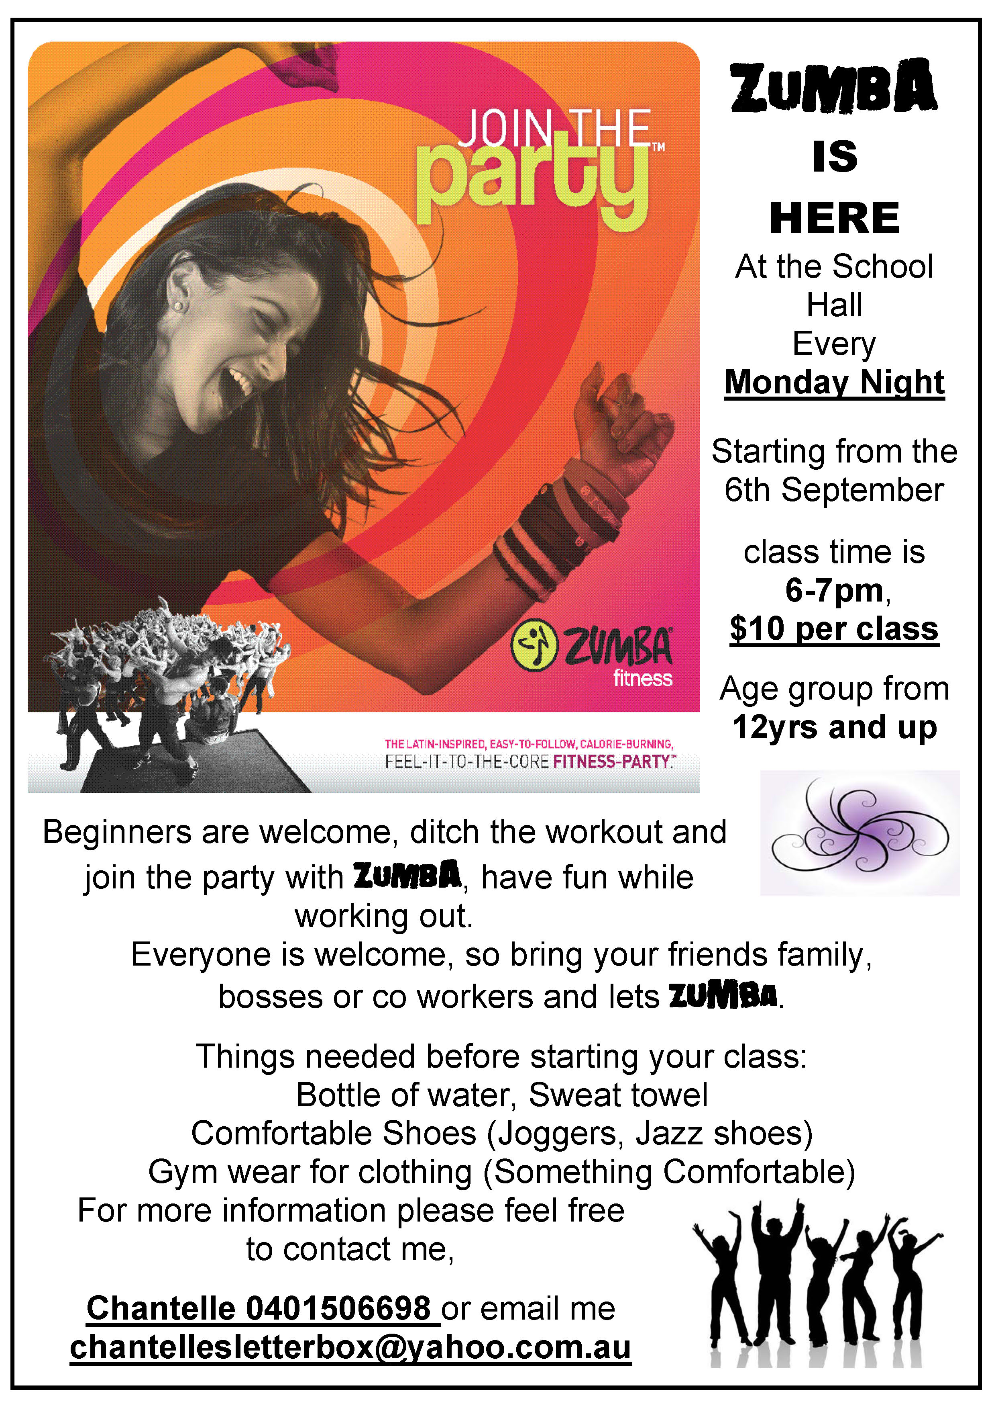

Wallsend Touch 
2010-2011 Junior Competition

Do you want your children to play a fun team sport that does not cost a fortune, is run at the same venue each week, has no individual training night and only takes 30 minutes playing time out of your busy schedule?

Wallsend Touch are gearing up for another big year with our Junior Competition, we take both team entries and individual entries. Please see the following information:-
Divisions Available

Boys and Girls (PLAY THURSDAY)
U/8 Born 2003, 2004, 2005
U/10 Born 2001 or after
U/12 Born 1999 or after

Boys and Girls (PLAY TUESDAY)
U/14 Born 1997 or after
U/16 Born 1995 or after
U/18 Born 1993

Registration Days – at Clubhouse, Upper Reserve, Wallsend

Saturday 4th September, 2010 between 11.00am and 1.00pm
Tuesday 7th September, 2010 between 5.00pm and 7.00pm

Registration Fees
Early Bird Discount –applies if paid in full on one of the registration days only
Individual fee $60
Family Rebate for 3 or more children from the same family $140
Normal price will apply after registrations of $70 p/p or $160 Family

REGISTRATION KITS ARE AVAILABLE IN THE CLUBHOUSE, DOWNLOAD FROM OUR WEBSITE www.wallsendtouch.com.au or Ph: 4968 8938



