

August 2010

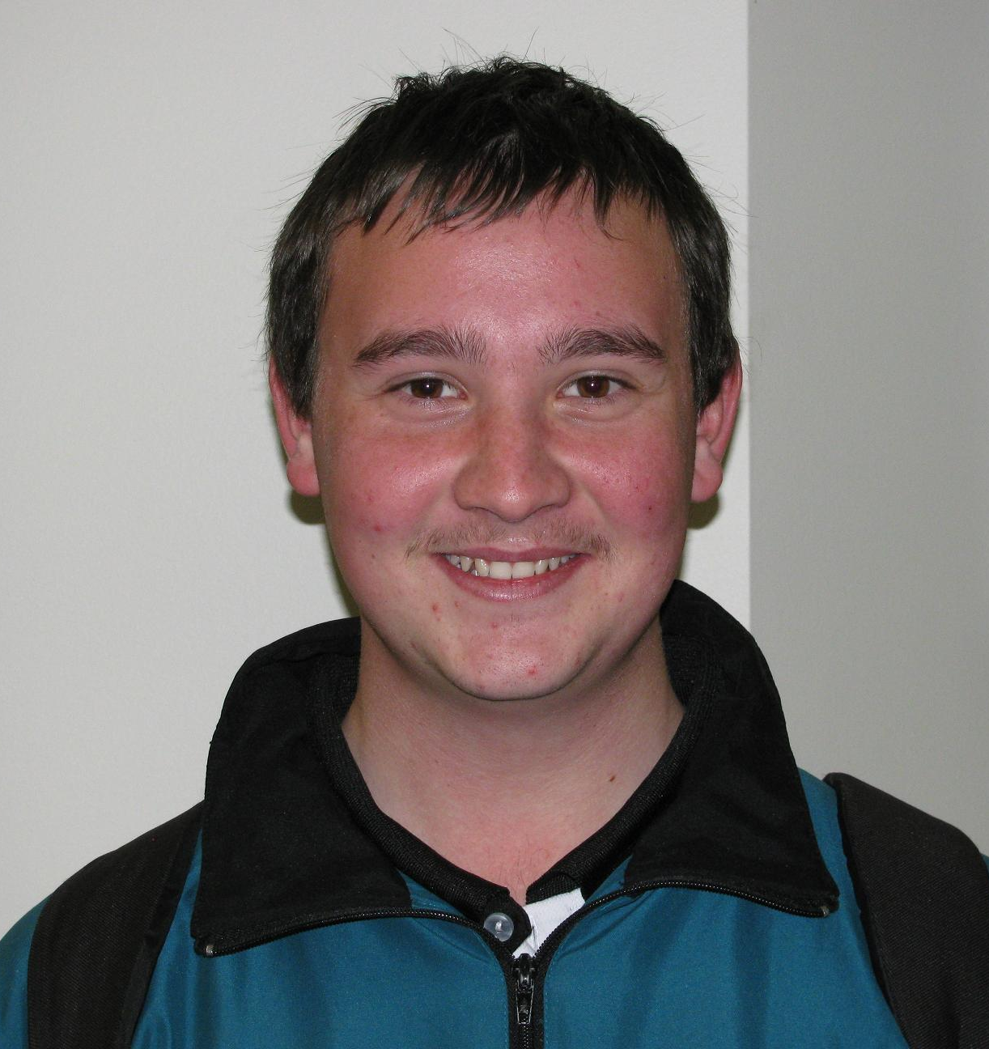
Two Ways Together Scholarships Congratulations to Reece Thompson, Bradley Burns, Tyler Smith and Kirsten Stanton in achieving this Scholarship to support your educational goals.

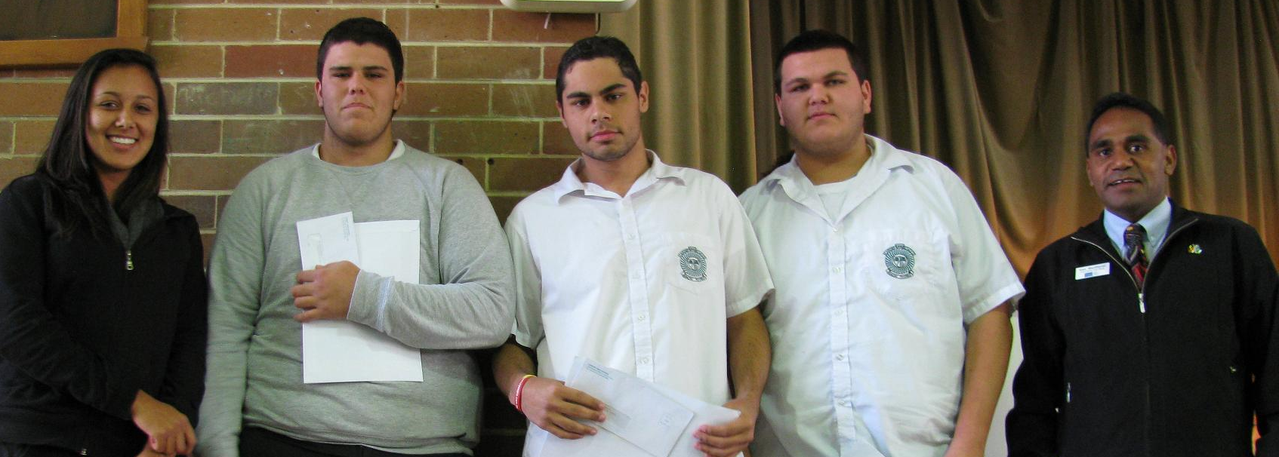
2010 Defence Technical Scholarships Congratulations to Reece Thompson, Tyler Smith and Jeremy Smith for achieving this recognition. I know this scholarship will support your educational endeavours.

Carissa Shines
Carissa Borrow competed in the Australian Swimming Titles in June in Brisbane.
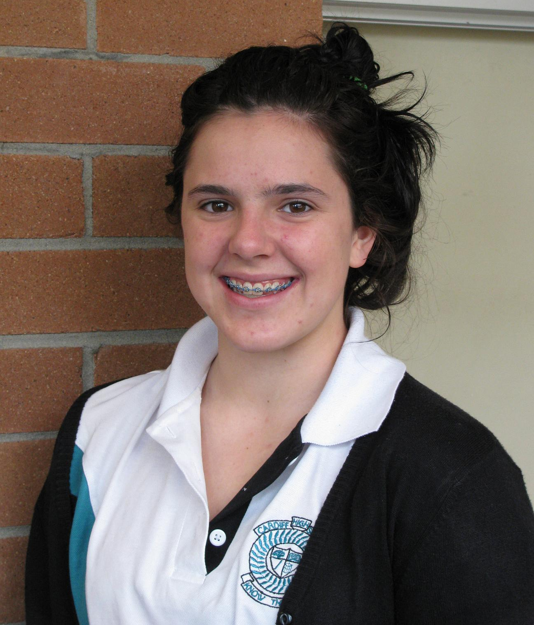
She won gold in the 100m Breaststroke, silver in 200m Breaststroke and gold in the Individual Medley Relay swimming the breaststroke leg. Congratulations Carissa.

FROM THE PRINCIPAL

LOTS HAPPENING AT CARDIFF
Drainage work
Approximately $200,000 is being invested in the school to remediate the severe drainage problems that we experience. Apart from the many drains being upgraded in the playground, behind the canteen, at the base of the main block and behind the library we are also having work done on our hill. This work should assist in the flow of overland water into the drains.

Trees being lopped
Our Maintenance Program continues in order to save our trees from becoming dangerous and continues to provide shade for our students. This work is costing $10,000.

Technology Infrastructure Upgrade
$22,000 is being spent on upgrading the technology infrastructure as we move to DET Technical Support. This work should make access even faster and more reliable than it has been. Thanks to Mrs Hicks andMrs Mepham for your work in this area.

Laptops for Year 9
We hope to have this roll out ready early Term 3. Awaiting the protective cases. We do not want to put parents and students at risk of damaging the laptops and then needing to find money to replace them. We appreciate your patience in this matter.
We have seen some students using commercial neoprene covers for their laptops. While this is an option you may wish to take up, please be aware these cases only provide protection against scratching and will not provide any shock resistance or protection if the laptop is dropped. Cost of replacing laptops is approximately $600 and this cost is borne by the parents.

Year 6 to 7 Transition
June 9th saw our Year 6 students enjoy the afternoon in a series of Leadership activities. They were very ably assisted by our very capable and enthusiastic leaders who attended camp earlier this term with Mrs Matthews. Thanks to Mrs Matthews and Mr Glassop who organised this day.

Star Struck
Well done to our Star Struck performers. Thanks to Mrs Heggs and Ms Wright for making this happen.

DATES TO REMEMBER

July 29-
August 3 Tanagura Visit

August 11 Yr8 Welfare Day

August 11 P&C Meeting 7pm

August 16 MADD Night Rehearsal

August 17 MADD Night Evening Show

August 18 MADD Matinee Show

August 23 Yr7 3rd Vaccinations

September 8 P&C Meeting 7pm

Drama
Three of our Year 11 students, Laura Goodwin, Matilda Eyre and Cassie Nicholas were involved in a Hunter Region Drama School production of “The Small Poppies” at The Playhouse on 25th & 26th June.

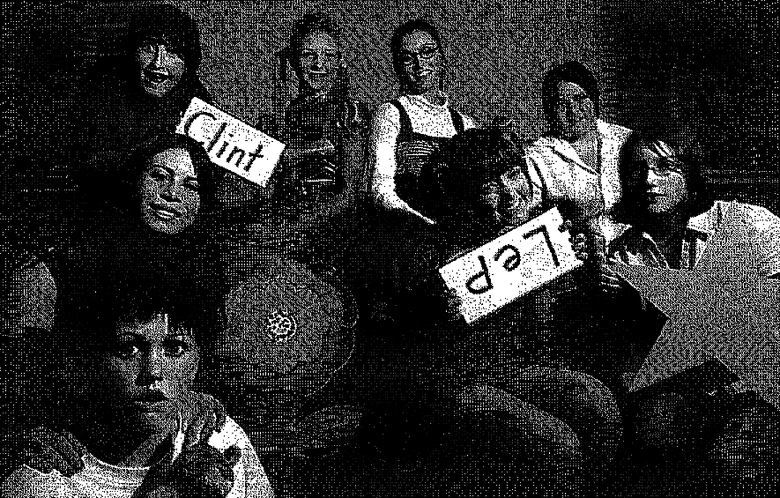
The young cast of The Small Poppies including Cardiff High School Students Laura Goodwin (bottom left), Cassie Nicholas (3rd, back row) and Matilda Eyre (3rd from right). The Newcastle Herald

“Overall, this was another strong addition to the impressive work being done by Hunter youth theatre groups.” (Excerpt from review by Ken Longworth)

Mrs S Russell
PRINCIPAL

DEPUTY REPORT

GROUNDS UPGRADE
Cardiff High School was a hive of activity in the July school vacation period. We had a work crew improving the drainage on the hill leading up to the Myall Road bus stop. The soil conservation team constructed swales to divert the flow of water to drains and to slow its progress down the hill. With the heavy rain yesterday it has been tested and we had less water flow. The area has been seeded with a wintergrass mix and now we should also see signs of this shooting to cover the turned earth.
The quadrangle and oval and other areas in the school have also been dug up by another drainage team who are replacing our stormwater drainage pipes. This has been considerably hampered by the constant rain however, we are hoping that the next two weeks will see this job completed. The oval will also have some returfing to repair the areas where machinery became “bogged” whilst trying to work.
Even though the work has created some inconvenience it will all be worth it when we finally sign off on the completed jobs. We do thank everyone for their support as with reduced car parking facilities and “roped off” and “unavailable” areas, staff and students have needed to adjust with their teaching and learning preparation and presentation, particularly the PD/H staff.

POLICY AND PROCESSES
Sport
A reminder to all parents and students. Wednesday afternoon sport is compulsory for all junior years – 7-10. It would be greatly appreciated if where possible dental and medical appointments were made after school hours rather than in the sport time. If a student has an injury which does require physiotherapy or cannot participate due to a medical concern permission to gain an Early Leavers pass is appropriate. Mrs Russell is required to sign off that all students have participated in sport during their four years at secondary school and sport is an essential part of our curriculum.
Uniform
The weather has become colder and unfortunately some students are wearing different coloured jumpers. I would like to remind everyone that our school jumper colour is either BLACK, the Teale/Black school jacket or the bottle green old style jumper or jacket. All other colours are not part of our uniform policy. Our shoes are also BLACK SUBSTANTIAL leather upper style shoes and the white canvas slip on

style of shoe is not acceptable due to Occupational Health and Safety regulations.
Absences
If students are absent from school for any reason it is expected that on their day of return they will bring a note explaining the absence and present this to their roll call teacher. If no note has been brought in after 5 days the absence is marked as an Unexplained Absence and this does not present a good impression to any prospective employers if students are seeking part time employment.
I would like to express my appreciation and congratulations to all of the students who do wear the full correct school uniform and display their pride in our great Cardiff High School.

Mrs H Matthews
Deputy Principal

CURRICULUM MATTERS

We are in the planning phase of setting our curriculum for 2011. Last term Year 10 students were asked to make choices for their study in Year 11 in 2011 and we are in the process of sorting those choices. Not all subjects had sufficient numbers for us to be able to offer a class and I will be speaking to individual students who need to make another choice over the next couple of weeks.
Current Year 9 students will be given a letter early August where they will be asked to indicate a preference order for their current three electives. The three elective lines studied in year 9 changes to two elective lines in year 10. Students are asked to return the form by Tuesday August 10th to the box located outside the Deputy’s office. Late return of the form may limit the choices available.
Current Year 8 students will be issued with a booklet containing information about subject choices for Stage 5, which covers Year 9 in 2011 and Year 10 in 2012. Please consider the information supplied and use it to assist your child make their choices for Stage 5 courses. If you need further information please contact Miss Kelsey at the school.
Subject choice forms are due to the box located outside the Deputy’s office by Friday 20th August. Late return of the form may limit the choices available.

Miss H Kelsey
Curriculum Coordinator

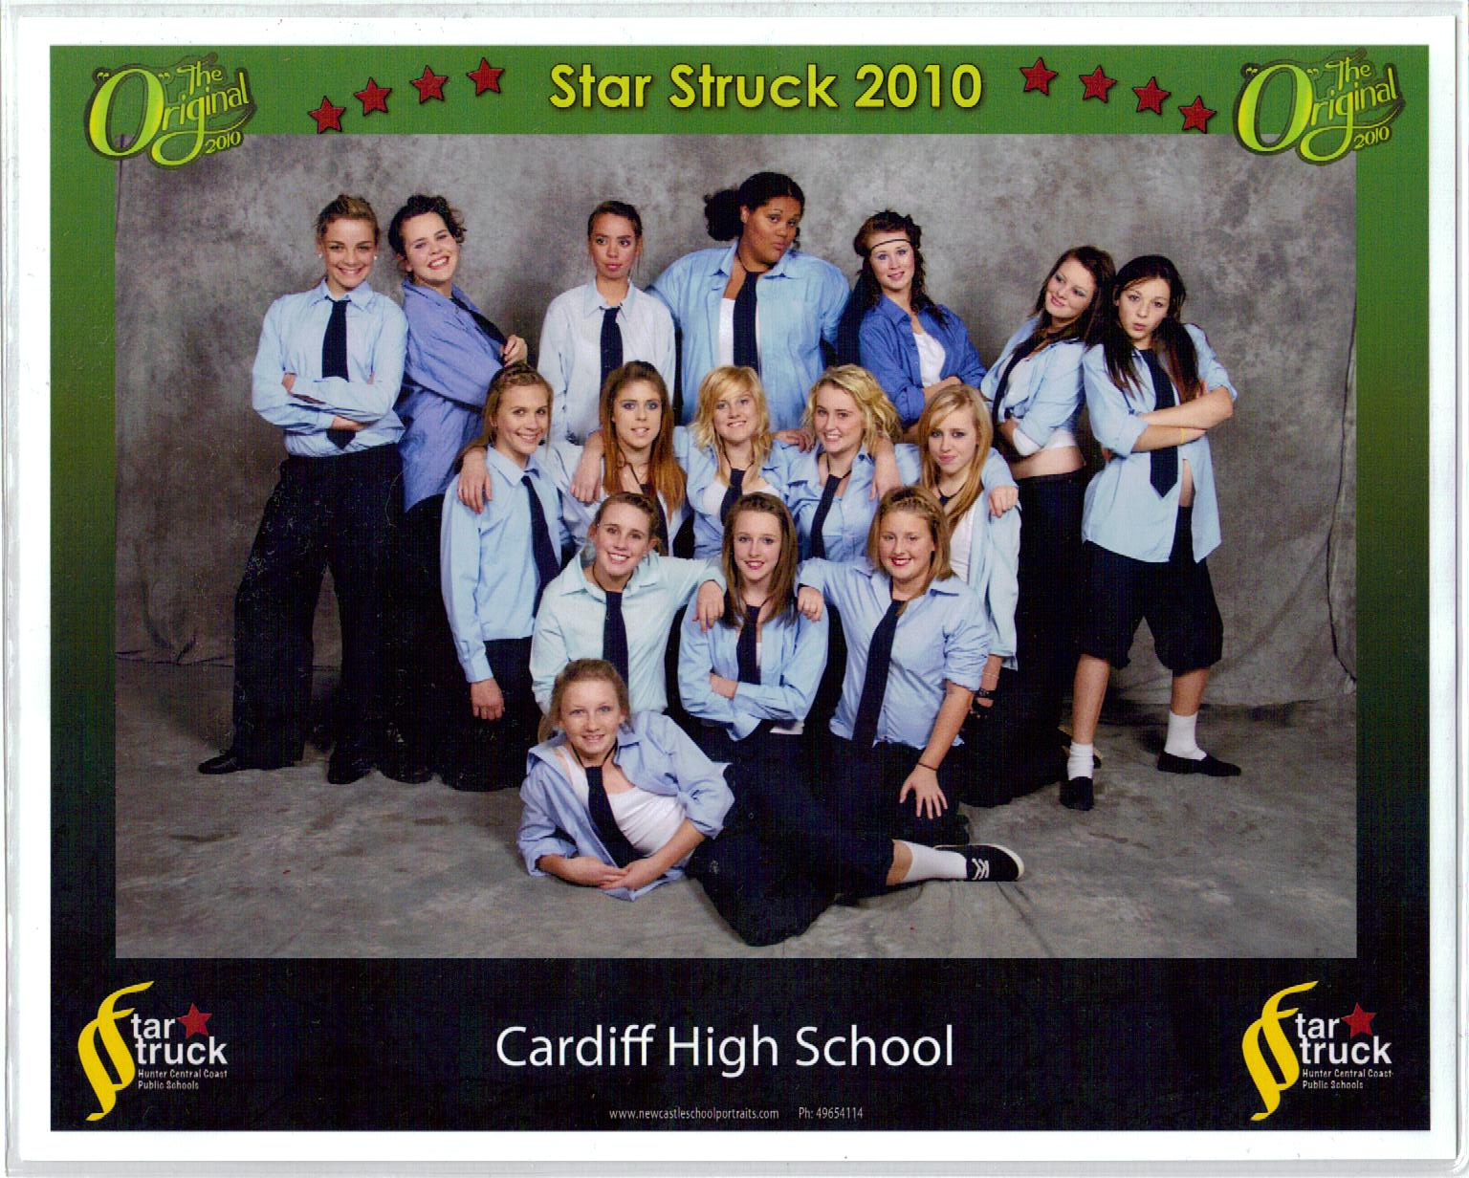





Star Struck 2010

University Open Day
The University open day for the Newcastle University is on Saturday 28th 2010 from 10am-3pm. If you are interested in finding out about other open days, can you come and see me.
Any year 12 student interested in getting a Principals Recommendation for University needs to see me.
UAC guides have arrived and will be given to Year 12 students next Tuesday during Period 3 in the library.

White Card
Cardiff High has successfully ran a White Card course (previously known as a ‘’Green Card’’) and will be organising another course to held again this term. Dates are yet to be finalised. The cost of the course will be $70. Congratulations to the 20 students that successfully completed this course last term.

INDIGENOUS POSITIONS VACANT AT CHARLESTOWN SQUARE IN THE FOLLOWING CATEGORIES:
· Lifestyle
· Fresh Food
· Food Court
· Entertainment and leisure
· Electronics
· Services
· Fashion

Apprenticeships and Traineeships
The following Apprenticeships are currently available:

- Novaskill Apprentices & trainee-
- Carpenter/Joinery,
- Painting & Decorating,
- Electrical,
- Motor Mechanics,
- Fitting/Machinist
- Plumbing
- Metal Fab
- Office Administration
- Plant Mechanic
- Horticulture

- Donaldson Coal- Electrical and Mechanical

- Bucyrus International- Electrical, Fitting & Fabrication Trades

- TransGrid- Electrical Fitter KINGS- Fitting, Machining &Boiler making

- Traineeships available:
- Childcare, Travel, Office Assistant, Office Junior, Pharmacy Assistant

If you have any questions, please see Mr French



We have begun Term 3 sport and are proud to introduce new sports including Zumba and Putt Putt. Mr Welch is using this time to start the development squad for SKO Volleyball targeting the State Knockout Competition next year. It is exciting to see some of our senior boys committing this time to training.

Zone Athletics
School representatives at Zone Athletics Carnival on June 17 & 18 were:
Drew Lambert Brittany Smith
Alysha Smith Stephanie Richardson
Tim Maynard Daniel Redpath
Grace Dixon Alahna Burrell
Sequoia Stewart Alannah Jobson
Kirsten Stanton Jesse Parkinson
Bradley Barwick Dana Williamson
Clare Williams

BMX
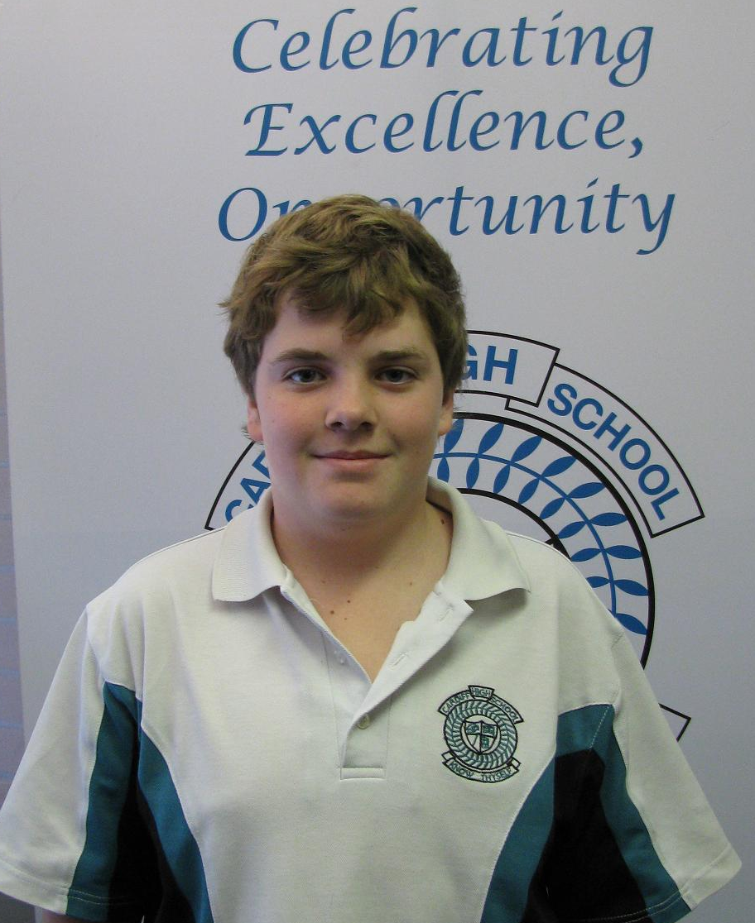
Brock Griffiths Year 7 competed last school holidays at the National BMX Titles and came 8th in the 12 yrs boys’ age division.
He also received a $500 scholarship from Hon. Greg Combet for his efforts.
Congratulations Brock.

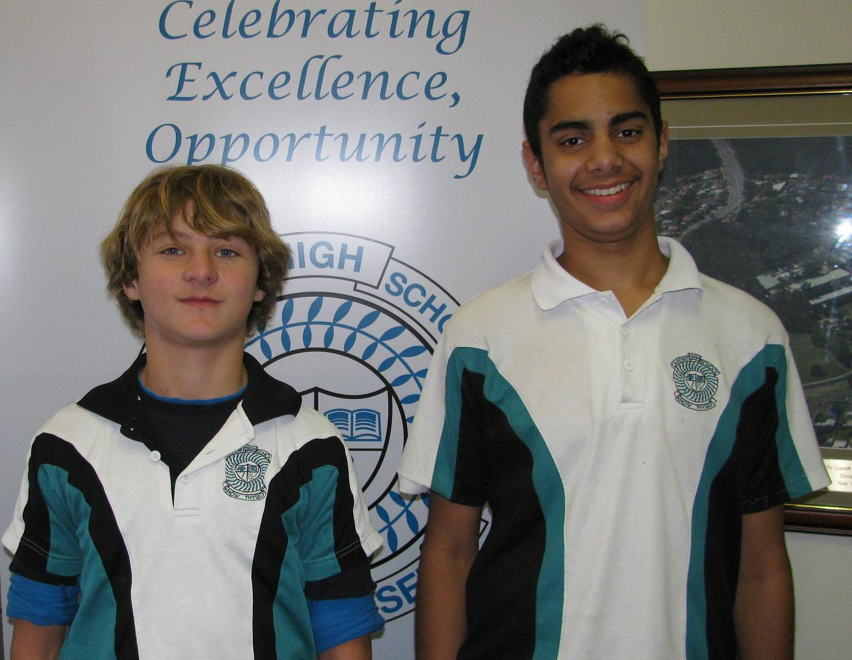
AFL
Lenden Pratt and Trent Thompson both of Year 8 were selected in the Under 14 Newcastle AFL team to complete in Sydney in July.
Congratulations Lenny and Trent.

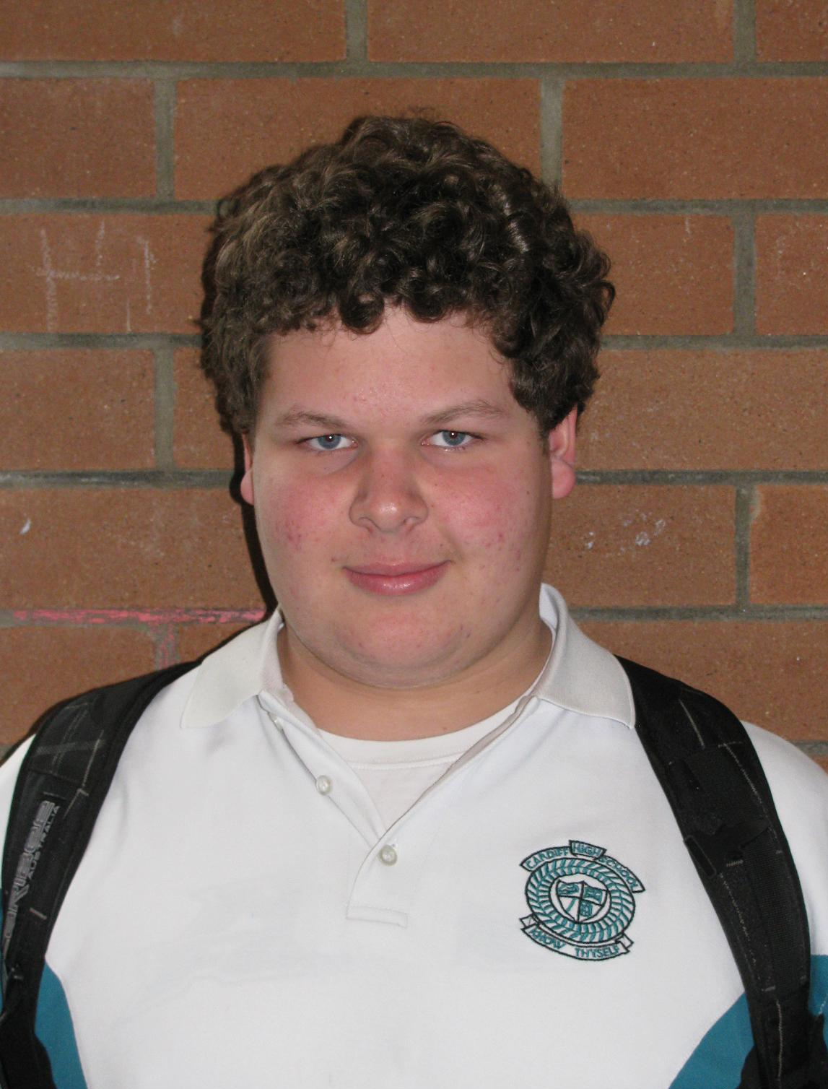
Rugby Union
Joel Futcher Year 7 is travelling to New Zealand this month to play Rugby Union for Southern Beaches under 14’s. The team will play 3 games in 6 days.
Good luck, Joel.

Boys Hockey
Great to see such competitive spirit. Unfortunately the boys lost their match
Reece McNally Aaron Thick
Daniel Walton Greg Skaza
Mitchell Herring Sam Higgins
Cameron Smart Jacob Tuck
Guy Wahlstedt Dean Tisdale
Alex Shanley Justin Winton
Mitchell Parker

Soccer team
Unfortunately the boy’s soccer team lost 9-8 in a penalty shootout against Lambton. Great courage shown here boys.
N Mullen A Wright A Thick
T Ansell B Butler N Hills
G Skaza T Neve C Smart
M Makuei C Foster J Baker
H Butler D Walton C Herring
J Winton

Student Volunteer Scheme
We have four student volunteers who are working through the NSW Premier's Student volunteer scheme
- Tarn Wahlstedt
- Hope Riley
- Tamara Ostler
- Adam Field

They have written and are undertaking a fitness and gross motor development program targeting
our special education students. They have devised a 10 week activity program that targets
and develop fitness goals in diverse settings. As a result they have coordinated facilities and venues to ensure a meaningful, fun and effective program. These students will become eligible for recognition through the challenge and will be part of an acknowledgement day and celebration at the end of the year. The qualifications gained can be added to resumes and are testament to the students who are focussed on gaining of useful skills that can be employed after school. This initiative is being run through the State Education Office and I am proud of the involvement of our students.

Regional Athletics
The Regional Athletics carnival was held on the 28th and 29th of July and we had 6 representatives.
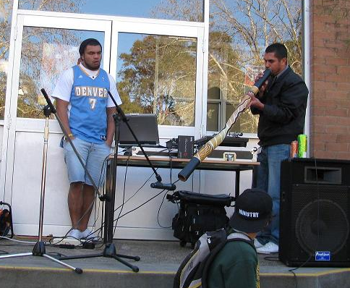
- Brad Barwick selected in the Zone team to compete in the Boys 13 years 800 metres run
- Drew Lambert in the 14 years Boys 800 metres and High Jump
- Tim Maynard in the 12 years Boys Discus and High Jump
- Dana Williamson in the 12 years Girls Discus
- Clare Williams in the 17+ years 3000 metre race and
- Alannah Jobson in the 15 years 100 and 200 metres races and the Long Jump
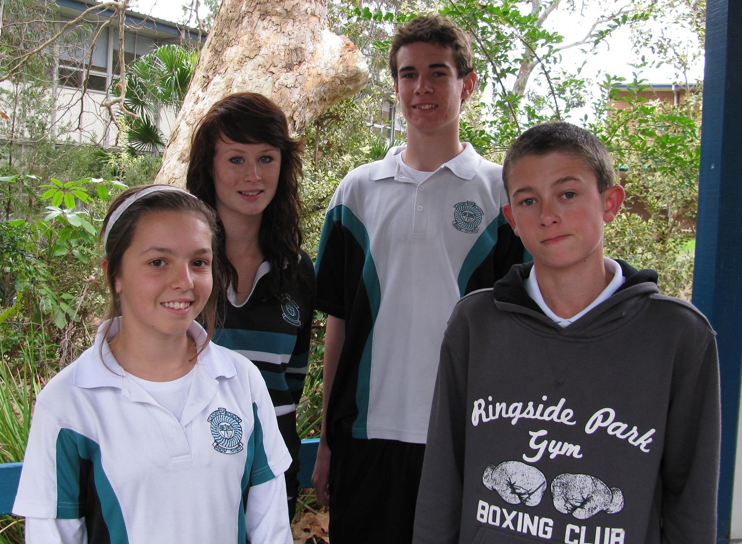
Congratulations on your efforts.

Premier’s Sporting Challenge
We are also running through Term 3 the Premier’s Sporting Challenge. This involves some classes who are individually and in groups, setting activity goals each week and completing their handbook. Students have tested their fitness levels and targeted areas for individual improvement. Each week we introduce specific activities so students can work on their targeted areas promoting responsibility for their health. This is being combined with their lessons aimed at highlighting the lifestyle determinants that impact on health and fitness. Each student will then retest at the end of 10 weeks and are then eligible for a reward for meeting their goals from the Premier of NSW.

NAIDOC Day was celebrated in the last week of Term 2.
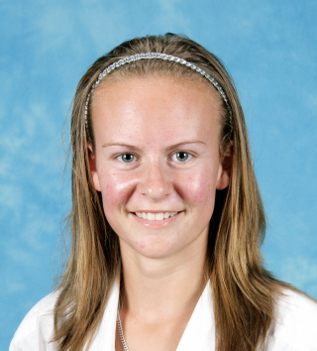
This year’s theme was “Unsung Heroes” –Leading through Example. Past students from Cardiff High Abie and Wok Wright from ’Street Warriors“entertained the whole school with DJ Entourage. They shared memories of their student years at Cardiff High. Ray Kelly yarned about the support offered to him as a student by teachers at the school and for current Aboriginal students to make the most of the opportunities offered to them.
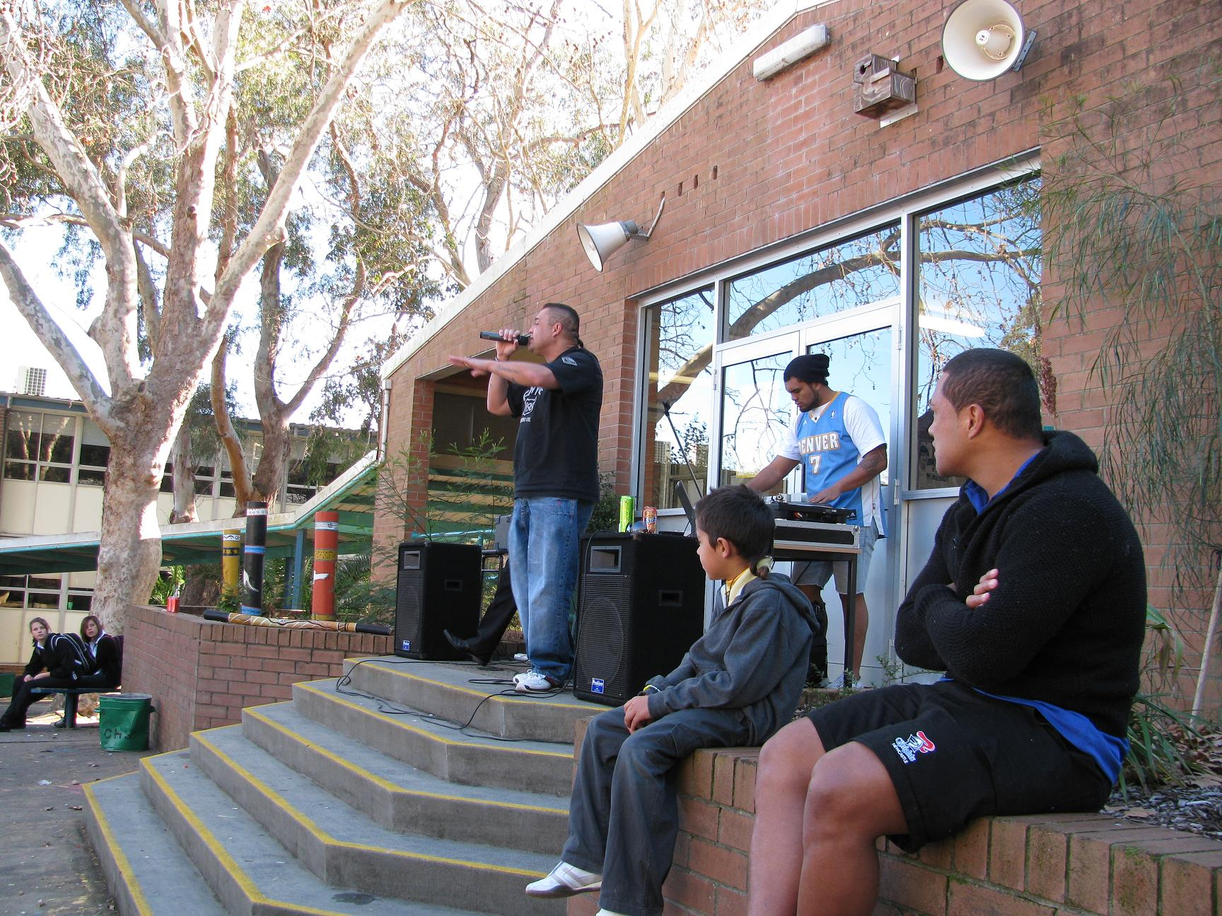

Junior Sa’u from the Newcastle Knights signed many autographs and was a great sport on the day. All students enjoyed the afternoon and it thank you to all the Aboriginal families that came to share the day with us.
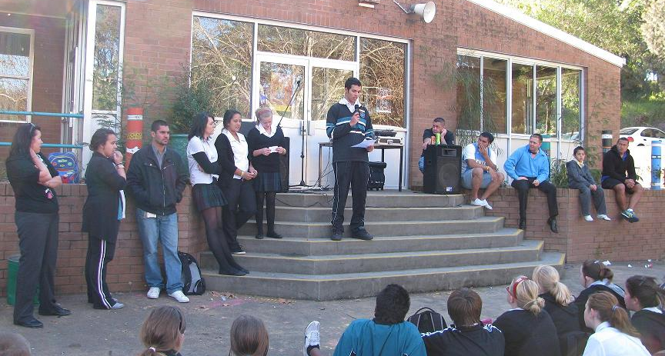


M&H Air Conditioning Pty Limited. A division of the Hastie Group
ABN: 80 115 325 089

M&H Air Conditioning Pty Ltd is entering its 21st year of successful business in air conditioning during the 2010/2011 financial year. Our success has strongly stemmed from the local Newcastle/Hunter Regions community support.
As a show of returned support and thanks to our region and community during this financial year from the 1st July 2010 to 30th June 2011, we would like to offer the following local school building fund donation program.
- This program is open to every Primary and Secondary School throughout the Newcastle and Hunter Regions NSW.
- It is offered to every parent of a child attending the school during this period and including teachers and clerical staff.
- For every air conditioning system purchased and installed by M&H Air Conditioning from a parent, teacher or clerical staff, we will provide a cash donation of $60.00 to the nominated schools building fund.
This donation is for the school and P&C to use in providing additional needs and equipment for our local students and their future. Considering that most schools have around 800 students and staff there is potential for a school to achieve $48,000 in donations towards a new building program or improvement.
It is my pleasure in offering this exciting program to your school.

Yours Faithfully,
Rob Carter
CEO



CANTEEN HELPERS NEEDED

Parents, if you can spare as little as one day per month to help out in the canteen please call the school on 49549966 and ask for Annette Salmon (Monday-Thursday) or Sue Smith (Friday).

Dr Peter Vaughan
BDS, MDSc (Syd Uni)

Specialist Orthodontist

- We provide an honest opinion especially in regard to the need for treatment and timing.
- We treat most clients without extractions
- Clear braces for all patients at no extra cost
- Written guarantee with treatment
- All x-rays are bulk billed to Medicare
- Medicare Teen Vouchers accepted
- If you are thinking orthodontics, get an honest opinion, the $85 consultation fee will be well invested.
- Referral not required

Visit our web site: www.orthodontist.com.au

Phone Charlestown or Wallsend on 49425244

ENTERTAINMENT BOOKS
AVAILABLE
AT THE OFFICE
$60.00




Fed Up with Children’s Behaviour?
SueDengate
is coming to Newcastle Wednesday August 11th
7.00pm @ Club Macquarie
(458 Lake Rd Argenton)
Former teacher and psychology graduate, author of the
famous Fed Up series, Australian of the Year finalist in 2009,
Sue Dengate became interested in food intolerance after
recognising the effect of foods on her own children.
In the past 19 years, Sue has spoken to tens of thousands
of parents in Australia, the USA and the UK.
‘Wow!!! Hearing Sue speak was probably the most enlightening experience I have had this year, if not this decade’
’we would still be living with an unhappy, difficult child’

This talk includes …
- arguments, oppositional defiance, tantrums, bedwetting, irritable bowel, asthma, itchy skin rashes, migraine, difficulty falling asleep, frequent night waking, depression, unexplained tiredness, difficulty concentrating , hidden and new food additives, and what’s wrong with fruit.

‘you gave us the chance to see what a beautiful little boy we have been blessed with’

*To Reserve your place at the talk please contact: Hunter Alliance for Childhood
on 49 544 717 or e-mail hunterac@live.com.au
(Cost: $12* incl.Tea/coffee & handouts *discounts apply)

N.B. Sue’s books and DVD will be available for purchase on the night at discounted prices (cash or cheque)

SPINE SOCIETY OF AUSTRALIA
An Affiliate of the Australian Orthopaedic Association

National Self-Detection Program for Scoliosis (NSDP) – 2010

July and August are the months the Spine Society of Australia recommend that all girls in Year 7 and 9 participate in the NSDP by downloading the self-detection brochure from http://www.scoliosis-australia.org/pdfs/self_detection_brochure.pdf.

An extract from the brochure....
WHAT IS SCOLIOSIS?
Scoliosis is a lateral or sideways curve of the spine. The spine also rotates on its long axis as it curves. It usually develops during early adolescence (age 10-13 years) when growth is most rapid.
WHAT IS THE CAUSE OF SCOLIOSIS?
The cause is unknown, but 80-90% of cases occur in otherwise healthy adolescents. This is called idiopathic (cause unknown) scoliosis.
We know that scoliosis is NOT contagious and NOT caused by bad posture, a soft mattress, carrying a heavy school bag or junk food.
WHY IS EARLY DETECTION IMPORTANT?
While very small curves are common and of no significance, about 2% of girls have a curve which warrants medical observation during the growth period. Three girls per 1,000 will require treatment during the growth phase. If treatment is required, the earlier it is undertaken, the better the long-term result. This is the basis for screening since in the early stages scoliosis produces no symptoms. The way to detect scoliosis is to look for it!

HOW DO YOU DETECT SCOLIOSIS?
Simply look for it!
It only takes 30 seconds


YOUR FIRST TAX RETURN?
TIPS FOR YOUNG PEOPLE AT TAX TIME

Young people are encouraged to take advantage of the Government’s support and information services available to help them lodge their tax return.
Before anything, young people should know the cut-off dates for lodging a return - If preparing their own, it must be lodged with the Tax Office by 31 October. If lodging through a tax agent, they must be contacted by 31 October.
To complete their return they will need their tax file number, and all records and personal information including payment summaries, bank interest details and receipts.
For more information including what to do when starting a job, what can be claimed and how much tax will be paid, visit www.ato.gov.au/youth.
Young people may even be eligible to receive free help to lodge a tax return through “Tax Help”, which is a free service using Tax Office trained volunteers for people who have simple tax affairs.

Useful tips for young taxpayers:
Step 1: Get a TFN
If you do not already have a tax file number (TFN), you should apply for one. If you are not sure if you already have one, you can phone the Tax Office on 13 28 61.
It is not compulsory to have a TFN but without one you cannot defer your uni fees or receive Centrelink payments.
If you are working and do not have a TFN your employer must take 46.5 percent of your pay in tax.
Remember your TFN should only be used for taxation purposes and you need to protect it at all times.



Step 2: Know what deductions you are entitled to claim
If you have spent money on something in order to do your job, such as purchasing uniforms, and paying for travelling or ongoing education expenses, you may be entitled to claim that cost as a tax deduction.
Remember to only claim what you are entitled to. You cannot claim private expenses or things that have been reimbursed by your employer.

Step 3: Keep all receipts
You will need to keep receipts for claims totalling over $300 and generally, tax records should be kept for five years.
Records may include:
• payment summaries from payers, including Centrelink
• receipts for deductions you are claiming
• a copy of your tax return
• statements from your financial institution, for example a ‘bank statement’ showing what interest you have earned.

Step 4: Lodge online with e-tax
The quickest and easiest way to lodge is online using e-tax – the Tax Office’s free tax preparation and lodgement service.
It has built-in checks, calculators and guides and you can also download information from third parties directly into your tax return, including payment summaries, government payments such as pensions and allowances, bank interest and private health insurance details.
Government and third party information held by the Tax Office will be available progressively from 1 July to pre-fill your return. You can subscribe to an alert service within e-tax which will let you know when pre-filled information becomes available.
E-tax is available from the Tax Office website at www.ato.gov.au



