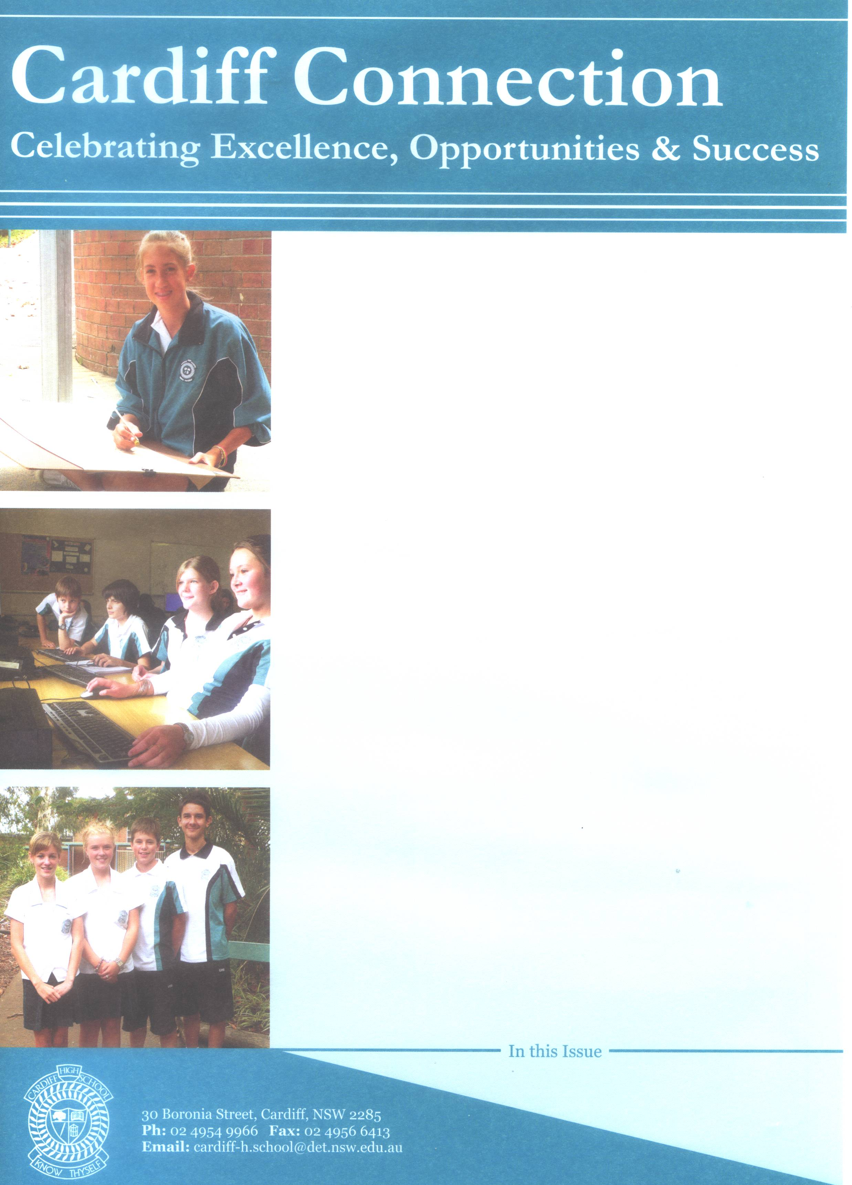

December
2009
Jessica Madden – Experience of a Lifetime.
Jessica has just learned that she has been announced as one of six Premier’s Anzac Memorial Scholarship winners in the state.
This means that Jessica will have the opportunity to spend two weeks in France and Belgium in 2010. Jessica had to make a written application and undergo an interview to progress to the final round. We are very proud of her achievement and envious of her opportunities in 2010.

Christopher Laidler off to Zone Finals
Christopher Laidler has won the Warners Bay Lions Youth of the Year in 2009. This means that Chris will progress to the Zone finals to be held in February. Chris had to undergo an interview, present a five minute speech as well as answer two impromptu questions. Chris spoke very well and handled the impromptu questions with aplomb. I watched the judges; they were too busy listening to even write comments. Well done Chris.

June 2010

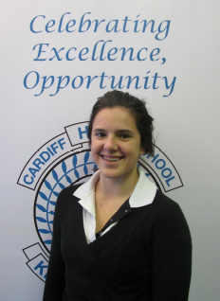

National Swimming Championships
Carissa Borrow has been selected to represent NSW All schools in the School Sport Australia national swimming Championships to be held at Chandler Aquatic Centre (Brisbane) in June. Thank you to the P&C who have donated $250 towards the costs. Congratulations Carissa. We are very proud of your achievements.

From the Principal

Student Achievements:

Girls Volleyball
Our girls KO volleyball team travelled to Forster to compete in the next round of the Knockout. Unfortunately they lost to Foster. Congratulations girls on your commitment and efforts in training and reaching this stage of the competition.
Anna Milat, Jess Lawrence, Sarah Palombini, Katie Wade, Mel Gordon, Laura Goodwin, Laura Niass, Sarah Hartree.

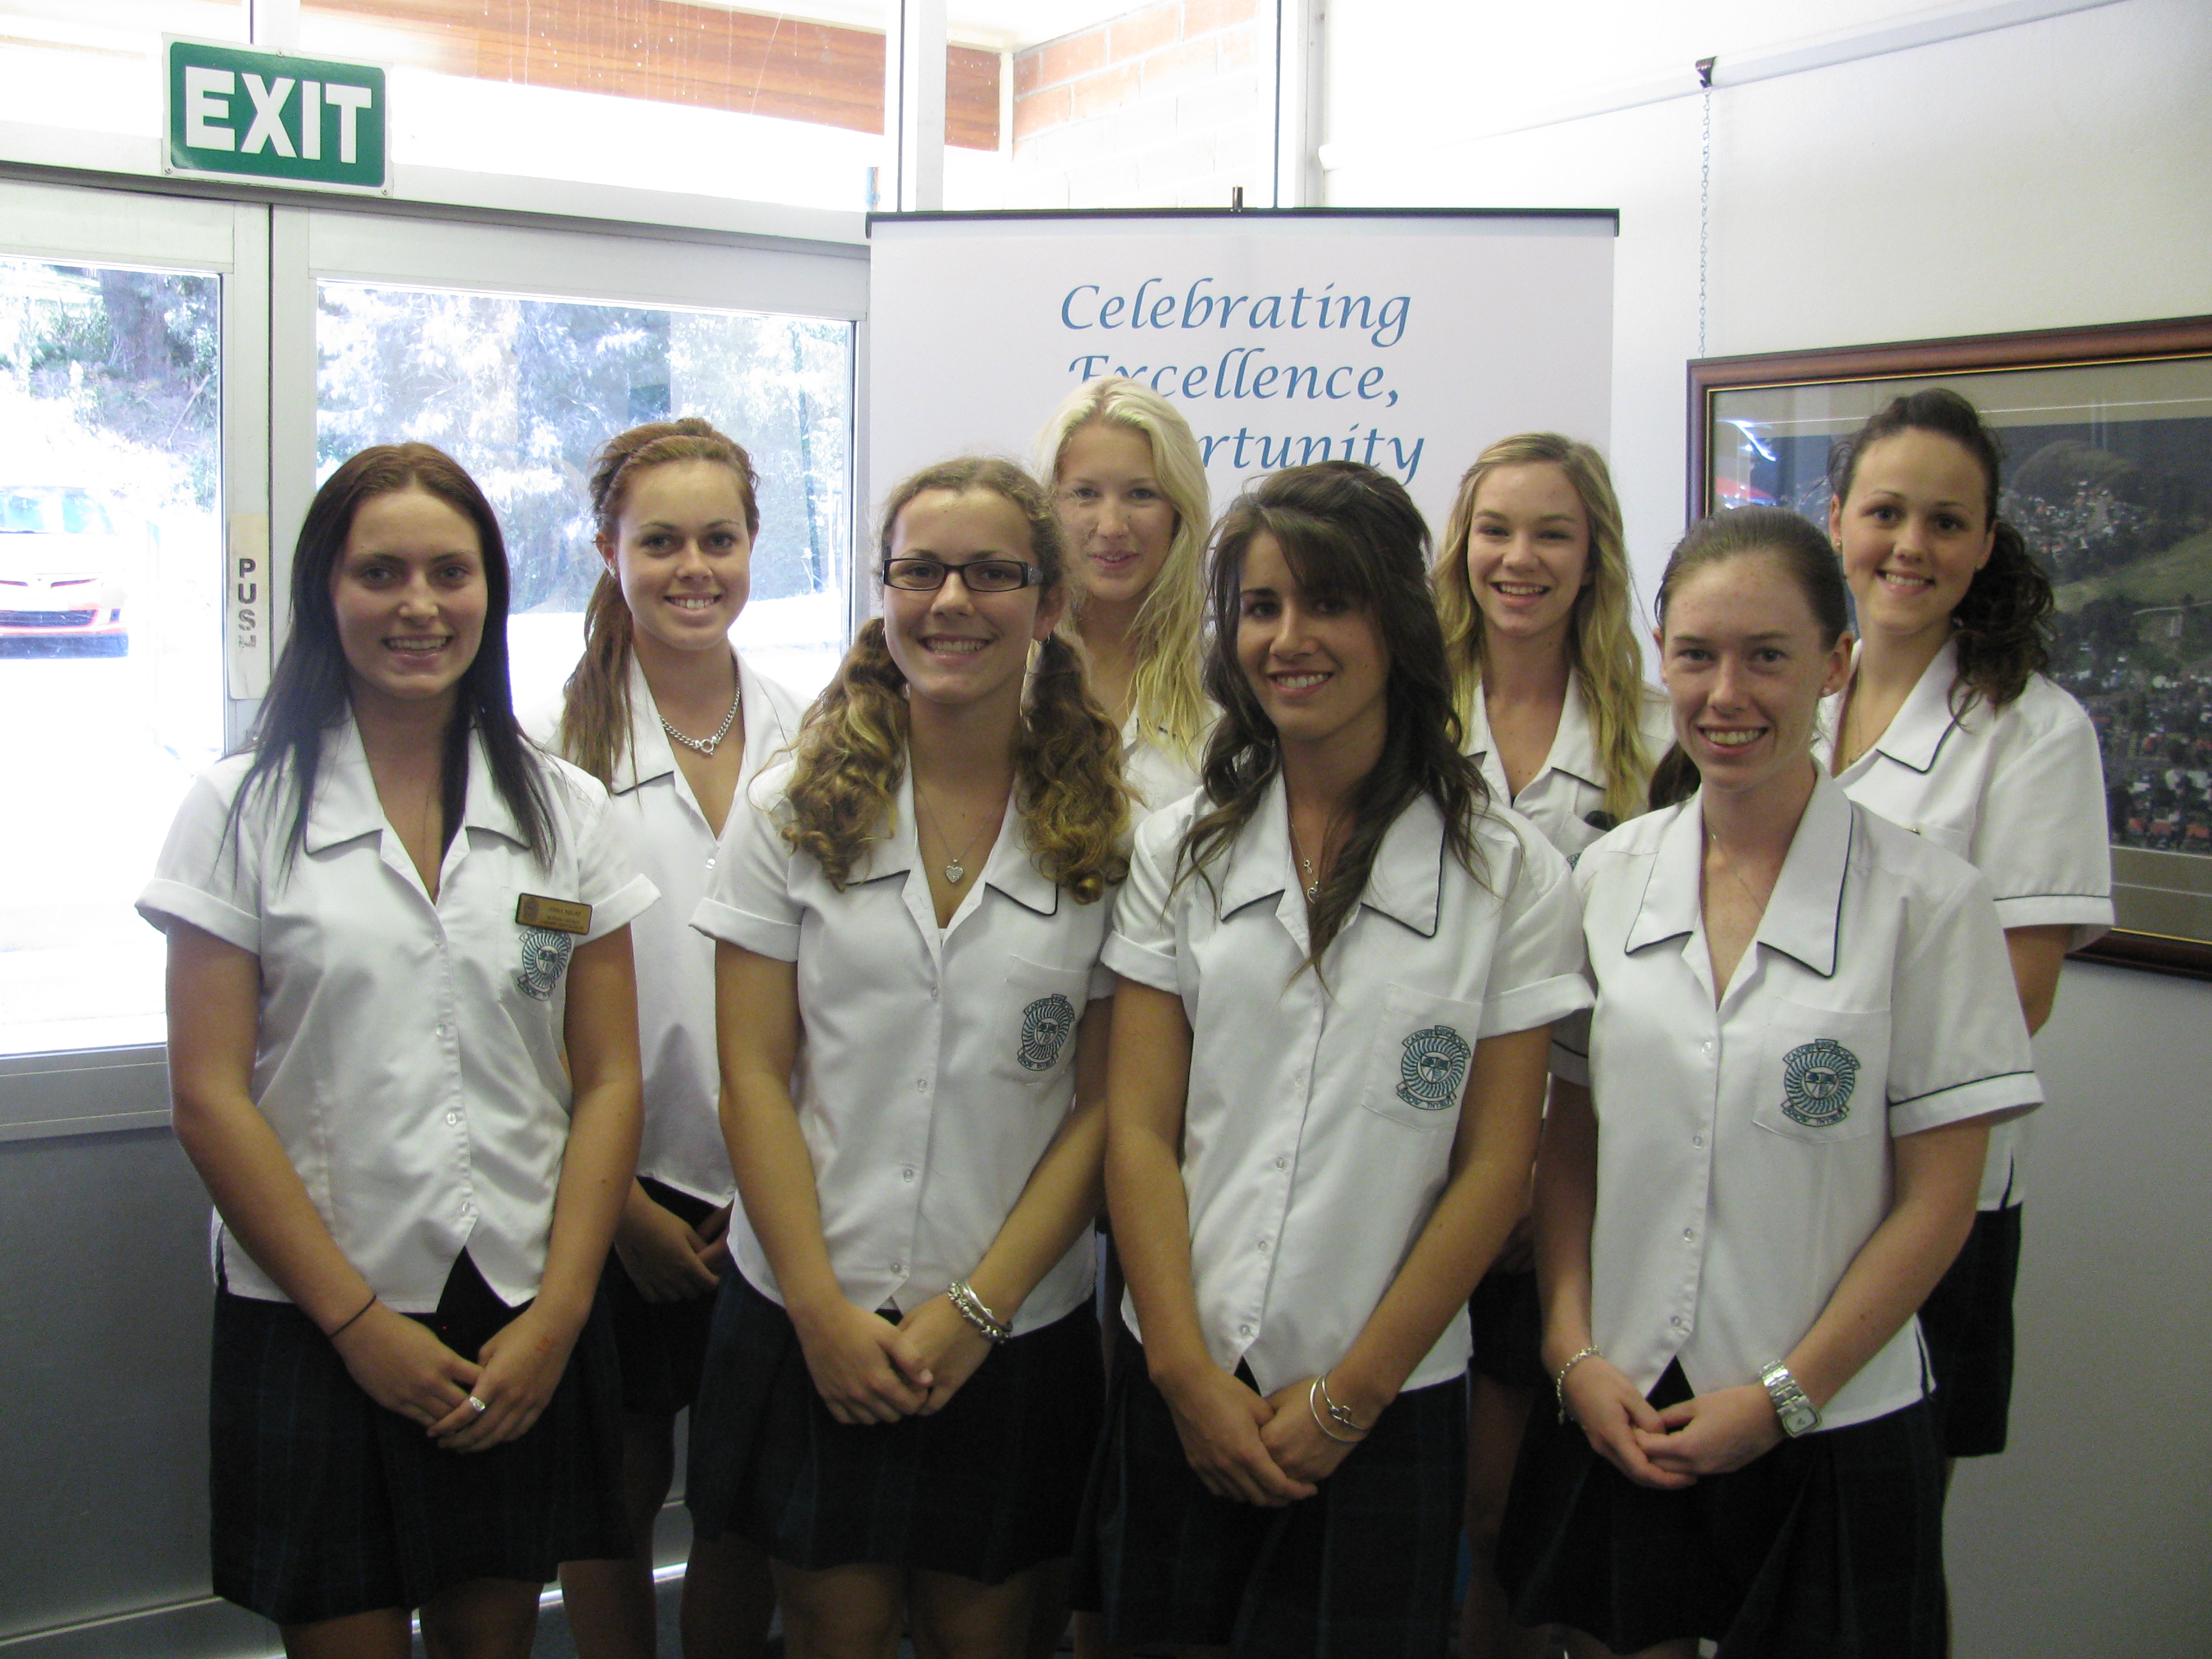

Rugby Union
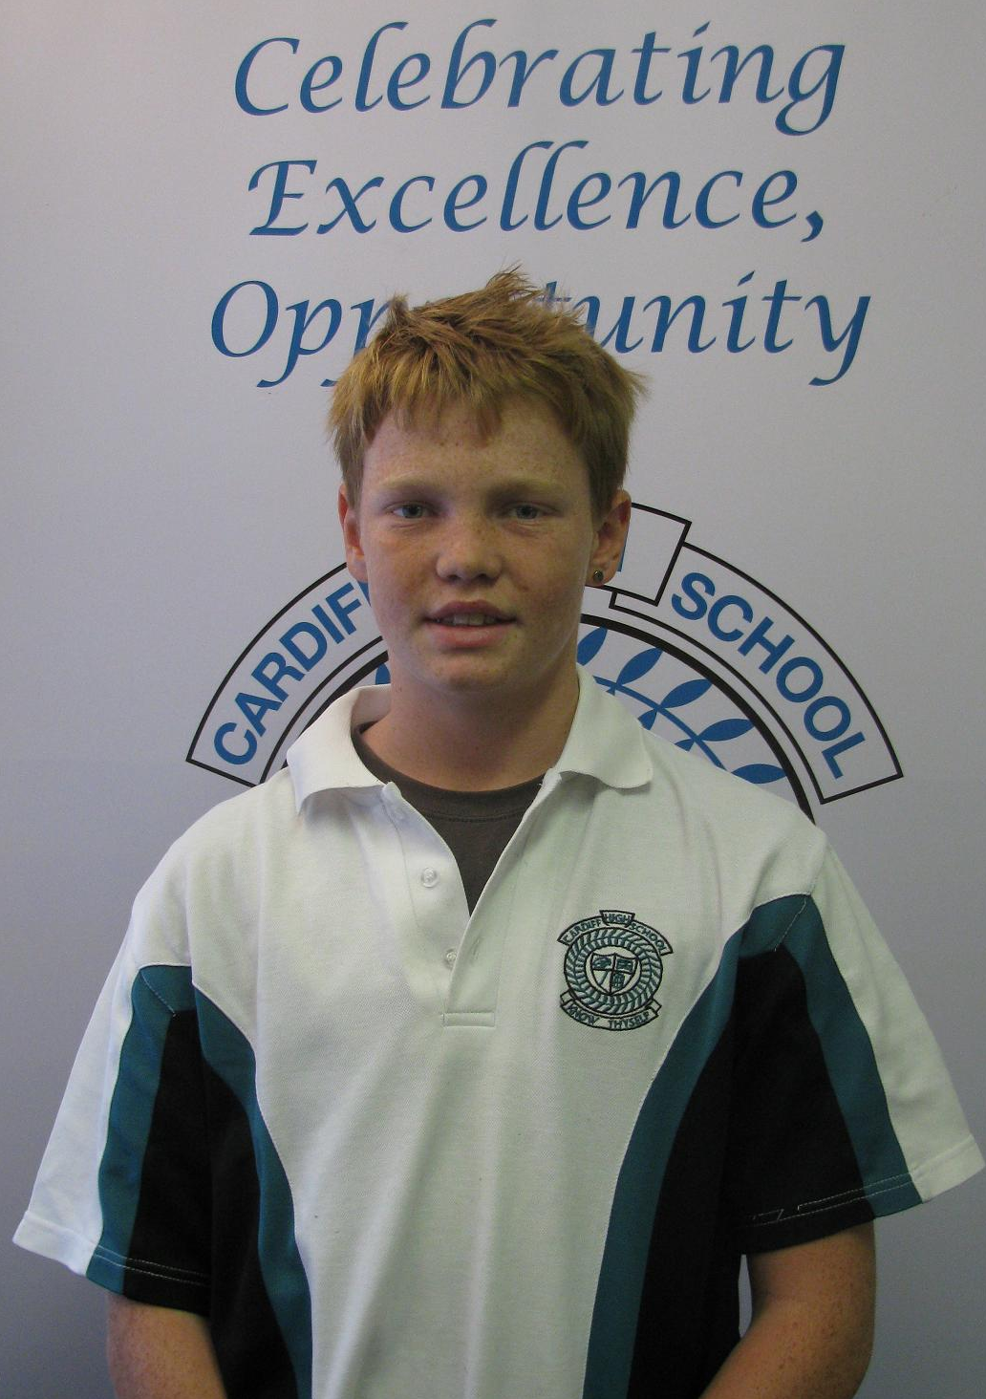
Joey Byrne in Yr 7, was the captain of the Hunter rugby union U12 team that went to Lismore recently winning the country championships. They were undefeated throughout the competition. The team will now go to the State U12 rugby union championships on the long weekend in June in Camden. Great leadership Joey. Good luck in the next round.

Girls Hockey
Congratulations to our girls Hockey team who defeated Newcastle High 6-0 recently. Thanks to Mr Carlton for coaching and Connor Evans for umpiring. Unfortunately our success was short lived in the following round.
Jossy Evans Christine Sheridan
Teale Watson Kristen Pollock
Maddison Nightingale Kirsten Stanton Cyarn Garvey Kate Blackley
Kaitlin Mason Caitlin Waide Jenna Drewitt Caitlin Oldfield
Tori Pearce Lilli Garvey

Boys Soccer
Great win in round 1. Washed out second round. Nicholas Mullen Aaron Thick
Luke Travis Tyler Neve
Aaron Wright Heath Butler
Nick Hills Greg Skaza
Makol Manyang Cameron Smart
Guy Wahlstedt Tye Ansell
Chris Foster Matthew Pichaloff
Justin Winton Blake Butler
Mitchell Herring Daniel Walton-assistant Jorde Baker-assistant
With thanks, Mr Gaul.

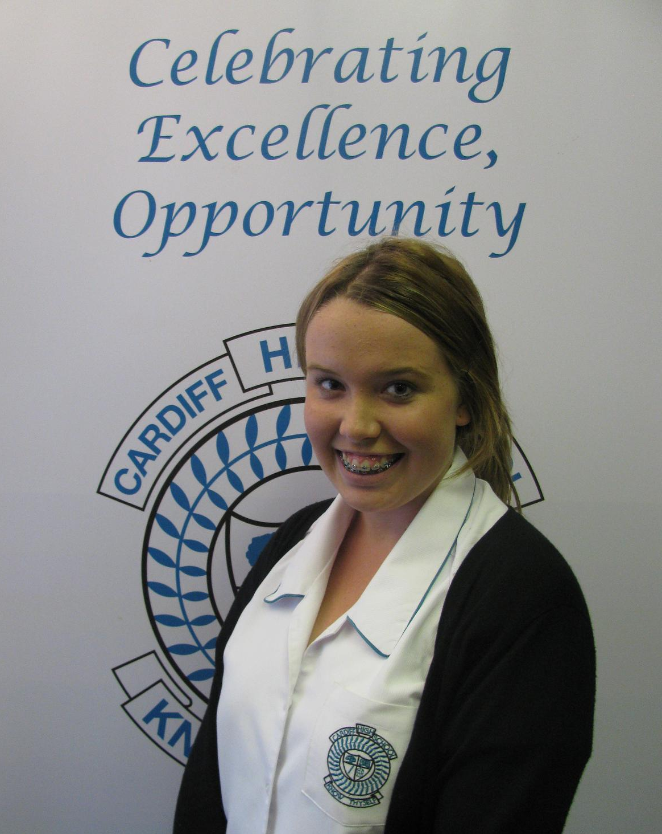
Netball
Year 9 Student Grace Keating will be a part of the 14yrs Lakeside Netball team to compete at the State Age Championships in Newcastle during the first week of the school holidays. Good luck Grace.

NAPLAN Update
Yes the tests did happen and have all been sent away for marking. Results usually arrive about September. We eagerly await these results as staff put a lot of effort into analysing the results to establish areas of strength and weaknesses and adjust the teaching programs accordingly.

Canteen
Congratulations to Annette, Sue and our volunteers. We recently had a health inspection and passed with flying colours. Remember, if you can spare a few hours a month Annette would love to add you to our roster. Please contact the school.

Thanks to P&C
Industrial Arts really appreciates the $1500 contribution to buying a container to store their materials.

Building Works Continue
At last our drainage issues are about to be addressed. Work has begun and will continue to the end of term to alleviate the flooding issues that we have experienced over the years.

Captains to Parliament and Government House
It was an honour to accompany Daniel and Anna to this leadership opportunity on 21st May. As usual they represented our school with pride.

DER Update
There has been a delay in the delivery of our laptops for Year 9. Apparently the protective case does not fit the new laptops and we are awaiting the delivery of these to ensure damage to laptops is minimised. As soon as these arrive, Year 9 parents will receive an invitation to the school to learn about the responsibilities of owning a DER. A charter will need to be signed accepting a series of responsibilities by parents and students before the laptops can be allocated.

Staffing changes
Due to some staff taking leave the following arrangements have been made:
- Year 10 Adviser- Mrs Bates will relieve in this position while Ms O’Donnell is on leave early in June
- Head Teacher IA/LOTE- Mrs Farrugia will relieve as HT while Mr Honeywill is on leave late June
- Deputy- Mr Trayhurn will relieve while Mrs Matthews is on leave late June.

Opportunities
I am always amazed at the opportunities our students are offered. Plans are well underway for our trip to Japan. Mrs Farrugia is also organising a trip to New Caledonia for her French students. I believe Yr 11 will also be offered the opportunity to join this trip as the Jindabyne trip was cancelled due to poor numbers. Yr 12 Advanced English is off to Hamlet at Bondi Pavillion and Yr 12 Geography had their excursion to the Stockton Dunes. Mr Trayhurn’s Year 9 visited Maitland Gaol recently.

Coal and Allied
Thanks to Mr Maher who has negotiated a $2000 grant through Extrata for the delivery of a road safety program to Yr 11 as part of their Crossroads Course.

Former Students Excel
Congratulations to Nathan Carter and Nick Wright who have achieved an Engineering scholarship from Bradken. Thomas Goodwin has also achieved an Engineering scholarship from Port Waratah Coal. Well done boys!

Mrs S Russell
PRINCIPAL

DATES TO REMEMBER

June 7-13 Yr12 VET Retail Work Placement

June 9 P&C Meeting 7pm

June 15 Yr9,10,11 Reports to be issued

June 16 Zone Athletics Carnival, Glendale

June 17 Yr7 Geography Excursion - Aust. Rainforest Sanctuary, Ourimbah

June 21 Yr9/10/11 Parent/Teacher interviews

June 21 Yr12 Chemistry Exp Fest, Newcastle University

June 22 Yr7 Welfare – “The Hurting Game”

June 23 Yr7,8 Reports to be issued

June 24 Yr12 Physics Exp Fest, Newcastle University

June 28 Yr7,8 Parent/Teacher interviews

June 29 Yr12 PDHPE Study Day, Hunter Valley Grammar School

July 2 End of Term 2

July 19 Staff Development Day – NO STUDENTS

July 20 ALL STUDENTS RETURN

July20-30 Yr12 Trial HSC

July 29-Aug3 Tanagura Visit

P&C News
Recently at assembly, I presented a cheque to Carissa Borrow from the P&C, for $250 to assist her with the costs associated with representing our school at the National Swimming Championships.
Carissa has a goal of getting into the Australian Institute of Sport, so we wish her all the best and hope this championship meeting will see her one step closer to that goal. Cardiff High School is proud of you Carissa. Good Luck!
Please join us at our next meeting, Wednesday 9th June, 2010, 7.00 pm in the staffroom.

Regards
Kris Eyre
P&C President

Deputy’s Report

At the Monday assembly on the 24th May all the Leadership students were presented with a Certificate to recognise their achievement in the Leadership Program. It was fantastic to see all the students who attended the Leadership Camp receive their awards and to present them to the school as the future leaders of Cardiff High. The recognition of achievement and success is an area in which Cardiff High is proudly aiming to increase, as many of our students excel in a wide variety of areas. We would appreciate parents and community members informing us of any other great achievements which our students have realised.
With the half yearly/end of semester one reports currently being prepared we would remind parents that the opportunity to discuss their child’s progress is available at the Parent Teacher Interviews (more information is available further in the Bulletin).

Attendance
As stated in an earlier Cardiff Connection Mrs Russell has stressed the importance of attendance. The administration staff has recently sent out letters to families where students have an attendance pattern of less than 85%. This is of concern as not only is valuable learning being missed, assessment tasks can be made more difficult and then students may become anxious. All absences from school need to be explained by a parental note and this is then noted on the roll.
The school has a duty of care to ensure that all students are present and accounted for and “spot checks” can occur at any time as some students occasionally decide that they may leave school grounds for a particular reason. This truancy will be investigated, parents will be informed and the consequences of this truancy could result in a student being suspended for continued disobedience.

Uniform
Students have been advised that with the cooler weather the uniform jumper is to be PLAIN BLACK with NO LOGOS. I would appreciate parent assistance in ensuring that they do purchase a plain black jumper for their children. These are available through the uniform shop or may be purchased at other outlets. If students attend in jumpers which are brightly coloured they will be asked to remove their jumper and will be provided with a green jumper which was the old style uniform. We would also appreciate a note explaining the reason for students being out of uniform.
I have also reinforced that our uniform is BLACK leather/substantial closed in shoes as this is a safety requirement and is part of Occupational Health and Safety legislation.

I would like to thank Mr Trayhurn for relieving in my absence from 11th June to 28th June as I will be supporting the Australian Socceroos in South Africa.

GO THE AUSSIES

Mrs Matthews
Deputy Principal
YR 10
Subject Selection Information Evening

Wednesday 2nd June
7pm in the Hall.
Parents and students are welcome.
Come to learn of the various options for senior study at Cardiff High.

Mathematics News

Mathematics classes have all completed assessments tasks recently and the outcomes studied will be reflected on student’s semester one reports. As we reflect on the results there may be some movement in classes for semester two. In particular, Year 8 will be graded to give students who have demonstrated their skills the opportunity to be extended more than is possible under the present makeup of classes. This will be beneficial for students to access the most appropriate course for them to study in Stage 5 for the School Certificate. We will be notifying individual students and parents before any changes for promotion or demotion take place.

Year 11 classes will also be adjusted as we are half way through the Preliminary course to reflect recent results on the assessment tasks.

It is also an appropriate time for Year 10 students to seek advice about the most suitable course for them to study if Mathematics is part of their senior plans.

I will be available at all parent teacher evenings if you wish to make an appointment with me to discuss any concerns you have.

Miss H Kelsey
Head Teacher
Mathematics

CONGRATULATIONS

The following students qualified to represent the school at the Regional Cross Country Championships which were held at Walka Water Works in Maitland on 28th May:

- Brad Barwick
- Steven Sheridan
- Drew Lambert
- Daniel Redpath
- Alex Hopkinson
- Aaron Niyronku
- Stephanie Richardson
- Lauren Finn
- Rhiannon Upsall

Gaol or Bail

On Friday 20th May Year 8 History and Year 9/10 Commerce had a real life look at the “other side”; they were summoned to Maitland Gaol where they experienced life as a prisoner of the State.

Having closed only 12 years ago, students were astounded at the primitive nature, the high security and freaky feel of the remains of one of the NSW’s most notorious maximum security prisons.

To add flavour and some realism the class was escorted through selected areas by an ex inmate (Pete) who continually spoke about his experiences at the gaol during his three stays (two for break, enter and steal and one for assault on a police officer). Shocking stories of bashings, corruption, attempted and successful escapes kept the students on edge, however what impressed the most was the stark reality especially when Pete discussed the attempt on his life where he was slashed across the face by a razor blade then pulled out his glass eye to show the damage done.

The reality of dark cells, privileges taken away, primitive conditions, tough hardened criminals surrounded by 35 feet walls covered in razor wire with armed guards constantly surveying small overcrowded exercise yards really put the wind up a number of the students. Sitting in Ivan Milat’s cell, hearing stories of attempted suicide and bashings, listening to various roles and actions of prisoners or viewing artworks of frustrated criminals made the day real.

The topic “Crime and the Law” now has new meaning for this band of budding lawyers. Many came away from the experience with a greater understanding of how society deals with wrong doers in the community and see how incarceration is the last option for the justice system. They now also value their freedom much more.

Mr S Trayhurn
Head Teacher
HSIE
Maths/Science Tutoring
Assignment/SCOPE Help
Years 7-10
Price: $20/hour
Connor Sherwood
Ph: 49567474
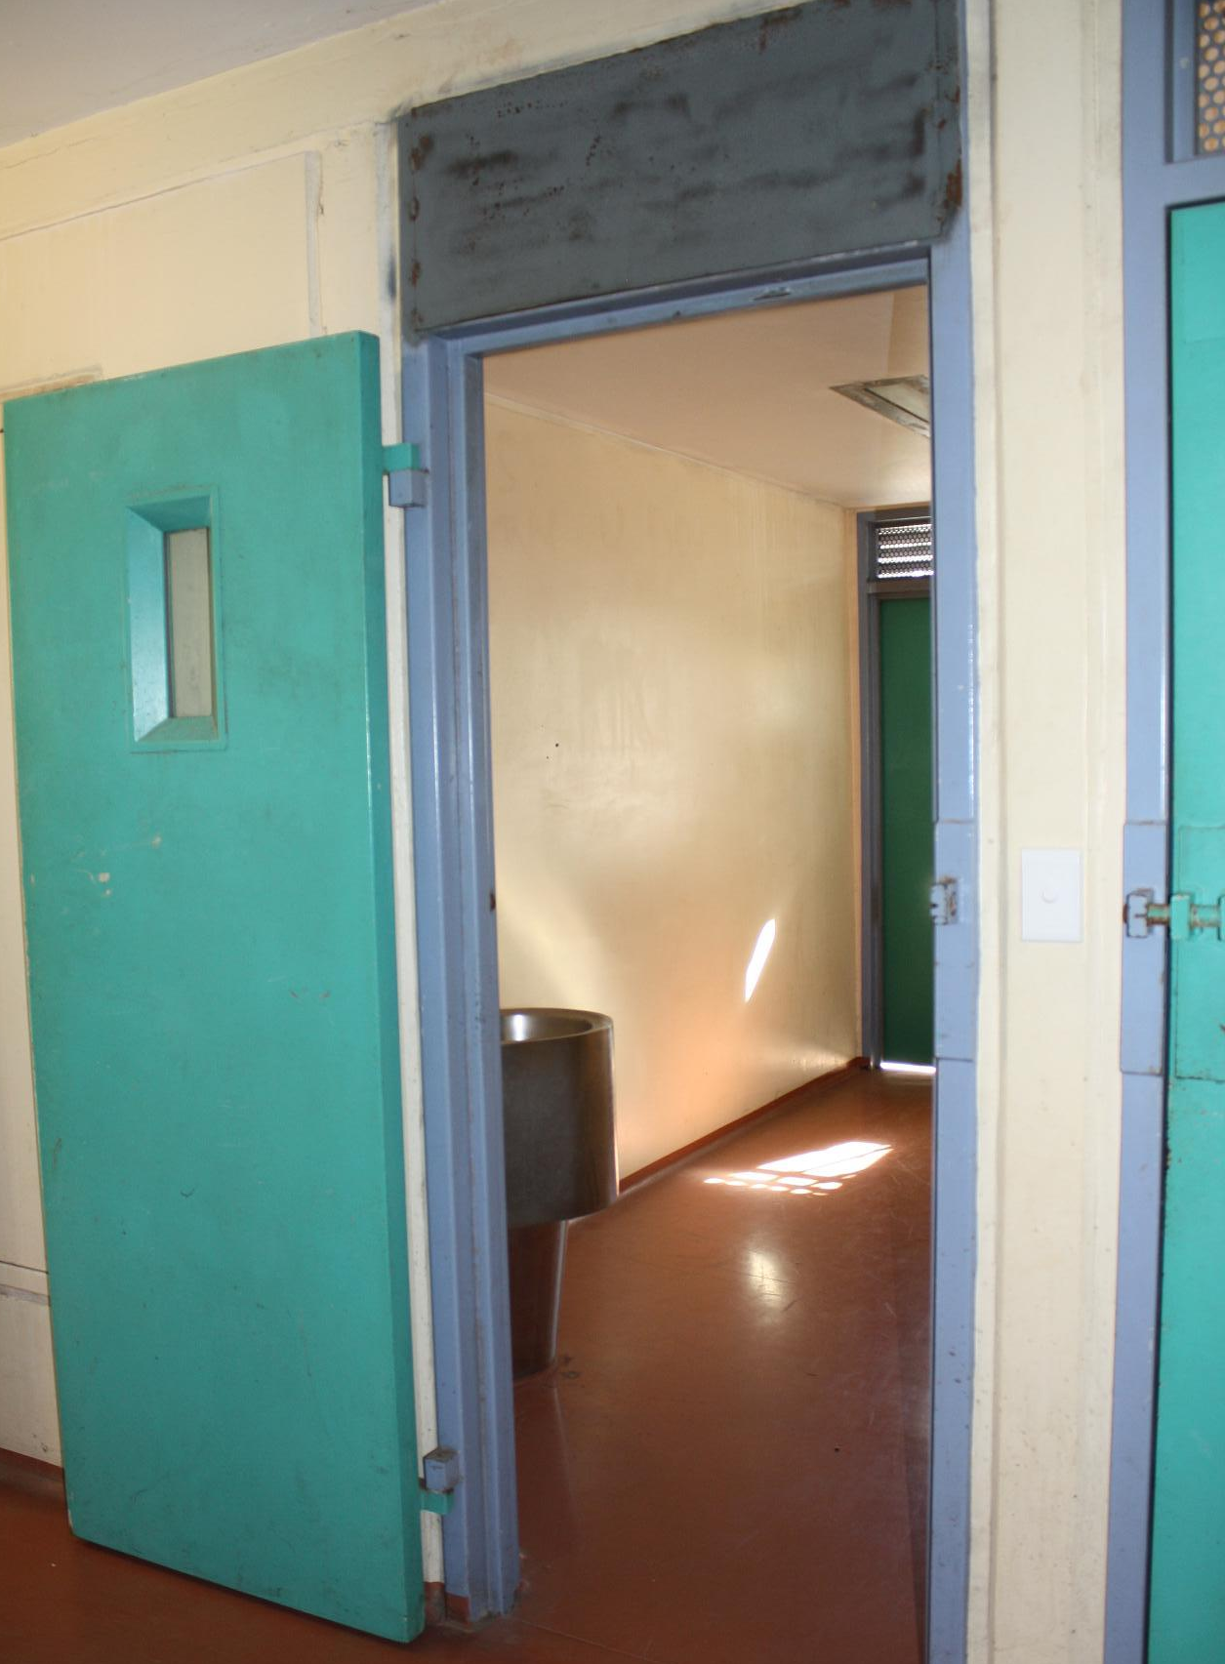
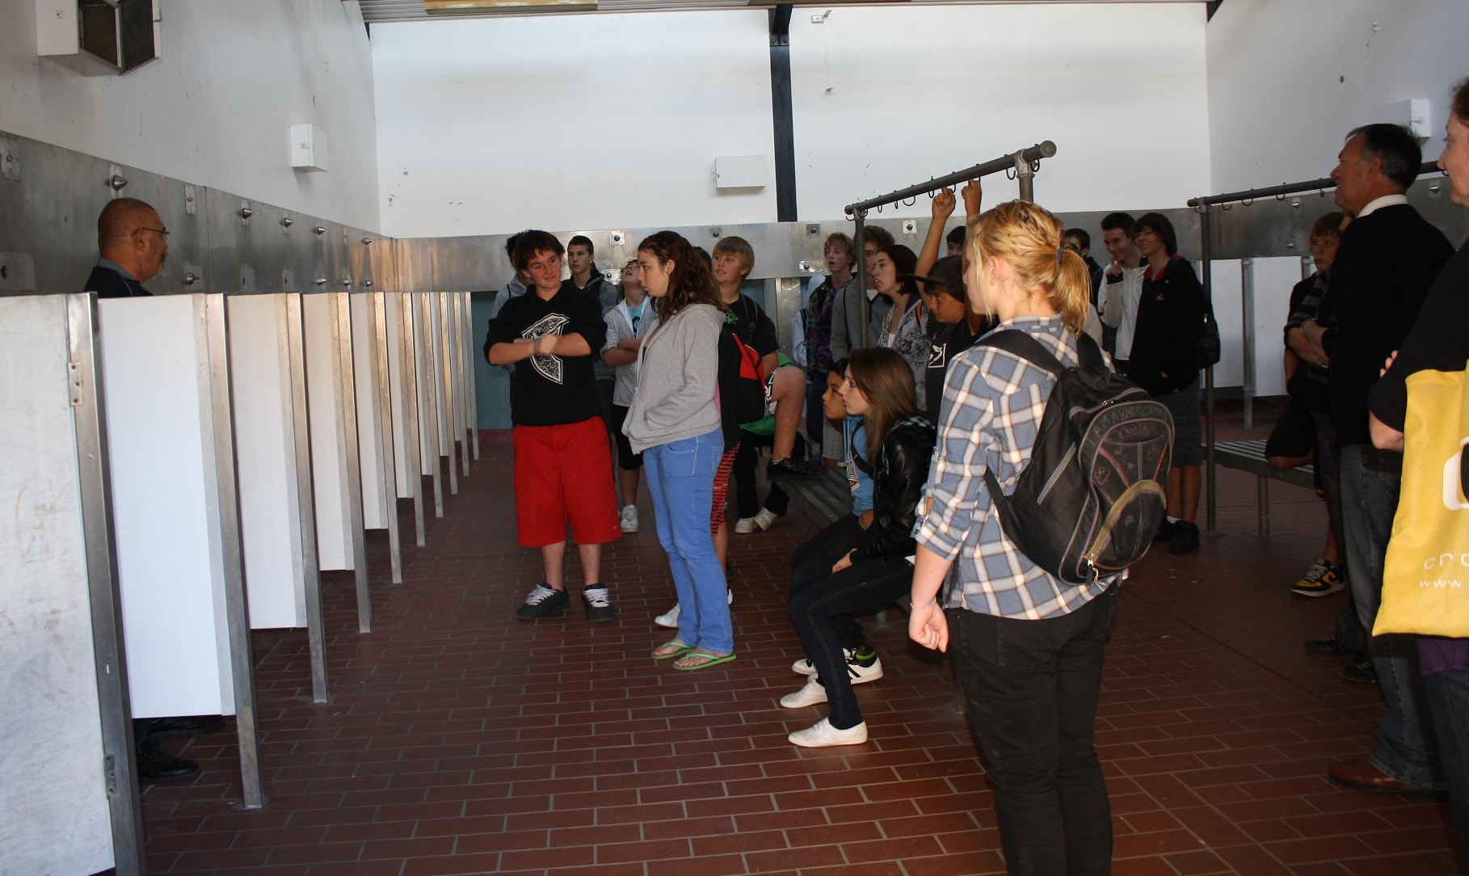
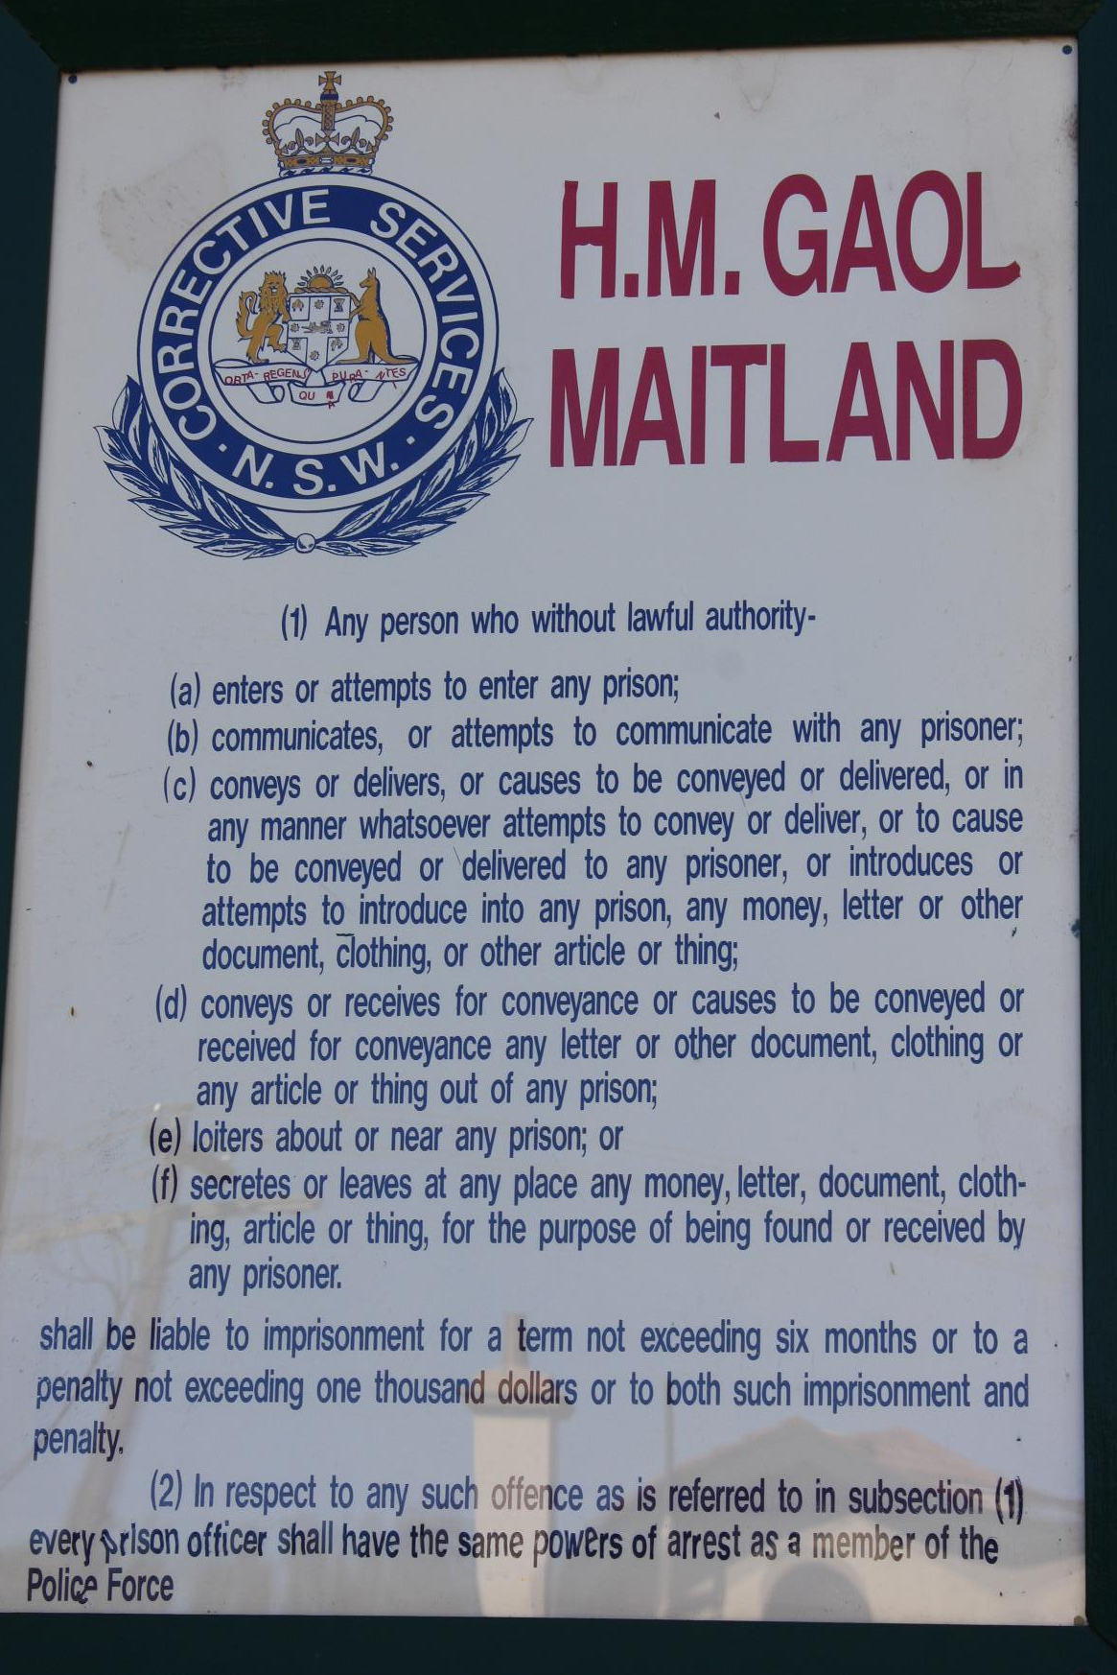


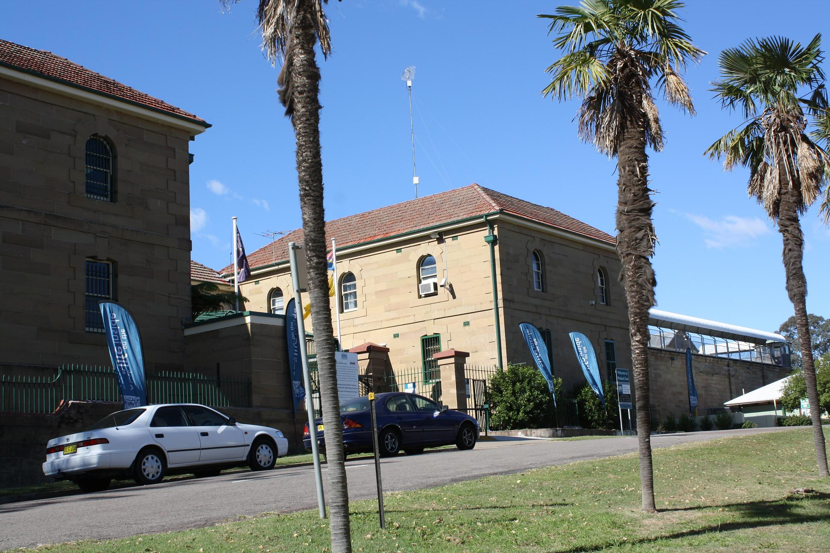
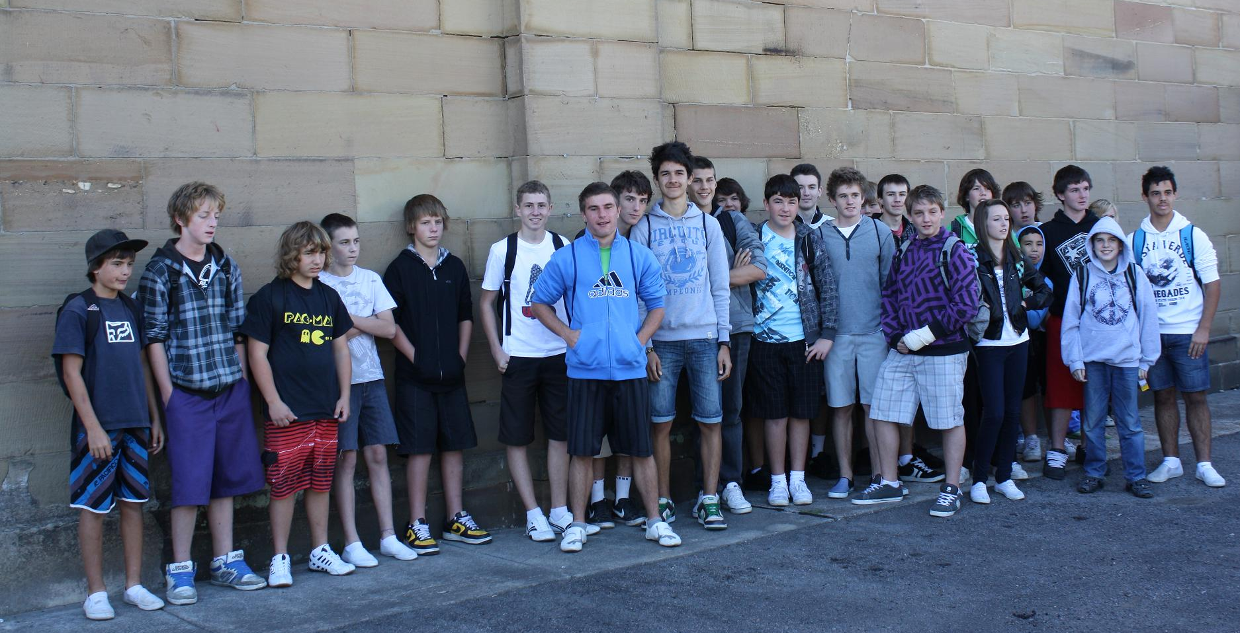
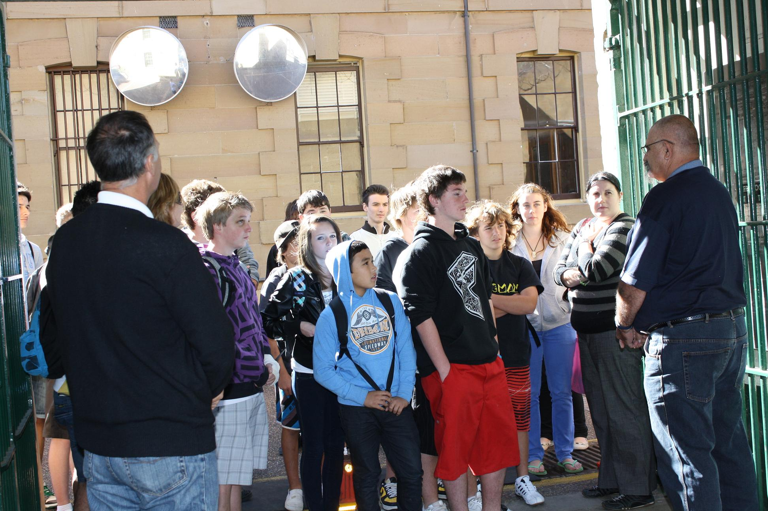
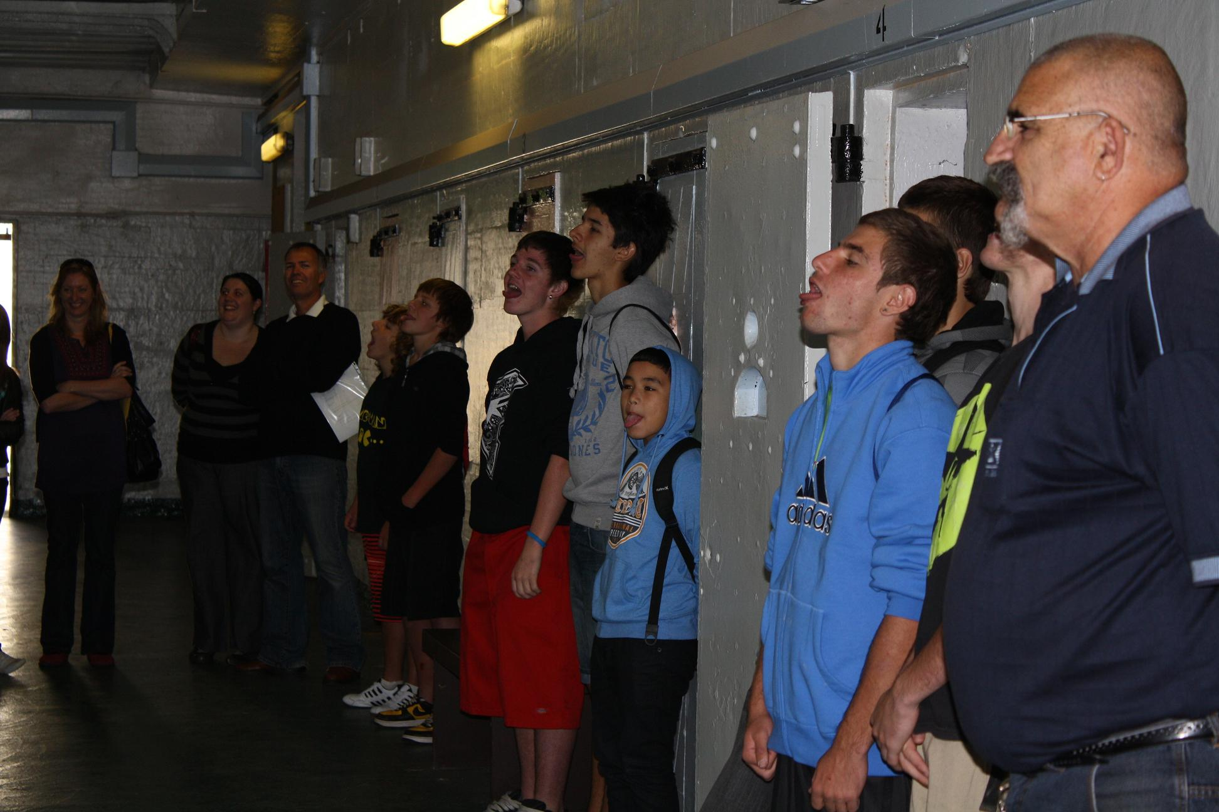

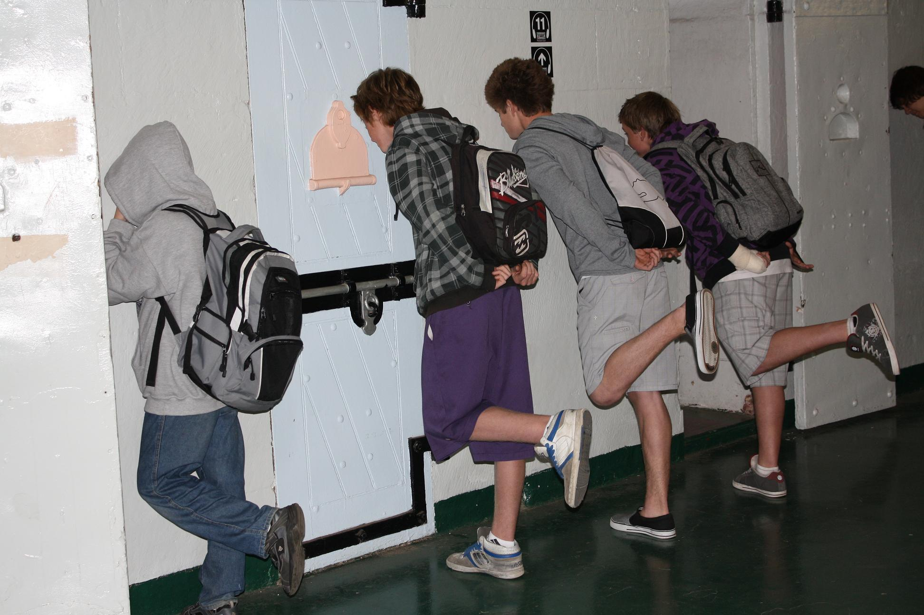
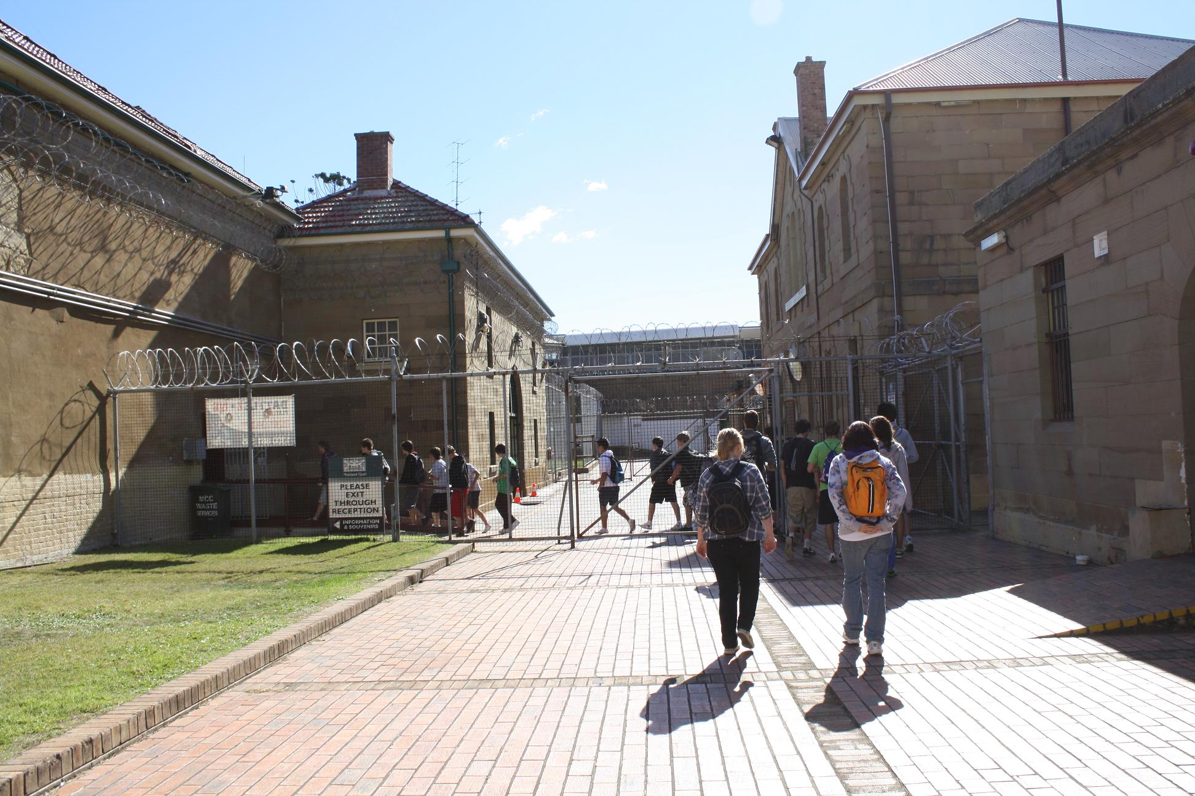

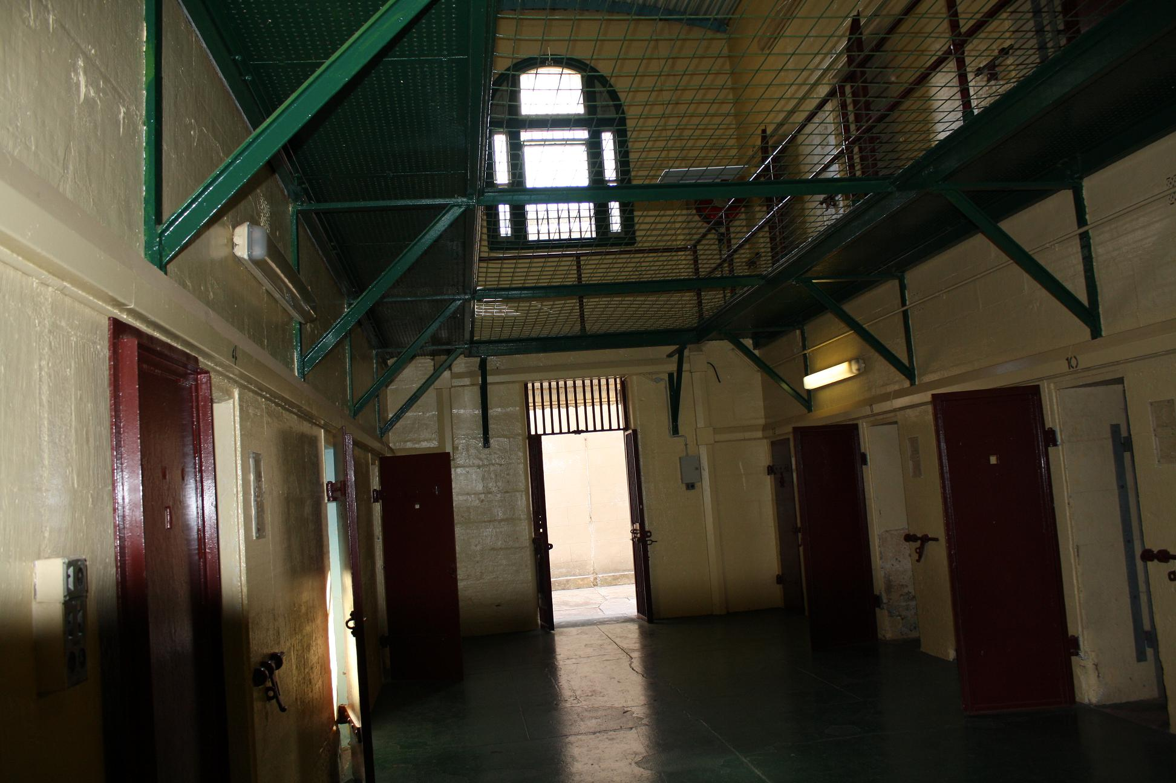

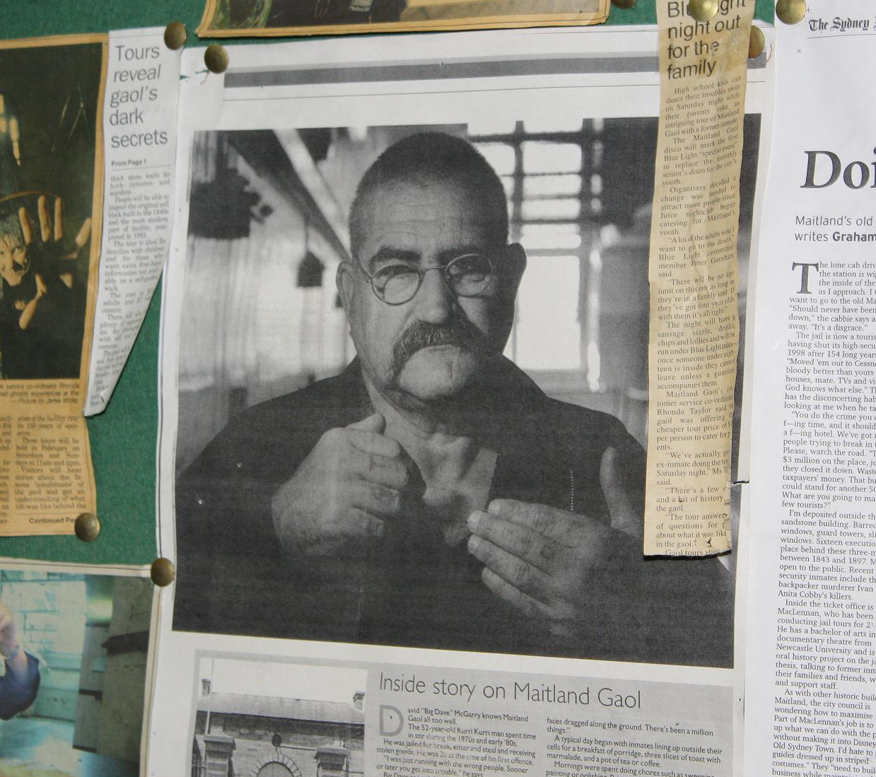

PDHPE / Sport Report

Term Two traditionally marks the time when students start to really hit their straps in PDHPE and Sport. Assessment tasks, sports carnivals and reporting all feature heavily at this time of the year. It also coincides with the beginning of winter and the ‘flu season.

Students across Years 7-10 have been busily completing their dance units and have stunned all with their ability to work together and actually enjoy dancing – congratulations to all. It was especially pleasing to see how the majority of Year 10 has taken the responsible approach to their Dance assessment task and worked cooperatively and independently on developing and ultimately performing their dances. Well done!

We have been fortunate this term to have Mr Daniel Clappe as our PDHPE Intern. He will be finishing his time with us shortly and we hope to see him in the future as a casual teacher at Cardiff HS. We will also have several Newcastle University Students with us in the coming weeks as they complete their practicum experiences at our school – we welcome them to our school and look forward to seeing them work with our PDHPE classes.

On the sporting front, several of our students have qualified for the Regional Cross Country Carnival. This is an outstanding result and again reflects how Cardiff HS is able to stand up on the sporting field against some schools that are up to double the size of our school.


One of our students has truly excelled. Carissa Borrow (Yr10) has been selected to represent NSW Allschools in the School Sport Australia exchange for Swimming to be held in Brisbane in June. When attempting to work out how many students in NSW make this team and comparing this to how many students attend secondary schools in NSW, this equates to Carissa being one in approximately 400 000!! Not too bad for a girl from Cardiff HS. We wish her all the luck and success that she deserves.


Students in Years 9 and 10 PASS classes will have received their information pack for the school snow excursion. This is traditionally the highlight of the year within PASS and I encourage students that are attending to start working and saving so that they can pay off this excursion. The trip will provide many students with experiences that will stay with them for a lifetime.
Year 12 PDHPE Enrichment Day: This is a planned excursion to Hunter Valley Grammar to take place in late June. Students have received paperwork for this excursion and I strongly urge students to participate in this day as it provides the opportunity to “look outside of the fishbowl” and gain some additional perspectives on the topics that they are studying for their HSC.

Subject selections – Year 11 2011: Students in Year 10 will shortly be asked to make some serious decisions about the path that they wish to follow into their future. I urge all students in Year 10 to talk with their parents and teachers and choose subjects that they enjoy and will be good at. I remind students to not choose subjects based on who is their teacher and who else may be choosing the subject – your HSC is not about your friends – it is about you. The only subject you must study in Year 11 and 12 is English. You will need to choose at least five other subjects as well and I ask that should you be interested in subjects within the PDHPE subject area to please talk with your PDHPE teacher before you make decisions about studying either PDHPE or Sport, Lifestyle and Recreation Studies.

Mr C Maher
Head Teacher PDHPE
WELCOME TO
BABY ISAAC JAMES
AND CONGRATULATIONS
Mr and Mrs Mulligan
(both teacher’s at CHS)
on the birth of your first child.
Mum and baby are home and both doing very well.
Our thoughts and best wishes
are with you.

Parent Teacher Interviews

Year 9/10/11 21st June

Year 7/8 28th June
Hall

3 p.m. – 6. p.m.

Dear Parents/ Caregivers

Parents are invited to attend Semester 1 Parent Teacher Interviews on the above dates.

Reporting student’s success, achievements and areas of concern are vital for students to sustain their diligent efforts and resolve any outstanding issues.

In order to support student’s ongoing success and enable students to address any problems prior to their written reports in Term 2 and Term 4 we are holding parent teacher interviews on the last Wednesday of Term 3.

We feel that is will be more beneficial for student’s to use this more timely feedback to ensure a positive written report.

This is part of our ongoing commitment to ensure communication with parents to support your child’s learning, so please feel welcome to attend.

To make sure you are not waiting unnecessarily in queues we ask your children to make 5 or 10 minute appointments with each of the teachers you would like to speak with. You will find on the back of this invitation a proforma for your children to use.

Parent Teacher Interview Appointment Sheet

Student’s job:

- Check what time Mum/ Dad/ Caregiver is available
- Make a list of your subjects and teachers your mum/ dad/ caregiver would like to see. Times are limited to 5 or 10 minutes. Make sure you tell your teacher what time you need.
- See your teacher and arrange an appointment time that suits. DO NOT WRITE ON THIS FORM UNITL YOU HAVE CHECKED YOUR TEACHER’S APPOINTMENTS.
- Record your appointments on this sheet and return to your mum/ dad / caregiver

Time that my mum/dad/ caregiver is available. ………….p.m to ………..p.m

Time | Subject | Teacher



Free
Professional
Counselling
24 hours a day

Separation is a difficult time for everyone in the family

A decision to separate is one of the hardest choices you may ever make, and it has consequences for everyone in your family. Both you and your children may feel confused about what is happening, and be unsettled about the impact of such change.

Separation can evoke strong feelings for everyone – you, your partner, your children, and even extended family members like grandparents, aunts and uncles. Your family is undergoing significant change - separation usually means that the family is dividing, and that one parent will be leaving the household.

With change comes emotion. You may feel sad or lonely, angry, guilty, or like you have failed in some way. Many parents have experiences of depression and anxiety. In fact, you may feel all these emotions at different times.

It is important to remember that your child also has strong feelings. They may feel grief, shock, insecurity and worry whether the remaining parent will leave them as well. Some may feel that they are to blame for the situation, while others may feel angry.

As a parent it’s important to understand that your children are also going through a distressing time, and to do what you can to reduce the impact on them. Here are some basic tips to assist with that:
- Prepare children as best as you can. Give them a simple explanation of why you are separating.
- Let your children know that both parents love them very much.
- Remind children that it is not their fault – it is a decision that you as parents are making about your relationship.

- Focus on the positives. Give lots of love and attention. Try to avoid conflict in front of your children, and avoid blame.
- Try to minimise the change to your children’s environment and routine.
- Acknowledge how your children are feeling, and that these feelings are okay.

For more information on separation or any parenting issue, call our professional counsellors for the cost of a local call from a land line, 24 hours a day, 7 days a week on 1300 1300 52 or read our information sheets on separation on www.parentline.org.au


CANTEEN HELPERS NEEDED

Parents, if you can spare as little as one day per month to help out in the canteen please call the school on 49549966 and ask for Annette Salmon (Monday-Thursday) or Sue Smith (Friday).

ENTERTAINMENT BOOKS
AVAILABLE
AT THE OFFICE
$60.00

Dr Peter Vaughan
BDS,MDSc (Syd Uni)

Specialist Orthodontist

- We provide an honest opinion especially in regard to the need for treatment and timing.
- We treat most clients without extractions
- Clear braces for all patients at no extra cost
- Written guarantee with treatment
- All x-rays are bulk billed to Medicare
- Medicare Teen Vouchers accepted
- If you are thinking orthodontics, get an honest opinion, the $85 consultation fee will be well invested.
- Referral not required

Visit our web site: www.orthodontist.com.au

Phone Charlestown or Wallsend on 49425244
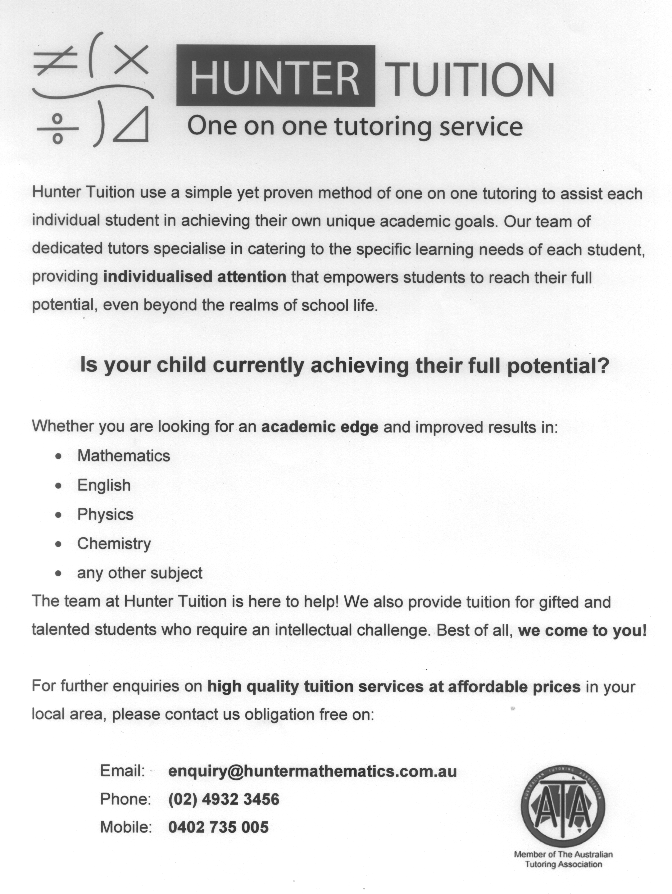


Like Some TUITION Help?

MATHS, ENGLISH
AND OTHER SUBJECTS

(Study Tips and help with Essay Writing)
Experienced, Competent, Friendly,
Patient Tutors, 1 on 1.
(We also offer pre-school and primary programs)

CHARLESTOWN STUDY CENTRE
In operation 15 years.
Ron and Heather Sterland
Phone: 49432211



