

May 2010

Nanga Mai Awards
Congratulations to Melanie Gordon who received the Nanga Mai Award for Academic Excellence. Melanie received this prestigious award at Customs House on the 30th March in recognition of her terrific School Certificate results in 2009. Melanie also receives an RTA Scholarship to assist her achieve her goals for the HSC.


All Schools Swimming Championships
Carissa Borrow and Ben Milton competed in the State Championships in the holidays and qualified for All Schools.

Carissa will complete in 50m Breaststroke, 100 m Breaststroke, 200m Breaststroke and 200m Individual Medley and Ben will complete in 200m Butterfly, 200m Backstroke, 400m Freestyle, 400m Individual Medley.
Congratulations and good luck.

FROM THE PRINCIPAL

Lions Youth of the Year Competition
Congratulations to Chris Laidler on reaching round 3 of the Lions Youth of the Year contest. I had the privilege of being in the audience to hear Christopher deliver his prepared and impromptu speeches. Christopher is a great ambassador for Cardiff High School.

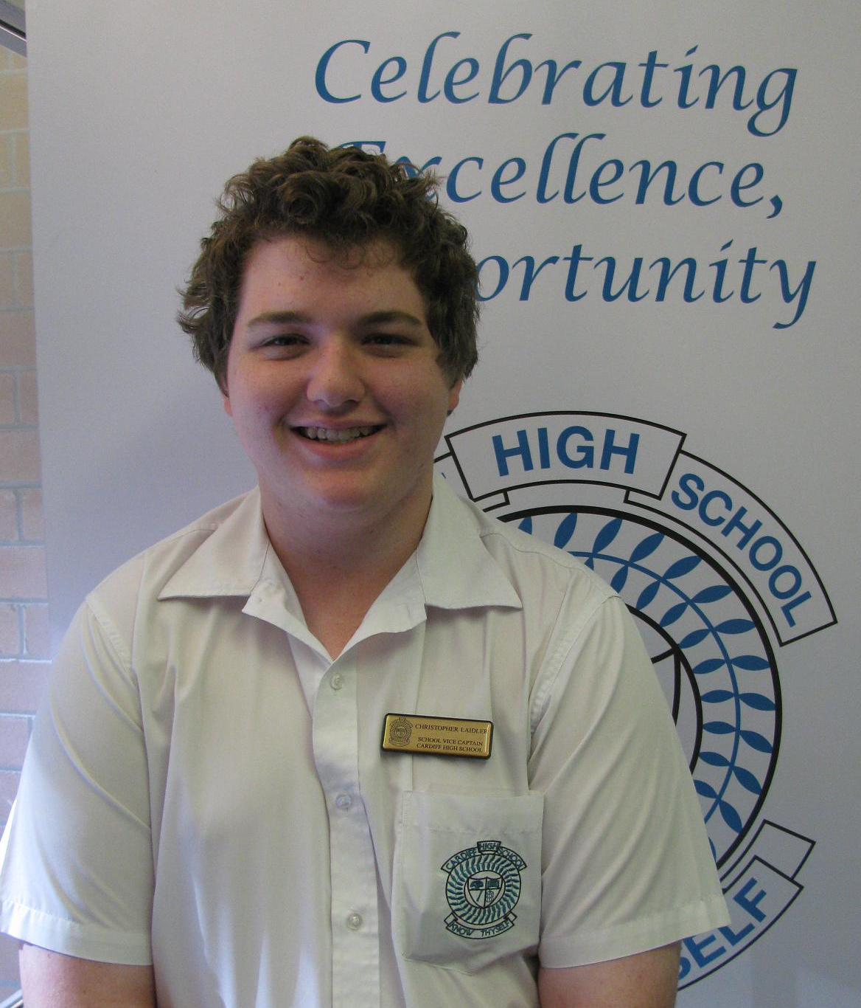

Trainee of the Year
Former student Jordan Nickels has just been named School Based Trainee of the Year. Jordan has taken up a traineeship with Downer EDI. Congratulations Jordan.

Student Leadership
Congratulations to Mrs Matthews and her team- Ms O’Donnell, Mr Turnidge and Mr Welch on a wonderful leadership camp. The photos are a testament to the wonderful learning, challenges and time you spent at Glenrock.

Yr 6 EXPO Day
Thanks too, to the group leaders for our Yr 6 EXPO Day. You did a great job looking after your groups.

State Diving Competition
Lilli and Cyarn came 5th at State Diving titles conducted during the recent holidays. Well done girls.




Congratulations to Yr 7 Periscope Presenters
I enjoyed my visit to the presentations of the Periscope project. I was impressed by the quality and work that was on display. It was terrific to see the calibre of the assignments on display and the amazing technology skills demonstrated.

Westlakes Zone Netball Gala Day
This day serves as the 1st two rounds of the NSW CHS Knockout competition. Congratulations to the following girls who represented us:
Katie Wade Ellen Bennett
Anna Milat Cassie Clare
Jessica Lawrence Elly Davis
Melanie Gordon Kirsten Stanton
Maddy McGrath Ashley Bennett
Hayley Travis Indianna Reed
Teale Watson

Red Heart Day
What a great day, organised by the SRC and Mr Welch with inspiration from Elly Davis. Elly’s brother, Ben, passed away 3 years ago from heart disease. Elly wanted a positive way to remember Ben and also educate our students about healthy lifestyles and heart care. Ms Penny Milson from the Heart Foundation was overwhelmed with the student response as they dressed in red and donated. Over $750 was raised for the Heart Foundation.



School Athletics Carnival
The weather cleared and a great day was had by those who attended. The atmosphere was great as records tumbled and were made. Two highlights included Alannah Jobson broke the 200m school record and Miss Kelsey set the 200m record for staff.

Girls Soccer
Laura Goodwin Sarah Hartree
Sarah Palombini Angie Herden
Laura Niass Kerina Tapp
Rhiannon Upsall Caitlin Waide
Lauren Finn Grace Dixon
Kiara Lorkovic Stephanie Richardson Tanique Munro Jasmine Munn

Soccer Scholarships
Congratulations to Guy Wahlstedt, Greg Skaza and Ty Ansell who have been awarded a Scholarship to America after their HSC. This is in recognition of their fantastic soccer skills. Well done boys.



SRC Regional Conference
Thanks to Brody Kirkbride and Dean Razmovski for attending the conference and returning with great ideas for the SRC to pursue.


Bloodbank
Once again community responsibility is high on the list of opportunities offered to our students.

Soccer Win
Cardiff vs Glendale HS. 1-0 win to Cardiff
N Mullen L Travis
D Walton B Butler
T Neve N Hills
J Baker M Manyang
A Thick T Ansell
G Skaza C Smart
G Waldstedt A Wright
J Winton M Holloway
H Butler M Pichaloff
S Marriott

DATES TO REMEMBER

May 11-13 Yr7&9 NAPLAN testing
May 12 P&C Meeting 7pm
May 17-21 Yr 9/10 Exams
May 17-21 Yr 11 Exams
May 24-28 Yr 7/8 Exams
May 24 Yr12 Advanced English HSC Study Day
May 24-30 Yr11 VET Business Services Work Placement
June 7-13 Yr12 VET Retail Work Placement
June 9 P&C Meeting 7pm
June 9 Yr7 Welfare Day (proposed)

My School Website
The Deputy Prime Minister Julia Gillard has repeatedly said she will not move to stop the publication of inaccurate league tables, and says she will redirect people to the My School website for accurate information.

As a professional educator I would like to recommend that you go to the NSW Secondary Principals' Council website and read the short article on the inaccuracies of the My School website and the need to re-adjust ICSEAs for many schools as the Australian Bureau of Statistics data used is misleading, and indeed the ABS advises that the data should not be used the way ACARA has used it to calculate the ICSEA.

If the Deputy Prime Minister were to listen to the reasoned voices of the profession, it is likely there would be no issues with NAPLAN and a much more informative My School website would be available for parents and the community. The SPC website is http://www.nswspc.org.au/



CARDIFF HIGH UNIFORM SHOP
OPERATING HOURS
SCHOOL TERMS

UNIFORM SHOP
“20% off SALE”

From 3rd May to 14th May 2010
Get in quick and only while stocks last

Items included are:

Boys Formal Trousers
Girls Formal Pants
Girls Formal Polo
Girls Formal Shorts
Tartan Skirts
Tights
Belts

Our shop hours are:
Tuesday 8.00 – 10.00am
Thursday 1.00 – 3.30pm

Phone: 02 4954 2429

You can view the price list online at www.alintaapparel.com.au

School Attendance –Cardiff High School
“It’s not OK to be away”.

Dear Parents/Caregivers
Following is an extract taken from the information for parents and carers from the Department of Education in regards to attendance at school. I would like to think together we can improve the attendance of all of our students at Cardiff High School. In any one year the normal expectation is that a student will miss up to ten school days due to illness or urgent family matters. I would ask that you keep an account of the number of days your child has off and support us in improving this most important factor in improving student results and prospects.
All students should:
- Aim for 100% attendance
- When absent, make sure they hand in an appropriate note the next day
- Be on time and ready for all school activities and lessons
- Leave the playground promptly at the roll-call/recess/lunch bell
- When late, make sure they have a signed late note
- Ensure they go through the sick bay if sick and need to go home early. (Under no circumstances should a child ring their parents directly and ask them to come and pick them up from school prior to the end of the day.)

Sport
For exemption from sport the following conditions apply:
- For either an indefinite period or permanently, a Doctor’s Certificate must be supplied to the Principal.
- In the case of minor illness, a note signed by the parent/guardian, dated and reason given, must be presented in the practical PDHPE lesson or in the case of sport to the Sport’s Organiser, Mrs Holmes, on Wednesday morning.

For both of the above (unless in exceptional circumstances) all students who are unable to attend sport due to an injury or minor illness will be required to attend non sport at school where they will be involved in private study. Mrs Holmes will provide these students with the room where non sport is held.
In order to obtain a School Certificate each student must have satisfactorily participated in sport, unless an exemption has been approved in writing from the Principal.
Students are NOT encouraged to use sports afternoon to attend appointments. The participation in sport is an important part of their development and education. Should a student be absent from sport, a note must be given to Mrs Matthews on the day prior to the appointment with proof of the appointment attached (i.e. a copy of the appointment card/notice). On Wednesday morning the leave pass will be available for the student to collect.
All children have a right to an education. Only by regular school attendance can children make the most of educational opportunities, leading to greater social and economic outcomes.
Schools, in partnership with parents, are responsible for promoting the regular attendance of students. While parents are legally responsible for the regular attendance of their children, school staff, as a part of their duty of care, monitors part or whole day absences. Parents and schools have specific responsibilities concerning children’s attendance at school.

Responsibilities of parents
The Education Act 1990 requires that parents (including carers) ensure that children are enrolled at and regularly attend school.
What is a justified reason for being absent from school?
Justified reasons for absences may include the student:
- Having an unavoidable medical or dental appointment (preferably, these should be made after school or during holidays)
- Being required to attend a recognised religious holiday
- Being required to attend an exceptional or urgent family circumstance (such as attending a funeral)
- Being sick, or having an infectious disease
Regular School Attendance
Absences for reasons such as some of the following may not be justified:
- Shopping
- Sleeping in
- Working around the house
- Minding younger siblings and other children
- Minor family events such as birthdays
- Hair cuts

Keeping the school informed
If your child has to be absent from school, it is important to tell the school and provide a reason for the absence. To explain an absence parents and carers may:
- Send a note, fax or email to the school
- Telephone the school, or
- Visit the school.
The Principal of the school has the right to question parents’ requests for their child to be absent from school. They may also question an explanation given for a child’s absence from school.

Holidays
Parents and carers are encouraged not to withdraw their children from school for family holidays. If this is necessary parents should discuss these absences with the Principal and may be requested to apply for a Certificate of Exemption from attendance at school. This will ensure that these absences are not permanently recorded as unjustified.

Arrival on time
Arriving at school and class on time:
- Ensures that students don’t miss out on the important learning activities scheduled early in the day when the students are most alert
- Helps students learn the importance of punctuality and routine
- Gives students time to greet their friends before class and therefore,
- Reduces the opportunity for classroom disruption.
Lateness is recorded as partial absence and must be explained by parents or carers in the same way as other forms of absence.
Must my child attend all activities, including sport?
YES. Sport and other physical activities help the healthy physical and mental development of children. Sports and sports carnivals are normal school activities and students must attend.

Mrs S Russell
PRINCIPAL

P&C News
Congratulations to our captains, Anna and Daniel, on your participation at the Dawn Service at Cardiff RSL on ANZAC Day. You both did a great job representing our school and I’m sure your parents and friends are proud of you, as is the community.
It is great to see so many members of the community there, up before dawn to acknowledge and pay respect to those who have served our country and given us the freedom we have today.

Please join us at our next P&C Meeting in the staffroom at 7.00 pm on Wednesday 12th of May.

Kris Eyre
P&C President

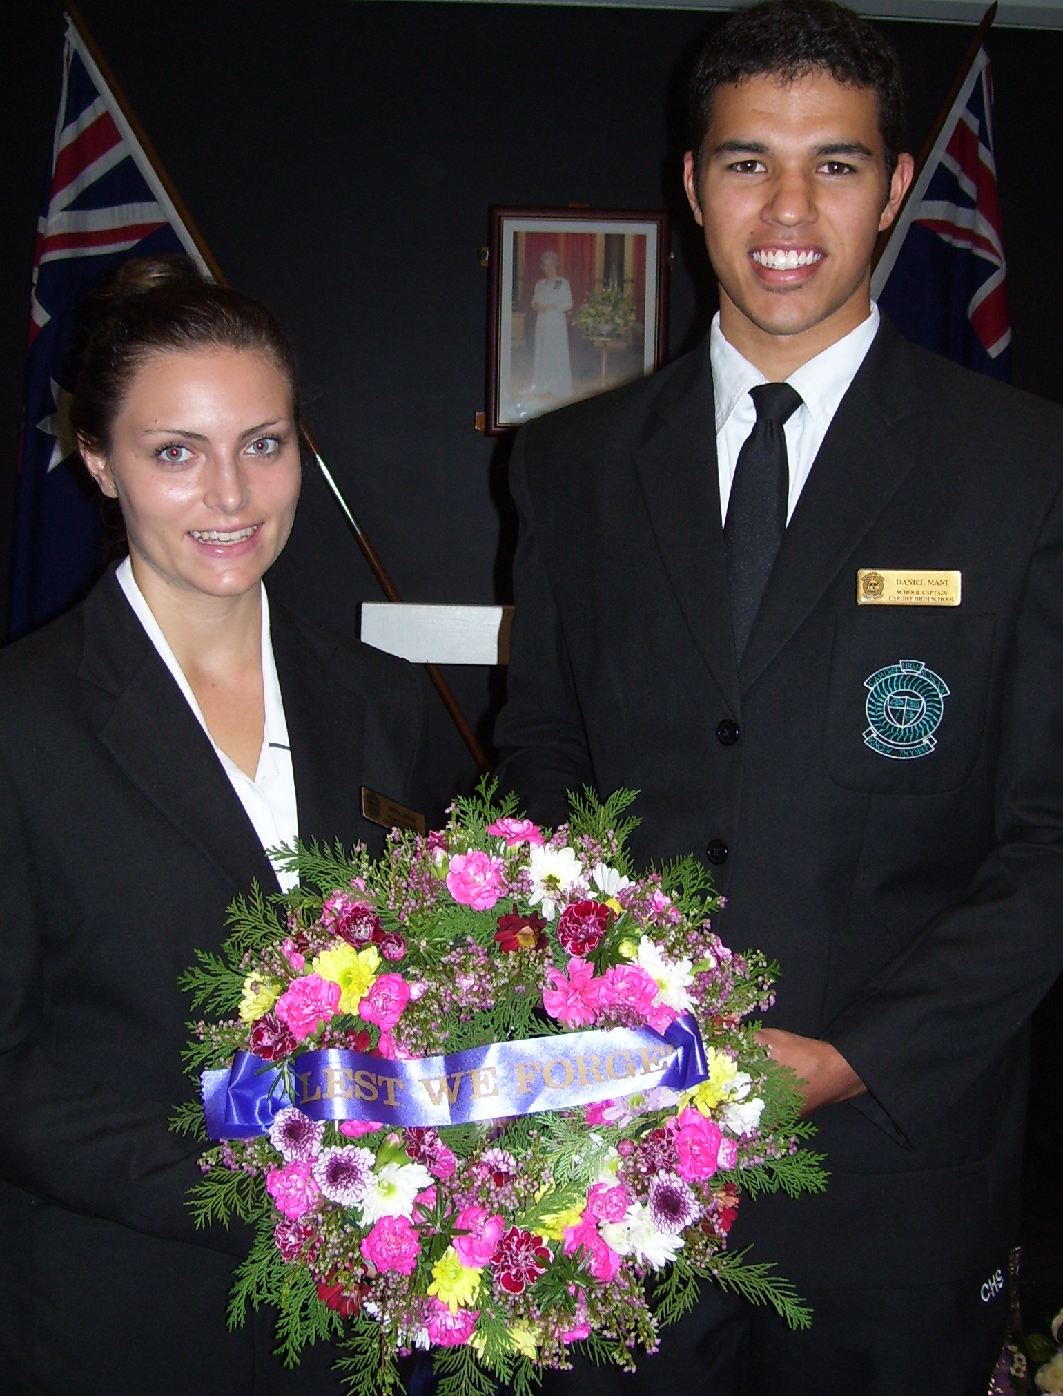

DEPUTY’S REPORT
Welcome back to Term Two at Cardiff High – a very busy term ahead with Half Yearly exams, assessments and our mid year reporting period. In our busy and advanced technological society the School Report is still a vital document when applying for either part time or full time employment. It is not essential that every student have all A and B grades on their report, what is essential however, is that the report teacher comment reflects a keen, enthusiastic and motivated young person who tries their best in every subject and who has the ability to interact with others in a positive way.

Achieving Excellence
All students have the opportunity at Cardiff High to excel academically, in the sporting arena, in the Creative and Performing Arts, in practical and vocational subjects and perhaps even in just one particular subject area. New technology and the opportunity to utilise their laptops in classrooms and at home have enabled Year 10 and later Year 9 to really explore their learning by incorporating new knowledge and techniques to build upon the syllabus content delivered within classrooms.
I strongly reinforce the importance of bringing the laptops to all lessons (other than on a Wednesday) as this enables students to embrace technology and ensures that they have the same skills as all other Year 10 students in our neighbouring schools. The Year 10 School Certificate Examinations include Computing Skills and
provides our students with the opportunity to showcase their knowledge and skills.

Uniform
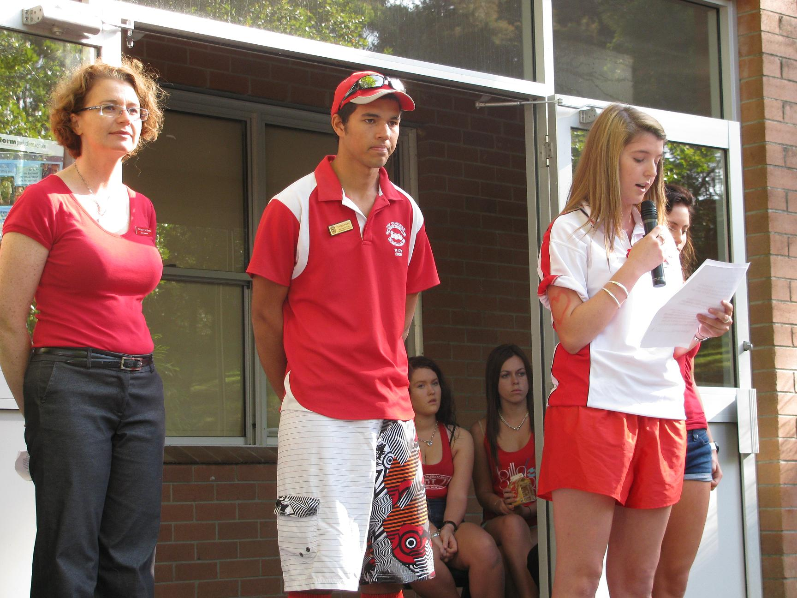
I would like to remind all students as the cooler weather approaches that our winter school jumper is a PLAIN BLACK jumper, either in a polar fleece, fleece or woollen knitted fabric. Cardiff High is very proud of our image within our community and we therefore request the support of all parents and students by ensuring that this image reflects the wonderful young adults which do attend our school by wearing our uniform with pride. CLOSED in BLACK LEATHER shoes are also essential uniform items. Please leave the white or black canvas “slip on shoes” to wear at the weekend.

Leadership Skills
The Leadership Camp which was held at the end of Term 1 once again highlighted the excellent Leadership and teamwork skills of Cardiff High students. The camp was at Glenrock Scout Camp and even though the accommodation is fairly basic by all accounts, the food was pretty good and the activities provided all different opportunities for students to lead others. Physical challenges, lateral

thinking puzzles and exercises, the Spiderweb rope, Raft Building and even the Trivia Night competition provided students with a wide range of opportunities. Comments in the evaluation included:
The Leadership skills we used were- Helping each other, teamwork, respect, cooperation, communication, leading, trust and responsibility. The food was great (better than expected), great scones. The majority of the students felt that a two night camp would have been better to further extend the teamwork and ability of all students to share the leader role. The “football team” concept was enthusiastically embraced with some great uniforms being worn by the Knights and Dragons in particular (we didn’t have the Storm!!) The general consensus was that it was AWESOME, I had a great time and got to know others as well as learn some great new skills and let’s have another one soon.
Many thanks to Mr Welch, Ms O’Donnell and Mr Turnidge who all worked tirelessly to help make the camp such a great experience. I hope to have another day later in the year to revisit and see “where to now”. Please see the attached photos of students having a great time.

Red Heart for Ben
The Red Heart for Ben fundraiser was also a great success with all students and most staff wearing red for the day and donating to a very worthy cause – The Heart Foundation. Ms Penny Milson was very impressed with our school spirit and also appreciative of the donation received. Elly Davis spoke with special feeling at the assembly and I know that the family are also supportive of the fundraiser theme. The attached photos also made it into the Post Newspaper which was great publicity for the caring students of Cardiff High.

Anzac Tradition
On Sunday 25th April our school captains, Daniel Mani and Anna Milat were our representatives at the Cardiff RSL Anzac ceremony and with Anna speaking and Daniel laying a wreath we were ably represented in the Cardiff Community. Mr Trayhurn organised our own Anzac ceremony at school on the Tuesday with once again our very own Mrs Heggs playing the moving ‘Last Post” on her trumpet.

Sailing Success
In the Easter break Mitchell Parker participated in the CHS Sailing Championships held on Lake Macquarie in his Class Europ boat. He improved his placing in 2010 and achieved a very creditable 18th placing overall in the Championships. He was 8th in the Aus Division and 6th in the CHS Division and 17th in the NSW All School result. These excellent results placed him as 18th overall and we congratulate Mitchell on such a wonderful achievement and wish him continued success in his sailing. We are proud of his achievements.


Netball Representatives
On the June Long Weekend – Kirsten Stanton will be representing the Newcastle Netball Association in the 17 Years team (the team Manager being a certain DP at CHS!) and we wish Kirsten all the best for these State Championships. Elly Davis is also participating in the same State titles and is a member of the 17 Years team playing for the Charlestown Association.
Good luck to both girls.

Mrs H Matthews
DEPUTY PRINCIPAL

MATHEMATICS NEWS

As we welcome back students to term 2 the Mathematics faculty has adopted the MathsOnLine program. Ms Fletcher and Mr de Beer have facilitated this initiative and completed the setting up required to allow our students to access this web based learning opportunity. Please see the accompanying information at the end of this article.
During this term all classes will have at least one assessment task across the whole year as well as individual class assessments that will contribute to the information supplied on the first semester report. Parents can monitor when the major tasks are scheduled by looking at the course planner issued to all students. Could you please assist us by reminding your child to bring all their equipment to every lesson? Exercise book, textbook, laptop, calculator, ruler, pencils and pens are required. The most successful way to study mathematics is to complete a large number of questions which is why we usually set work to be completed at home. Teachers may now use the Mathsonline program to provide an alternative source of homework. If you do not have access to the internet at home please let us know so we can provide alternative work for your child.
We are encouraging all our students to make an attempt at the work presented in class. Learning maths comes from trying solutions and being prepared to make numerous attempts before necessarily achieving the best solution to a problem. Being prepared to take a risk and perhaps making mistakes is an essential part of the process of learning.
For years 10 and 12, I would encourage them to make use of the Board of Studies website to access past School Certificate and Higher School Certificate papers to practice their skills and knowledge. There are self marking multiple choice questions available for School Certificate and General Mathematics students which can provide a regular review of work. Year 12 should also consider buying the MANSW booklet of past papers with written solutions as this is an excellent study source.

Miss H Kelsey
Head Teacher Mathematics

MathsOnLine
Information for Newsletter/Parents

The Staff of Cardiff High School would like to announce a fabulous new initiative just introduced into our mathematics teaching programs. We have registered all of our students to use the fabulous teaching/learning resource at www.mathsonline.com.au . You may have seen the recent TV advertisements by their sponsors McDonalds Australia, and it is through this sponsorship that the program which previously cost its many thousands of satisfied clients $40 per month for access, is now FREE to our students.
Some of the features that this program has are as follows;
- Full lessons for each concept with a voice over and numerous examples of varying difficulty. Every lesson has a pause and rewind facility to help students grasp concepts at their own pace.
- Every lesson has an accompanying printable summary and worksheet to consolidate the concept, with full worked solutions provided also.
- A student’s ongoing use and progress in the program is stored for theirs and their teacher’s perusal at any time.
- The program can be accessed from any internet ready site, not just at school.
- The entire Year 7 to 12 programs is available to every student, not just their particular year group or course.
- Parents may register to get weekly updates on their child’s program use and progress, by clicking on the ‘Parents area’ tab within their child’s account.
- Many more features will also be made available on-line over coming months.
Given that the program covers most of the concepts that we teach, and as good as this resource is, the school wish to make it clear that it was never intended by its creators to replace the wonderful work that our mathematics teaching staff already do. This program is best used as a support/supplement to the classroom teaching/learning experience.
All students will be issued with their unique logins and passwords over the next few days by their maths teacher, and are encouraged to use this resource as directed by their own teacher.

Now available at Administration Office

Munibung Price $30

Or

For families who paid the General School Contribution in 2009 - Price $20

Munibung



ROTARY AUSTRALIA & NEW ZEALAND STUDENT EXCHANGE
2011 PROGRAM
EXPRESSIONS OF INTEREST OPEN

This program is designed for 14-16 year old students (In Year 9 or 10 in 2011) to experience a true ‘exchange’ with a family in New Zealand. Local Students are matched with a New Zealand student who travels to Australia to attend school during Term 2, 2011. Both students then return to New Zealand and attend school there for Term 3, 2011.
The students’ family hosts the NZ student and includes them in their normal family life.

This is an exciting way to experience another culture with the support of Rotary.

More information and expression of interest forms can be found at: www.eastmaitlandrotary.org.au/anzyep/

Expressions of interest close 30 June 2010

Maths/Science Tutoring
Assignment/SCOPE Help
Years 7-10
Price: $20/hour
Connor Sherwood
Ph: 49567474

NAPLAN IS HERE AGAIN

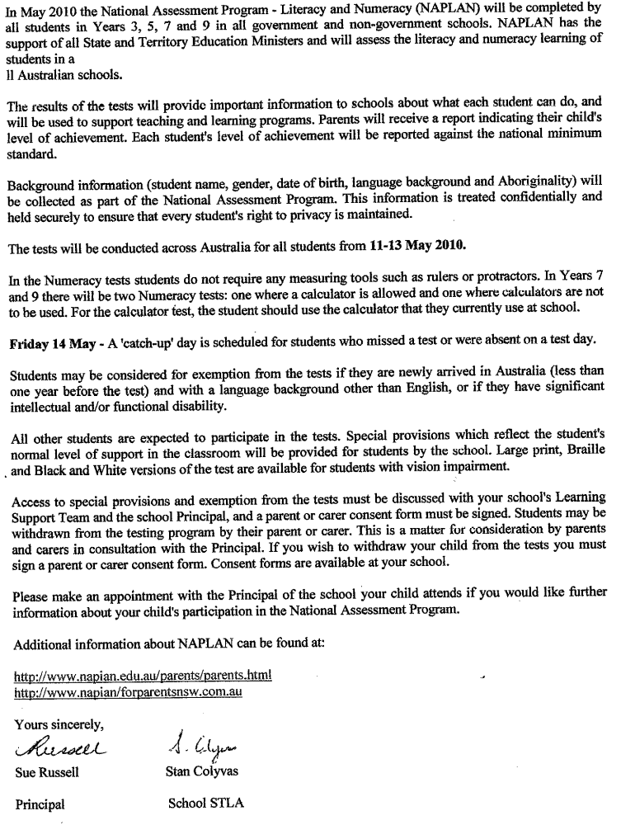

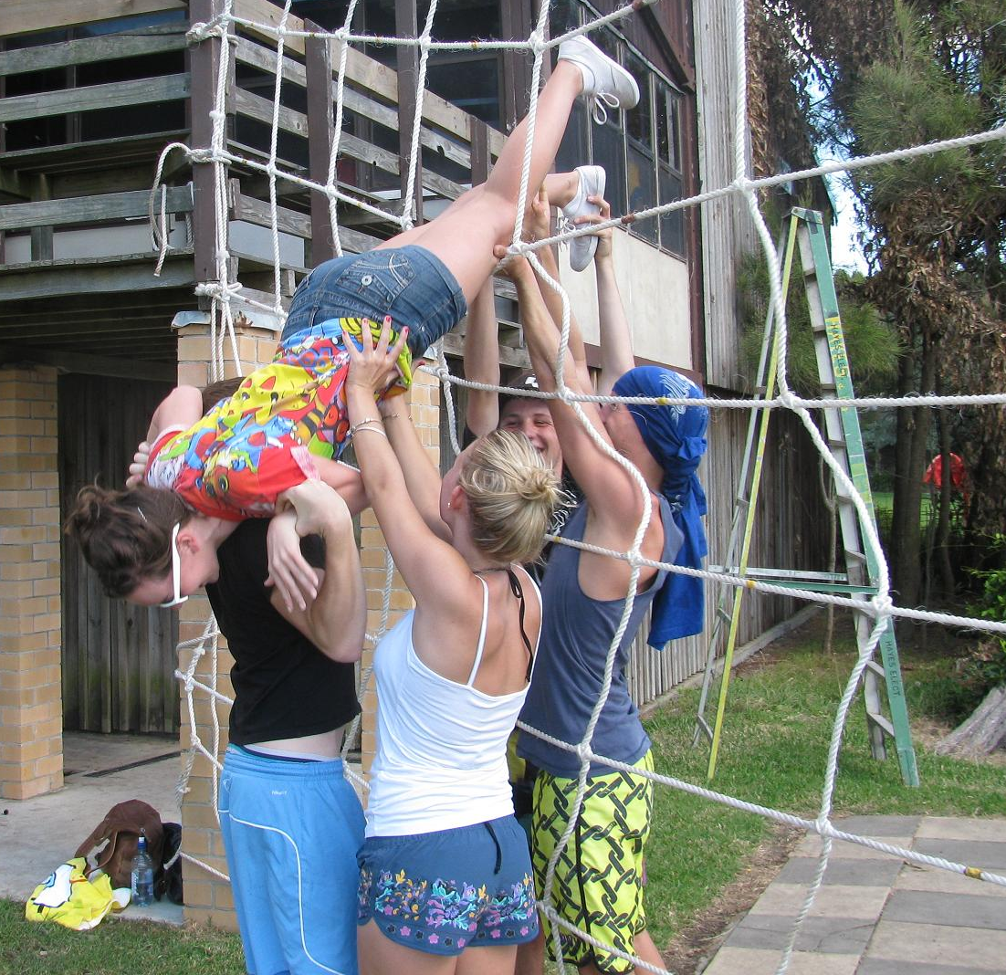

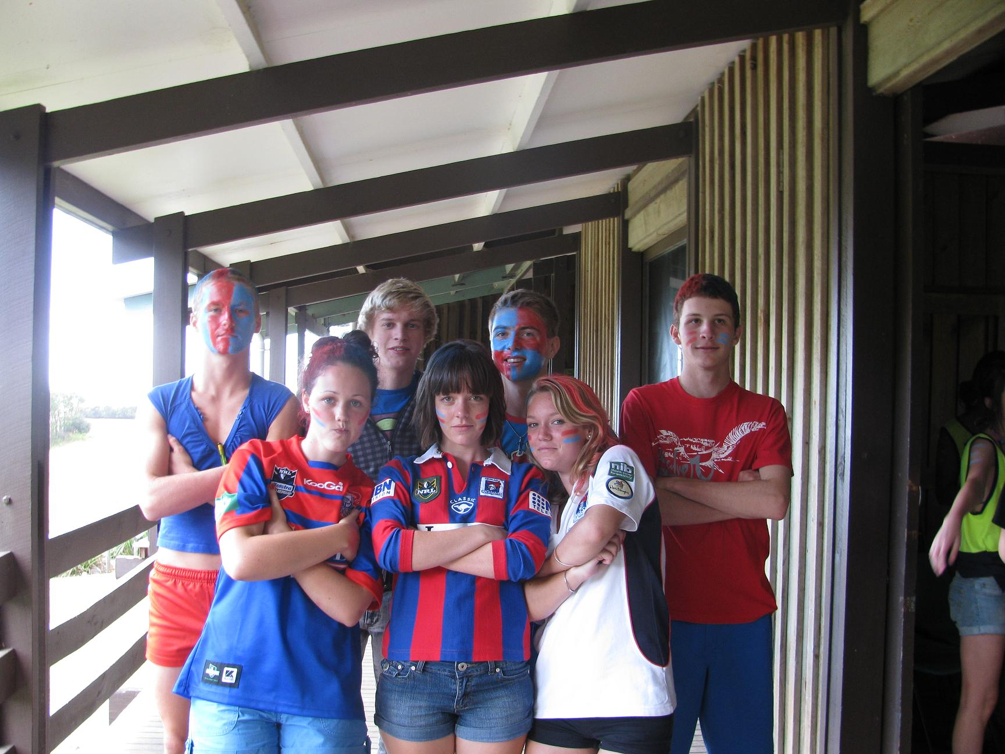

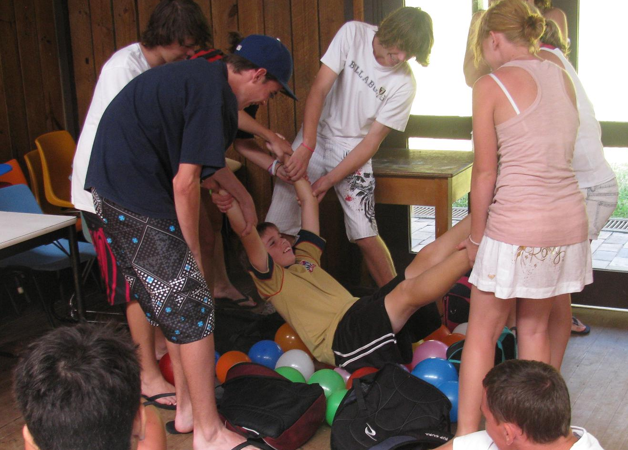



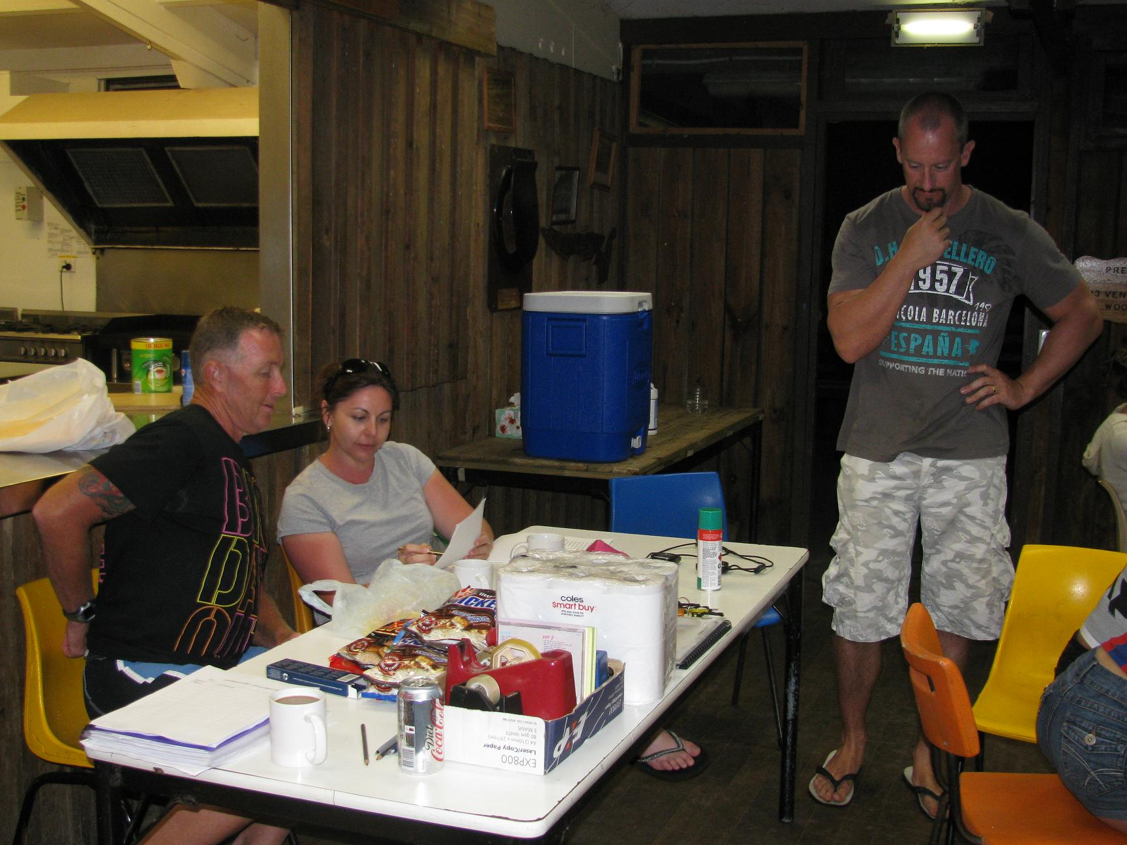

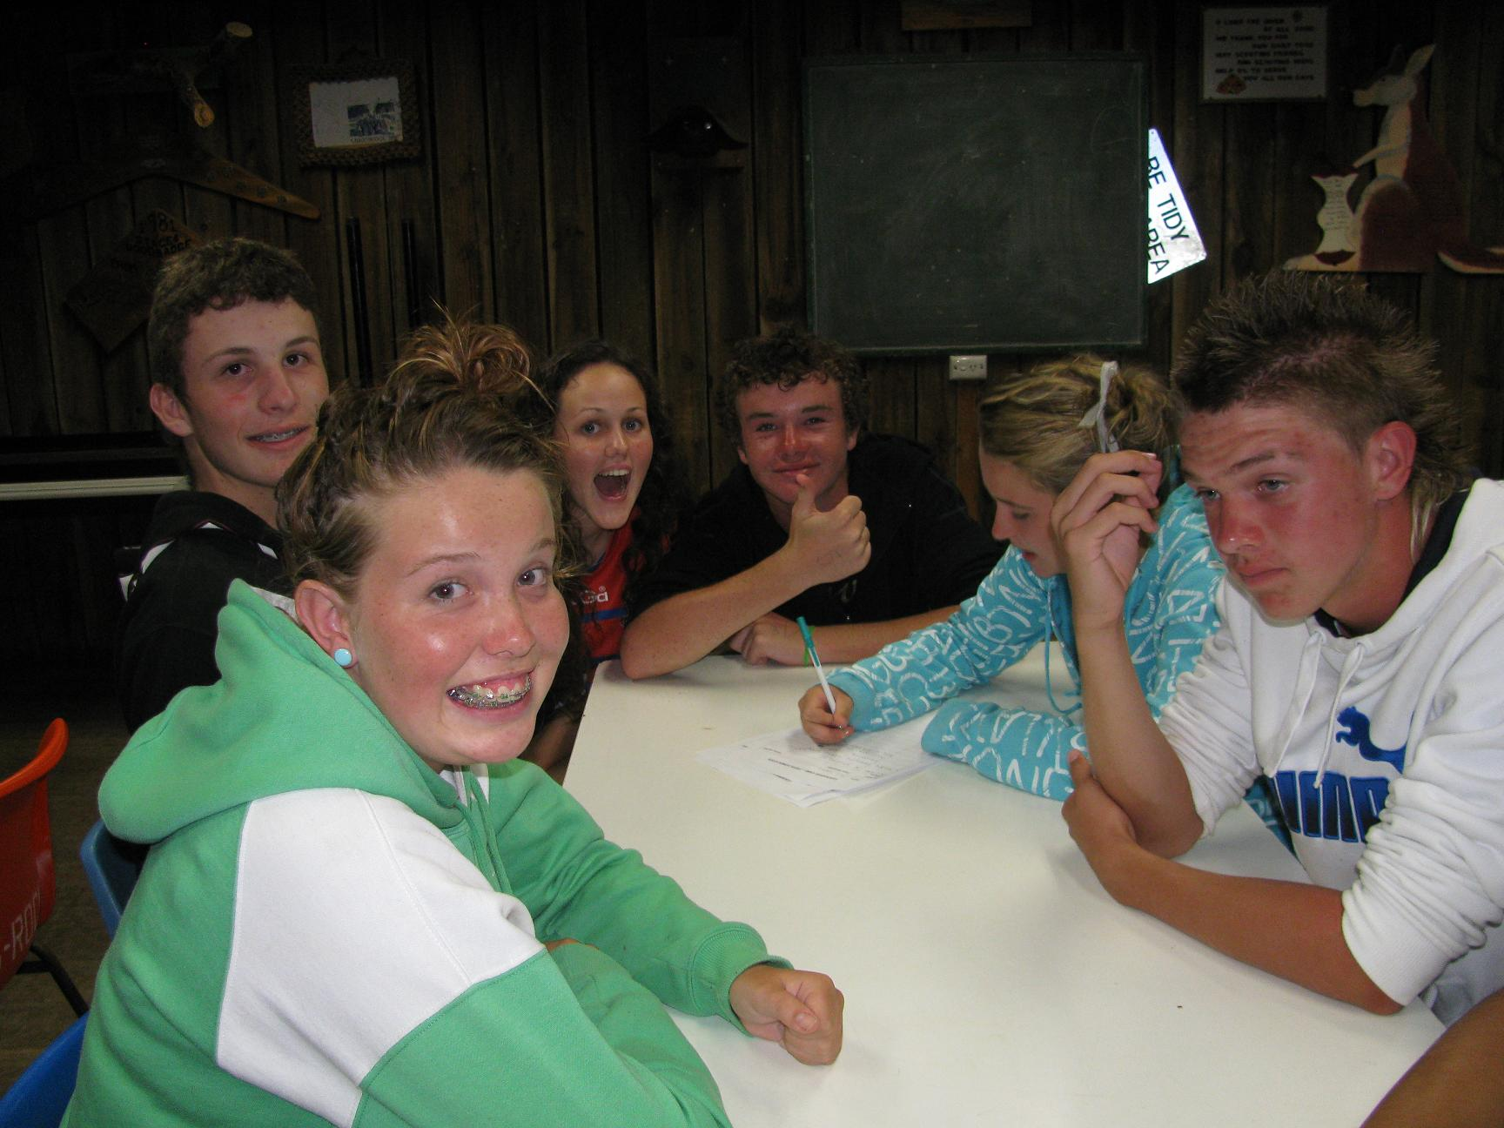


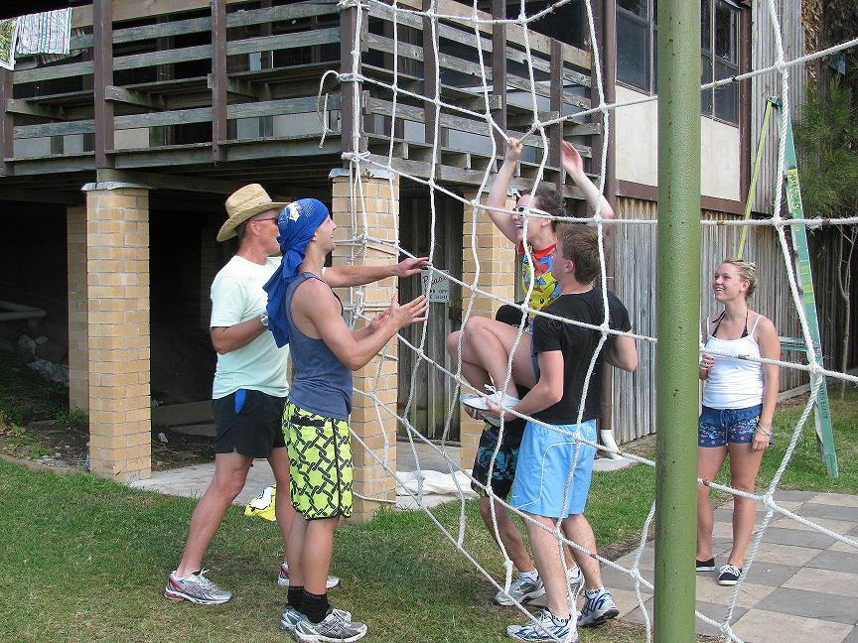



HSIE REPORT

End of Term one assessment has come and gone with many students receiving pleasing results for their efforts. Special mention goes out to Jack Tuxford, Jessica Elloy and Mitchell Campbell of Year 10 who have been promoted into the top graded class due to their focused efforts in term one Geography and History classes. Commendation letters will be distributed this week for others who are obviously showing improvement and commitment to their studies.
Year 11 are nearing the mid way point of their preliminary courses and as usual should be consulting their assessment guide to get a heads up on when their next tasks are due. It is critical that all students attend classes as there is a strong relationship between attendance and success.
Workstudies students have been involved seeking work experience over the last couple of weeks. It is a daunting task for young people to approach employers, go through an interview process and sell themselves as assets to a business. Thanks to Mrs Gibson and local businesses all work ready students have been successful in gaining employment.
Mr Mungoven’s Year 8 Eco Warrior group have done a wonderful job in cleaning up the school’s rainforest area. Brad Peters, Alex Armstrong and Jacob Maher have made great inroads into the weeds and unwanted plants. Hope they’re as helpful at home. They have also visited and discussed the changes to Winding Creek Weir which the Council and Water Board have proposed.
Plans are under way for excursions for Year 7 Geography (local area landscapes) and the combined Year 9/10 Commerce class (Maitland Goal – Crime topic). Year 12 classes will have opportunities at study days this term.
Scope tasks for Year 8 History, Year 9 History and Geography and Year 10 History are all due this term. Be prepared, don’t leave it to the last minute and always do your very best as they contribute to your assessment.

Mr S Trayhurn
Head Teacher HSIE

Letter to parents re school league tables

Dear parent/caregiver,
The teachers at our school are writing to you to explain why we oppose the publication of school league tables. We hold these views strongly because the creation and publication of school league tables by the media will undermine the educational outcomes of your children.
Recently, commercial media organisations created and published school league tables using the “NAPLAN” data from the Federal Government’s MySchool website. NAPLAN is the National Assessment Program – Literacy and Numeracy tests given in years 3,5,7 and 9. In NSW legislation has previously stopped newspapers publishing league tables.
Now media organisations are demanding the right to publish their own score card on schools. They make these tables in order to make money. Politicians are now allowing the media to produce a spurious ranking which names and shames schools of their choosing. This is wrong and we can’t allow it to continue.
The NAPLAN tests were designed to assess each child in aspects of literacy and numeracy. The purpose was to find out more about what each child can and can’t do so that we – teachers and parents together – can help them to do even better.
Teachers do not oppose the tests if they are used to help students learn. We strongly oppose the misuse of students’ test scores to rank students and schools against each other.
The NAPLAN test has a place but schools do much more than teach literacy and numeracy. The over-emphasis on a test given in one week every two or so years will force teachers to cut other parts of the curriculum such as history, geography, music and physical education.
We can’t let this happen. School league tables have already severely undermined the quality of education in England and the United States. At present, Australian school performance is far above the performance of these countries. We can’t let misguided politicians import the known failures of overseas governments into Australia. The education of our children is too important.
For these and other reasons we want the government to again put in place laws to stop league tables being published in any print, electronic or other media.
Please contact your child’s teacher if you require further information on this matter. It is important to us that teachers and parents work together to ensure school have the best chance to provide a quality public education for all children.

Yours sincerely


Federation Representative.



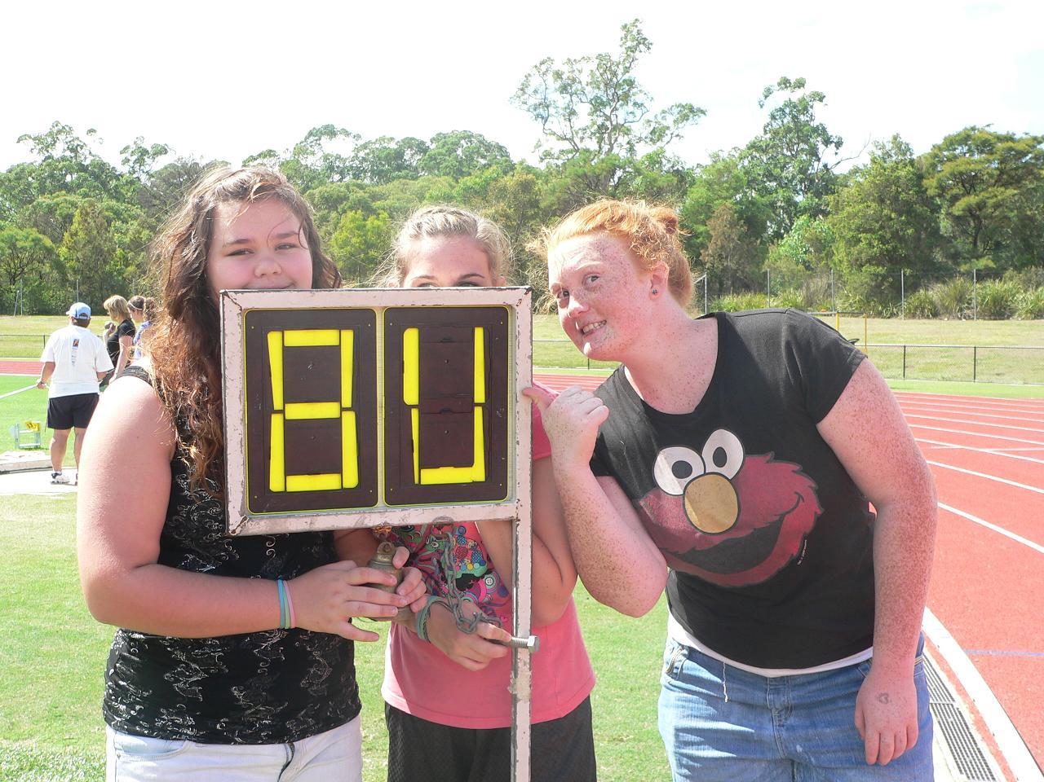

Athletics Carnival

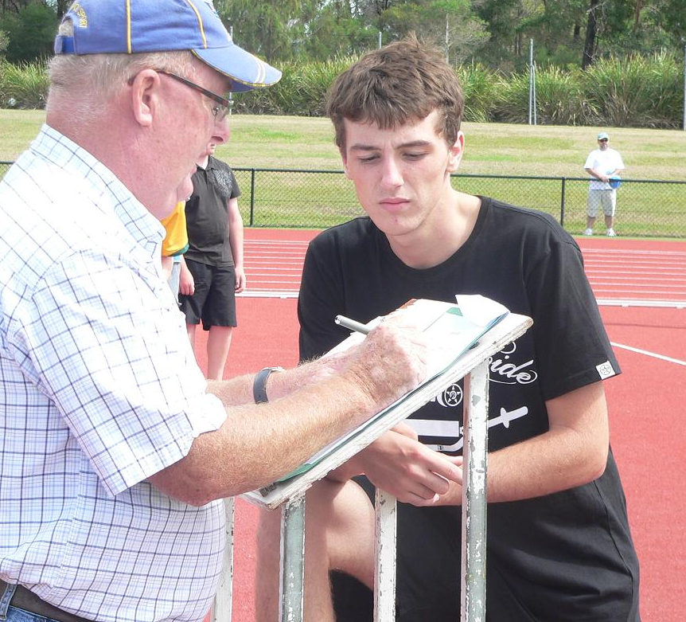
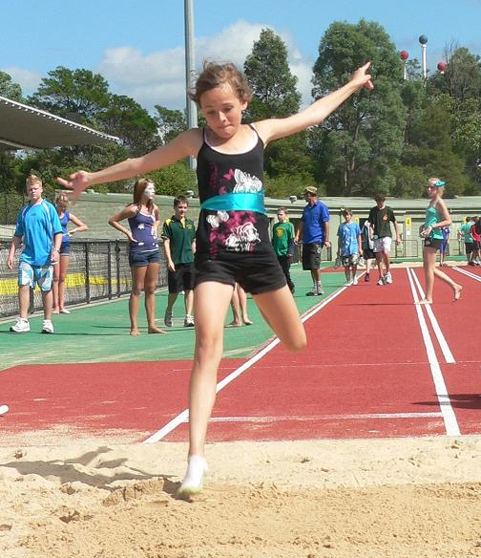

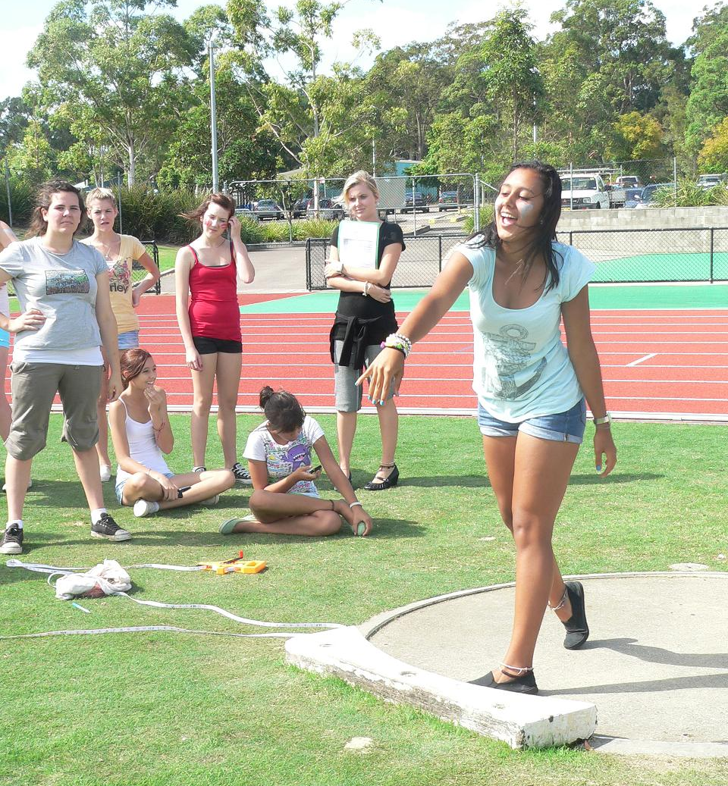

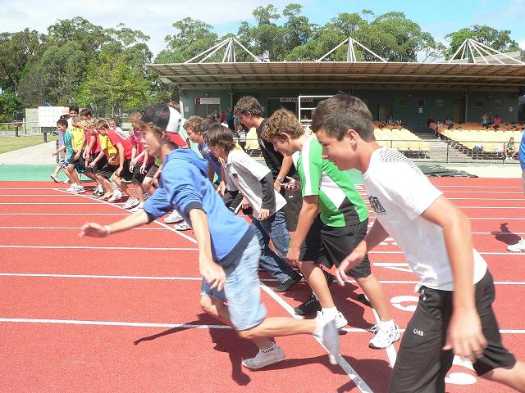



A Message to parents from Telstra in regard to Cybersafety
Educating Australian kids, parents and carers about safe and secure internet and technology
use is a key priority for Telstra.
The web and technology changes fast and it takes time to ensure that we’re on top of these
changes to keep our experiences safe.
Telstra takes its responsibility as a trusted internet services provider and integrated
telecommunications company seriously. We work with industry, government, community
organisations and internet users to address the range of evolving online risks and to
develop measures that promote online safety.
• We have been working to help Aussies enjoy their online experiences for many years.
• We recognise the need for every age-group to access information and expertise to allow them to safely obtain full value from their online experience. This continuing commitment is reflected in our awareness programs, retail product offerings and customer communications.

TIPS FOR TEENAGERS:
1. Be careful about talking to people you meet online. Not everyone is who they say they are.
2. Don’t post, send or share anything you wouldn’t want your parents, teachers, future employers or someone who may be making unwanted advances towards you to see.
3. Remember what you post online stays online for a long time - so think before you click!
4. Keep your private information private – do not give out personal details online like your birthday or address, even on social networking sites like Facebook.
5. Your username and password should belong to you, and only you.
6. Remember to change your passwords regularly. Passwords should be completely random and unique, but still memorable. Try using numbers and letters.
7. Don’t leave a computer whilst your account is still logged in - anyone could start using it.
8. If you wouldn’t say something to someone offline then don’t say it online.
9. Monitor your online and mobile usage. Not all content you view online is free to browse. If you’re with BigPond, look out for green dot content as it doesn’t count towards your download limit. Look at your usage meter regularly or think about getting a pre-paid account.
10. If you feel like you are being bullied talk to someone you trust – don’t deal with it on your own. Your parents, teacher or even the Kids Helpline can help you. You can call Kids

Helpline on 1800 551 800 - it’s Australia's only free, private and confidential, telephone and online counselling service specifically for people aged between five and 25.

TIPS FOR ADULTS:
1. Use your common sense. If an offer, scheme or sale seems to be too good to be true then it
probably is.
2. Keep your private information private – do not give out personal details online such as your birthday and address, even on social networking sites like Facebook.
3. Be wary of emails, phone calls or SMS messages from unknown sources asking you to update, validate or confirm your account details, password or personal information.
4. Remember what you post online stays online for a long time so think before you click.
5. Change passwords at least twice a year.
6. Passwords should be completely random and unique, but still memorable. Try using numbers and letters.
7. Don’t leave a computer whilst your account is still logged in because anyone could start using it.
8. Install security software and update regularly to prevent potential viruses and fraud.
9. Always type the address of a website you are wanting to look at in the address bar.
10. Ensure your mobile phone is PIN locked
COMMON SCAMS TO BE AWARE OF….
1. Phishing
Beware of any unsolicited emails from organisations requesting you to update your
personal/financial details. To make their emails look genuine, the phishers may have copied an
organisation's logo, images or even their entire website. Call your service provider if you are unsure.
2. Wire Transfer Scams
Beware of any sellers requesting you to send funds overseas - this scam involves the
seller engaging the buyer off-site (usually via email) and convincing them to send money
through an international money transfer service for an item that will never be shipped.
3. Domestic Non-Delivery Fraud (Domestic)
Beware of ads for high value electronic items advertised for a low price - unsuspecting
buyers make contact and send funds to the seller but never receive the item.
4. Buyer Fraud Scam
Beware buyers requesting you send the item you are selling overseas. They may send a fake invoice from a financial provider to dupe you into thinking they have paid.










